

**Creo for Tool and Die Design**

PRODUCT DESIGN AND DEVELOPMENT LABORATORY

### This lab allows you to visualize your imagination in a virtual environment and which can be further developed and optimized. PTC Creo software package is used to achieve this and which helps you to save time, money and effort to develop new concepts and bring them into reality. In any design cycle, product design and development is the critical stage to bring life to any conceptual model.



IDEA

TESTING

DEFINE

DESIGN &

DEVELOPMENT

PROTOTYPE

CONCEPT

DEVELOP

### In this lab you will be learning basic modeling of parts (solids, sheet metals and Class – A surfaces), Assembly, Drafting, creating of different tools and dies for manufacturing special parts and also Math CAD to create report of your mathematical calculations related to your design.

### The list of courses offered,

|  |  |  |
| --- | --- | --- |
| **S. No** | **Name of the Course** | **Duration** |
| 1 | Creo for Design | 108 Hours |
| 2 | Creo for Industrial Engineers | 72 Hours |
| 3 | Specialization program for Tool and Die design | 40 Hours |
| 4 | MathCAD | 40 Hours |

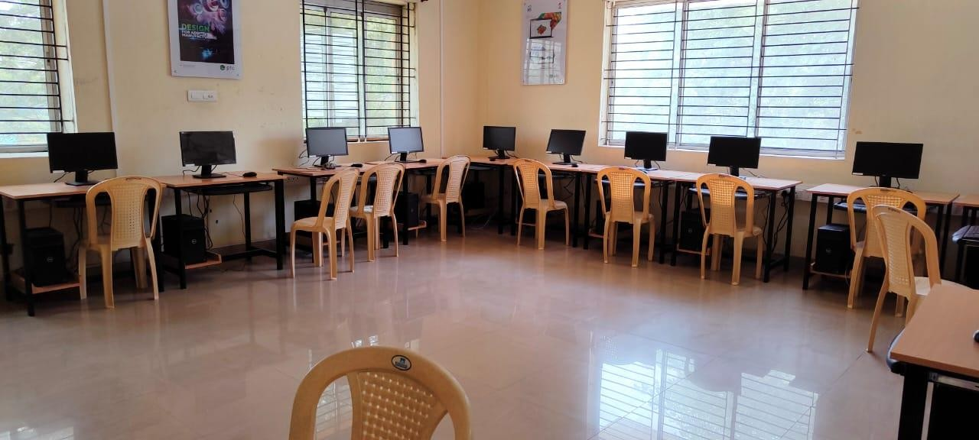

CREO FOR TOOL AND DIE DESIGN

### Creo for tool and die design course is designed for users who are new to use CAD tools to design complicated designs with the help of surfacing tools and free form modelling tools for mold process. This course will introduce users to design parts with more degree of curvatures and also to analyse the surface curvatures. The users will equip the skill to enhance themselves in a broader way in the design field. The users will also skill themselves to work on the dump models.

|  |  |  |
| --- | --- | --- |
| **S. No** | **Name of the Course** | **Duration** |
| 1 | Creo for tool& die design | 40 Hours |

**SOFTWARE PACKAGES > Creo parametric 6.0.3.0**

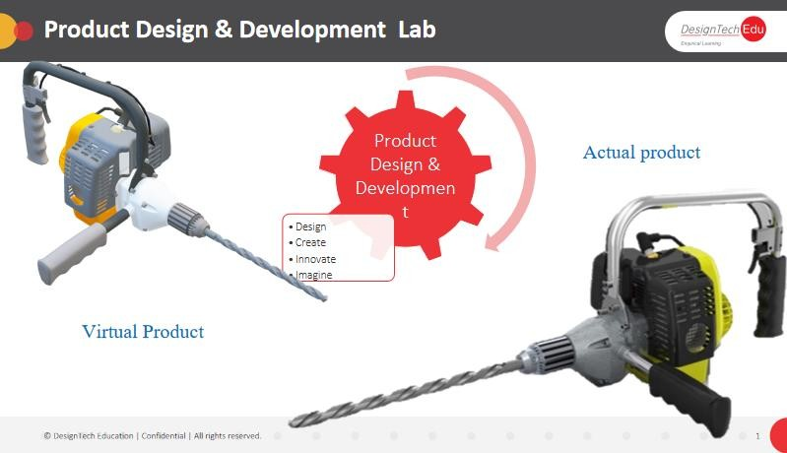

**Contents**

##### 1.Introduction to the Creo Parametric Basic Mold Process

Creo Parametric Basic Mold Process

##### 2.Design Model Preparation

Understanding Mold Theory

Preparing Design Models for the Mold Process

Creating Profile Rib Features

Exercise 1: Creating Profile Rib Features

Creating Drafts Split at Sketch

Creating Drafts Split at Curve

Creating Drafts Split at Surface

##### 3.Design Model Analysis

Analyzing Design Models Theory

Performing a Draft Check

Performing a Section Thickness Check

Performing a Thickness Check

##### 4.Mold Models

Creating New Mold Models

Analyzing Model Accuracy

Locating the Reference Model

Assembling the Reference Model

Creating the Reference Model

Redefining the Reference Model

Analyzing Reference Model Orientation

Analyzing Mold Cavity Layout

Analyzing Variable Mold Cavity Layout

Analyzing Mold Cavity Layout Orientation

Calculating Projected Area

Exercise 1: Creating the Shower Head Mold Model

##### 5.Shrinkage

Understanding Shrinkage

Applying Shrinkage by Scale

Applying Shrinkage by Dimension

##### 6.Workpieces

Creating Display Styles

Creating a Work piece Automatically

Creating a Custom Automatic Work piece

Creating and Assembling a Work piece Manually

Reclassifying and Removing Mold Model Components

##### 7.Mold Volume Creation

Surfacing Terms

Understanding Mold Volumes

Sketching Mold Volumes

Creating Sliders using Boundary Quilts

Sketching Slider Mold Volumes

Creating a Reference Part Cutout

Sketching Lifter Mold Volumes

Exercise 1: Sketching Lifter Mold Volumes

Replacing Surfaces and Trimming to Geometry

Sketching Insert Mold Volumes

**8.Parting Lines**

Understanding Parting Lines

Creating an Automatic Parting Line Using Silhouette Curves

Analyzing Silhouette Curve Options: Slides

Analyzing Silhouette Curve Options: Loop Selection

**9.Skirt Surfaces**

Understanding Parting Surfaces

Creating a Skirt Surface

Analyzing Skirt Surface Options: Extend Curves

Analyzing Skirt Surface Options: Tangent Conditions

Analyzing Skirt Surface Options: Extension Directions

Analyzing Skirt Surface Options: ShutOff Extension

Exercise 1: Creating the Shower Head Parting Surface

**10.Parting Surface Creation**

Analyzing Surface Editing and Manipulation Tools

Merging Surfaces

Creating a Shadow Surface

Exercise 1: Creating Parting Surfaces using Shadow Surfaces

Creating a Parting Surface Manually

Creating Saddle Shutoff Surfaces

Creating Fill Surfaces

Extending Curves

Filling Loops

Creating Shut Offs

Exercise 2: Creating Parting Surfaces Manually

**11.Splitting Mold Volumes**

Splitting the Workpiece

Splitting Mold Volumes

Splitting Volumes using Multiple Parting Surfaces

Blanking and Unblanking Mold Items

Analyzing Split Classification

Exercise 1: Splitting the Shower Head Mold

Exercise 2: Splitting the Mouse Mold

**12.Mold Component Extraction**

Extracting Mold Components from Volumes

Applying Start Models to Mold Components

Exercise 1: Extracting Shower Head Mold Components

Exercise 2: Extracting Mouse Mold Components

##### 13.Mold Features Creation

Creating Waterline Circuits

Analyzing Waterline End Conditions

Performing a Waterlines Check

Understanding Mold Analysis Settings

Creating Sprues and Runners

Exercise 1: Creating Sprues and Runners

Creating Ejector Pin Clearance Holes

Creating UDFs

Placing UDFs

Exercise 2: Creating Waterline Circuits

Exercise 3: Creating UDFs in the Casing Mold Model

##### 14.Filling and Opening the Mold

Creating a Molding

Opening the Mold

Draft Checking a Mold Opening Step

Interference Checking a Mold Opening Step

Viewing Mold Information

Exercise 1: Opening the Shower Head Mold Model

##### 15.Introduction to the Creo Parametric Sheetmetal Design Process

Creo Parametric Sheetmetal Design Process

##### 16.Sheetmetal Model Fundamentals

Sheetmetal Model Fundamentals

Understanding Developed Length

Creating a New Sheetmetal Part in Assembly Mode

Creating a New Sheetmetal Model in Part Mode

##### 17.Creating Primary Sheetmetal Wall Features

Understanding Sheetmetal Wall Features

Creating Planar Walls

Revolved Sheetmetal Wall Features

Blend Sheetmetal Wall Features

Creating Offset Walls

Sheetmetal Wall Sketching Tools

Advanced Primary Walls

##### 18.Creating Secondary Sheetmetal Wall Features

Understanding Secondary Walls

Creating Secondary Flat Walls

Using Flange Walls

Using Extruded Walls

Wall Dashboard Options

Using Partial and Overextended Walls

Understanding Relief

Creating Twist Wall Features

Extending and Trimming Walls

Using the Merge Feature

##### 19.Bending and Unbending Sheetmetal Models

Creating Bend Features

Adding Transition to Bends

Bending in Multiple Planes

Creating Planar Bends

Creating Unbend Features

Creating Bend Back Features

Previewing and Creating Flat Patterns

Creating Flat States

Creating Split Area Features

##### 20.Sheetmetal Form Features

Punch Form Features

Utilizing Punch Model Annotations

Creating Die Forms

Creating Die Forms Using Annotations

Creating Sketched Forms

Flattening Forms and Unstamping Edges

##### 21.Modifying Sheetmetal Models

Sheetmetal Cuts

Notches and Punches

Creating Multiple Bend Reliefs

Bend Line Relief Placement

Creating Corner Relief

Creating Rip Features

Joining Walls

Patterning Walls

Mirroring Walls

##### 22.Sheetmetal Setup and Tools

Bend Line Adjustments

Using Bend Tables for Bend Allowances

Fixed Geometry

Info Tools and Reports

Design Rules

Defaults and Parameters

UsingConversionFeatures

**1.INTRODUCTION TO THE CREO PARAMETRIC**

**BASIC MOLD PROCESS**

#### Module Overview:

In this module, you learn about the basic mold process that is typically used to take a part from its design stage to the creation of its mold. This simplified process is used at most companies; however, your specific company process may differ. The process is explained in further detail throughout the course modules.

#### Objectives:

After completing this module, you will be able to:

* Run a draft check on a design model.
* Create a new mold model and assemble the reference model and workpiece.
* Create a slider mold volume for undercut geometry.
* Create the mold parting surface using a skirt surface.
* Create the mold components by splitting the mold volumes and generating the cavity components.
* Create mold features by creating a runner in the mold model.
* Fill and open the mold by creating a molding and performing a mold opening analysis.

•

* **Creo Parametric Basic Mold Process**

### **Preparing and Analyzing Design Models**

When you create a mold for a design model, you should first inspect the model and analyze it to verify that it is indeed ready to be molded. Typically, the reference model geometry that you use for a mold model is derived from the design model. You can analyze the design model and reference model for adequate draft features and consistent thickness, adding draft features if necessary. It is critical that the final reference model has sufficient draft so that it can be cleanly ejected from the mold.

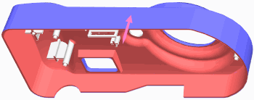

### **Creating the Mold Model**

Start the mold design by creating a mold manufacturing model. Creo Parametric automatically creates the mold assembly when you create the mold manufacturing model. The mold manufacturing model is also referred to as the *Mold Model*. Next, you assemble the reference model, which can be either the design model that is to be molded or a new model derived from the design model. You can account for the contraction of the molding part during cooling in the molding process by applying a shrinkage factor to the reference model. You also create or assemble the workpiece that represents the full volume of all the mold components that are needed to complete the mold model.

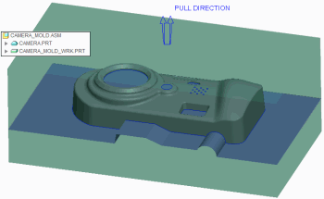

### **Creating Mold Volumes**

You can create mold volumes manually using sketch-based features. A mold volume is a three-dimensional, enclosed surface quilt with no mass in the work-piece of a mold model. You can also manually create a special type of mold volume called a *slider*. Creo Parametric can also create one automatically by calculating undercut areas in the mold model.

### **Creating Parting Surfaces**

You can create parting surfaces for the mold model using the skirt surface technique. The skirt surface technique requires parting lines that you create by using silhouette curves. You can use the parting surfaces to split the work-piece into separate mold volumes later in the mold design process. You can also create parting surfaces manually.

### **Creating Mold Components**

You can split the work-piece volume into one or more mold volumes based on the parting surfaces. The main mold volumes are classified into *core* and *cavity*. Once the desired mold volumes are created and split, you can create the mold components, including sliders, from the mold volumes. The mold components are fully functional parts that you can open and modify in the Part mode of Creo Parametric. You can also machine the components using Creo NC.

### **Creating Mold Features**

You can create regular and user-defined assembly features to facilitate the molding process. Regular features include mold-specific features such as waterlines, runners, and ejector-pin clearance holes. You can also create user- defined features from regular cuts and slots that are placed on mold models to create sprues.

### **Filling and Opening the Mold**

You can create the molding component that represents the filled mold cavity. Creo Parametric creates the molding component automatically by determining the volume remaining in the work-piece after extracting the mold components.

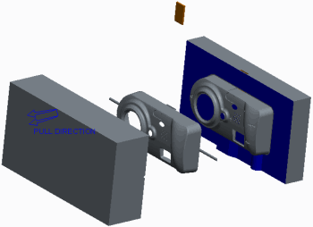

You can then define the steps for the mold-opening process for every component in the mold model except the reference model and work-piece. During the mold opening analysis, you can determine whether there is interference with any static components for each of the steps that you define.

# Excercise1: Creo Parametric Basic Mold Process

To avoid naming conflicts, it is recommended you save your work, click **File** > **Close** until no models display, then click **File** > **Manage Session** > **Erase Not Displayed**.

Click **File** > **Manage Session** > **Set Working Directory** and navigate to the **PTCU\CreoParametric3\Process\Mold** folder and click **OK**

Click **File** > **Open** and double-click **CAMERA.PRT**.

#### Objectives

* Prepare and analyze a design model for manufacturing.
* Create a mold model.
* Create mold volumes.
* Create a parting surface.
* Create mold components.
* Create mold features.
* Fill and open the resulting mold.

You are a design engineer in a camera company. You have been provided with the front housing of a new camera design and are tasked with creating the manufacturing mold for it. You know from previously received models that you must first prepare and analyze the design model to verify that it can be manufactured. Once you have verified that the design model can be manufactured using a mold, you can create the mold model and mold volumes. You can then create the mold-parting surface and mold components. Finally, you can fill and open the resulting mold.

#### 1. Step 1. Prepare and analyze a design model for manufacturing.

* Enable only the following Datum Display types: .
* In the ribbon, select the **Applications** tab.
* Mold/Cast Click **Mold/Cast** from the Engineering group to toggle from the standard application to the Mold application.

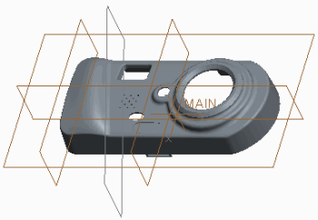

* ick **Draft**  from the Analysis group.
* To perform a draft check, do the following:
* In the model tree, select CAMERA.PRT.
* In the Draft Analysis dialog box, clear the **Use the pull direction** check box.
* Click in the Direction collector and select datum plane TOP.
* 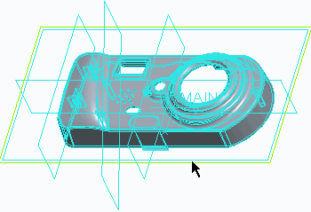Type **0.5** as the value for the Draft angle and press ENTER.

* In the Color Scale dialog box, click **Expand Expand **.
* Edit the number of colors to **3**.

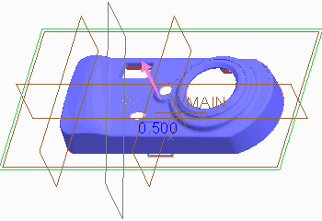 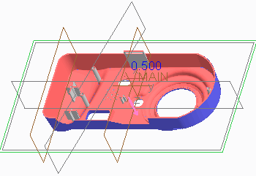

* Click **OK** from the Draft Analysis dialog box.Close 
* Click **Close** from the Quick Access toolbar.

#### 2. Step 2. Create the camera mold model.

* Click **New New ** from the Quick Access toolbar.
* In the New dialog box, do the following:
* Select **Manufacturing** as the Type.
* Select **Mold cavity** as the Sub-type.
* Type **camera_mold** as the Name.
* Clear the **Use default template** check box and click **OK**.
* Select the **mmns_mfg_mold** template.
* Click **OK**.

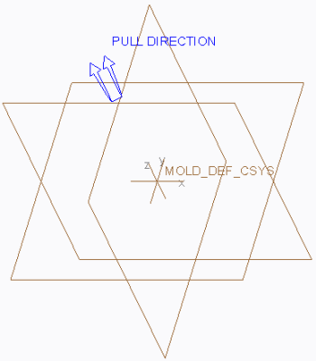

* Click **File > Options** and select the **Configuration Editor** category.
* Click **Add**.
* Type **enable_absolute_accuracy** in the Option name field.
* Select **yes** as the Option value and click **OK > OK > No**.
* Select **Locate Reference Model** from the Reference Model types drop-down menu in the Reference Model & Work-piece group to assemble the reference model.Locate Reference Model 
* In the Open dialog box, select CAMERA.PRT and click **Open**.
* In the Create Reference Model dialog box, select **Same model** as the Reference model type and click **OK**.
* Specify the mold cavity layout by doing the following:
* Click **Reference Model Origin Reference Model Origin ** from the Layout dialog box and select the MAIN coordinate system in the CAMERA.PRT sub-window.
* Click **Preview** and notice how the reference model is assembled and oriented.

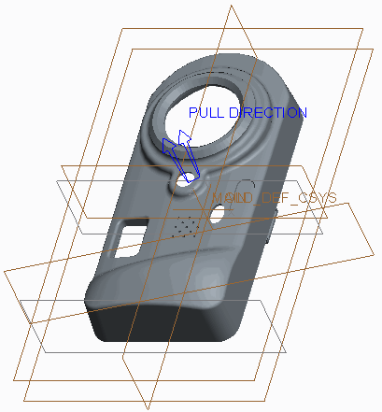

* In the Layout dialog box, select **Rectangular** as the Layout.
* Select **X-Symmetric** as the Orientation.
* Type **120** as the X Increment value and **150** as the Y Increment value.
* Click **Preview**.
* Notice that a pattern of reference models, symmetric about the X-axis, are assembled to create a multi-cavity mold.

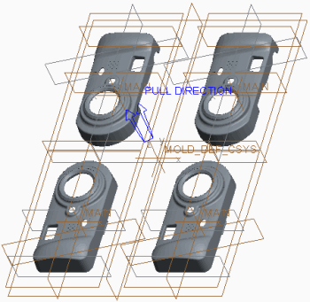

* In the Layout dialog box, select **Y-Symmetric** as the Orientation and click **Preview**.
* Notice that a pattern of reference models, symmetric about the Y-axis, are assembled to create a multi-cavity mold.
* Select **Single** as the Layout to create a single-cavity mold and click **OK**.
* In the Warning message window, click **OK** to accept the change in the absolute accuracy value.

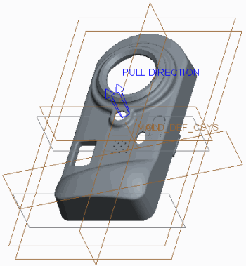

* Apply shrinkage to the reference model by doing the following:
* Select **Shrink by scale Shrink by scale ** from the Shrinkage types drop-down menu in the Modifiers group.
* In the model tree, click the node for CAMERA.PRT to expand it and select the PRT_CSYS_DEF coordinate system.
* Type **0.005** as the Shrink Ratio in the Shrinkage By Scale dialog box and press ENTER.
* Click **Apply Changes** .Apply Changes 

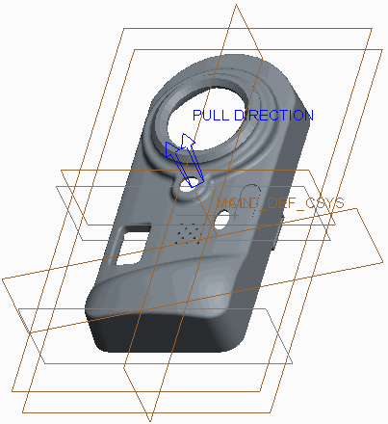

* Select **Automatic Work-piece Automatic Workpiece ** from the Work-piece types drop-down menu in the Reference Model & Work-piece group to create an automatic work-piece.
* In the Automatic Work-piece dialog box, do the following:
* Select the MOLD_DEF_CSYS coordinate system from the graphics window as the Mold Origin.
* Type **20** for the negative, and type **20** for the positive X direction values.
* Type **30** for the negative, and type **30** for the positive Y direction values.
* Type **20** for the negative, and type **20** for the positive Z direction values.
* Click **OK**.
* Disable **Plane Display** and **Csys Display** .Plane Display  Csys Display 

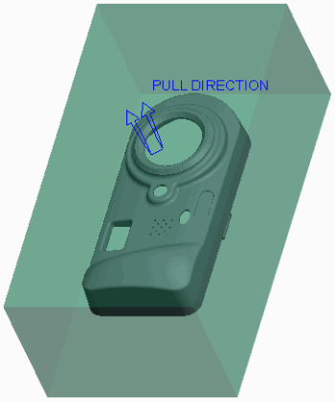

* Select CAMERA_MOLD_WRK.PRT.
* In the ribbon, select the **View** tab.
* Click the Model Display group drop-down menu and select **Component Display Style > Wire-frame**.
* Select the **Mold** tab.

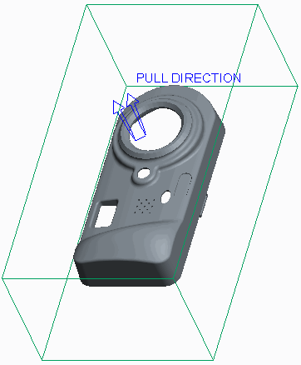

#### 3. Step 3. Create slider mold volumes.

* Select **Mold Volume Mold Volume ** from the Mold Volume types drop-down menu in the Parting Surface & Mold Volume group to create the slider volume.
* To rename the mold volume feature, do the following:
* Click **Properties Properties ** from the Controls group.
* Type **Slider** as the Name of the mold volume in the Properties dialog box and press ENTER.
* Click **Slider Slider ** from the Volume Tools group.
* In the Slider Volume dialog box, do the following:
* Click **Calculate Undercut Boundaries Calculate Undercut Boundaries ** .
* Press CTRL and select **Quilt 1** and **Quilt 2** from the Exclude column.
* Click **Include Boundary Surfaces** to add the selected quilts to the Include column for slider calculation.Include Boundary Surfaces 
* Click **Select Projection Plane Select Projection Plane ** and select the right surface of the work-piece.

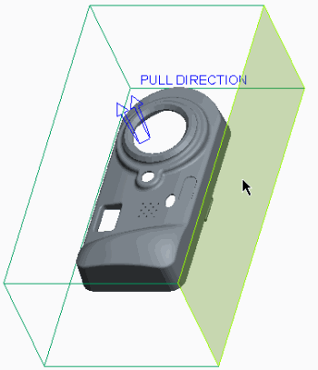

* Click **Apply Changes** from the Slider Volume dialog box.Apply Changes 
* Click **OK** from the Controls group.OK 

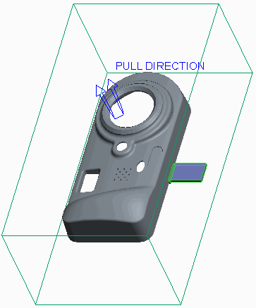

#### 4. Step 4. Create a parting surface.

Silhouette Curve 

* Click **Silhouette Curve** from the Design Features group to automatically create parting line curves.
* In the Silhouette Curve dialog box, click **Preview** to observe the silhouette curves automatically created at all edges of the mold model.

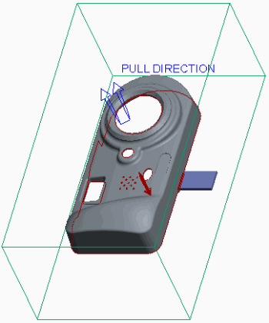

* Notice that some adjustments need to be made to the automatic parting line curves.
* In the Silhouette Curve dialog box, double-click **Slides**.
* Select the slider volume from the graphics window.
* Click **Done/Return** from the menu manager.

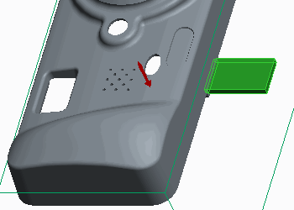

* In the Silhouette Curve dialog box, double-click **Loop Selection**.
* Select the **Chains** tab.
* Select chain **4–1** and click **Lower** to move the curve from the upper edge to the lower edge of the hole.
* Click **OK** from the Loop Selection dialog box.

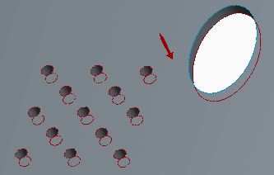

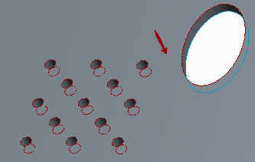

* lick **OK** from the Silhouette Curve dialog box to complete the parting line.

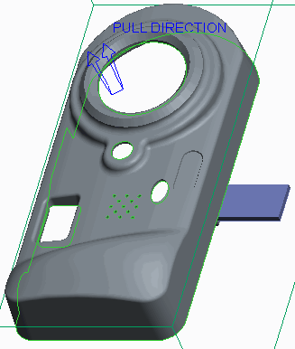

* Click **Parting Surface Parting Surface ** from the Parting Surface & Mold Volume group.Skirt Surface 
* Click **Skirt Surface** from the Surfacing group to create an automatic parting surface.
* Select the work piece.
* Select the silhouette curve.

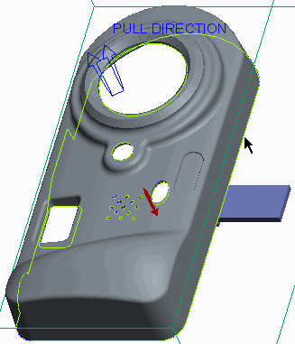

* Click **Done** from the menu manager.
* In the Skirt Surface dialog box, double-click **Extension**.
* In the Extension Control dialog box, select the **Extension Directions** tab.
* Click **Add**.
* Press CTRL and select the two vertices.

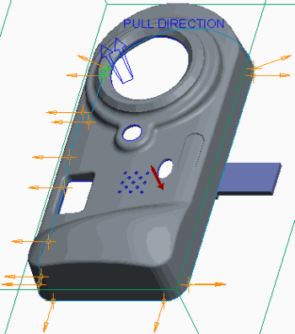

* Click **OK** from the Select dialog box.
* Click **Done** from the menu manager.
* Query-select the left surface of the work piece as the normal plane.
* Click **Okay** from the menu manager.
* Click **OK** to close the Extension Control dialog box.
* Click **OK** from the Skirt Surface dialog box.
* Click **OK** from the Controls group to complete the parting surface.OK 

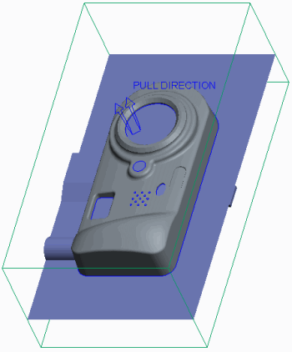

#### 5. Step 5. Create the mold components.

* Select **Volume Split** from the Mold Volume types drop-down menu in the Parting Surface & Mold Volume group to split the work piece into mold volumes.
* Click **Two Volumes > All Wrkpcs > Done** from the menu manager.
* Select the slider and click **OK** from the Select dialog box.

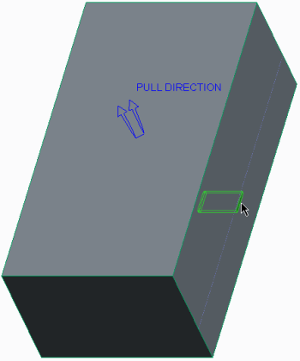

* Click **OK** from the Split dialog box.
* In the Properties dialog box, type **main_vol** as the Name of the first volume and press ENTER.
* In the Properties dialog box, type **slider_vol** as the Name of the second volume and press ENTER.
* Click **Volume Split** to split the main volume into core and cavity inserts.

##### Click Two Volumes > Mold Volume > Done .

* In the Search Tool dialog box, do the following:
* Select **Quilt: F11(MAIN_VOL)** from the list of items found.
* Click **Add Item** to add the selected quilt to the list of items selected.Add Item 
* Click **Close**.
* Select the parting surface (you may have to use query select) and click **OK** from the Select dialog box.

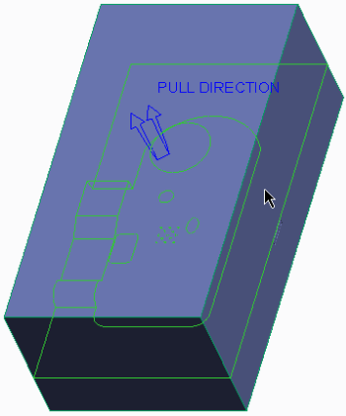

* Click **OK** from the Split dialog box.
* In the Properties dialog box, type **core** as the Name of the first volume (the lower half) and press ENTER.
* In the Properties dialog box, type **cavity** as the Name of the second volume (the upper half) and press ENTER.
* Select **Cavity insert Cavity insert ** from the Mold Component types drop-down menu in the Components group.
* In the Create Mold Component dialog box, press CTRL and select CAVITY, CORE, and SLIDER.
* Click **OK**.
* Notice that the mold components appear as individual solid parts in the model tree.

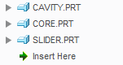

Figure 24

* 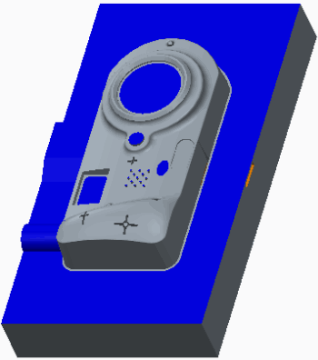In the model tree, right-click CORE.PRT and select **Open** .
* Close Click **Close** .
* In the ribbon, select the **View** tab.
* Click **Mold Display**  from the Visibility group.
* Select the **Mold** tab.
* In the Blank and Unblank dialog box, press CTRL and select CAMERA, CAMERA_MOLD_WRK, and CORE from the Visible Components list and click **Blank**.
* Click **Parting surface Parting surface ** as the Filter.
* Select PART_SURF_1 and click **Blank**.
* Click **Volume Volume ** as the Filter.
* Select SLIDER_VOL and click **Blank**.
* Click **OK**.
* In the model tree, right-click SILH_CURVE_1 and select **Hide Hide **.

#### 6. Step 6. Create a runner mold feature.

* Click **Runner** from the Production Features group.
* Click **Half Round** from the menu manager.
* Type **3** as the runner diameter and press ENTER.
* Query-select the bottom surface as the Sketching Plane and click **Okay > Default** from the menu manager.

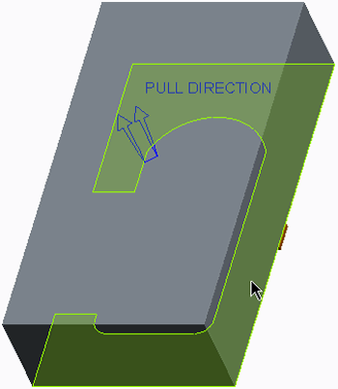

* Click **Sketch View Sketch View ** from the In Graphics toolbar.
* Select datum plane MOLD_RIGHT and the top and bottom edges as references, and click **Close** from the References dialog box.
* Click **Line Chain** and sketch two lines of equal length.
* Click **One-by-One**  and edit the length to **29**.

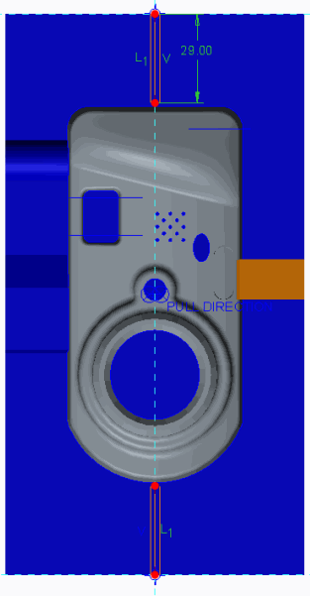

* Click **OK**
* Press CTRL+D and select CAVITY.PRT as the intersected component.
* Click **OK** from the Intersected Components dialog box.
* Click **OK** from the Runner dialog box.

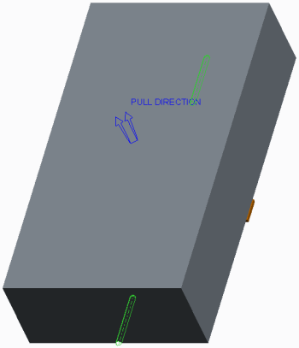

* In the model tree, right-click CORE.PRT and select **Unblank**.

#### 7. Step 7. Fill and open the mold.

* Click **Create Molding**  from the Components group to create the molding.
* Type **camera_molding** as the Part name and press ENTER.
* Press ENTER to accept the default Mold Part Common Name.

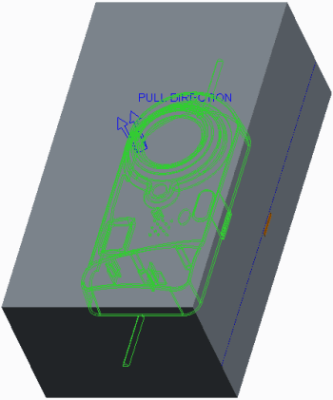

* Click **Mold Opening Mold Opening ** from the Analysis group to perform a mold-opening analysis.
* Click **Define Step > Define Move** from the menu manager.
* Select SLIDER.PRT.

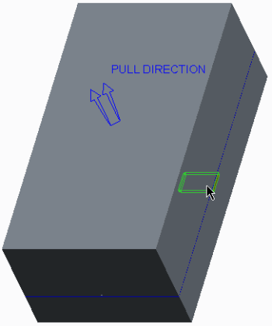

* Click **OK** in the Select dialog box.
* Select the edge to define the direction of the move.

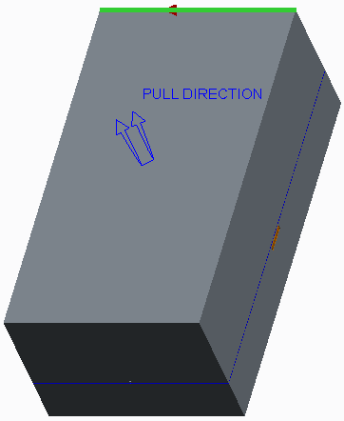

* Type **-100** as the translation value and press ENTER.
* Click **Done** from the menu manager.
* Click **Define Step > Define Move** from the menu manager.
* Select CAVITY.PRT.

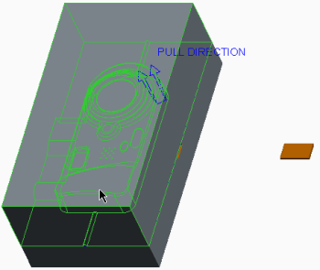

* Click **OK** in the Select dialog box.
* Select the edge to define the direction of the move.

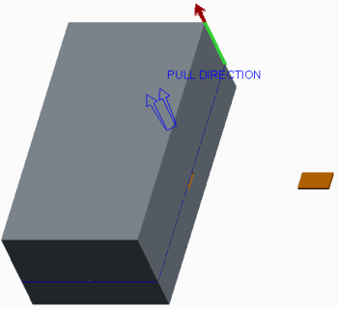

* Type **100** as the translation value and press ENTER.
* Click **Done** from the menu manager.
* Click **Define Step > Define Move** from the menu manager.
* Select CORE.PRT.

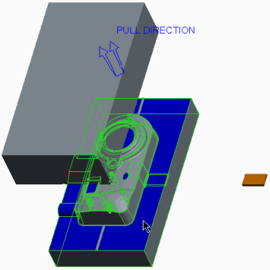

* Click **OK** in the Select dialog box.
* Select the edge to define the direction of the move.

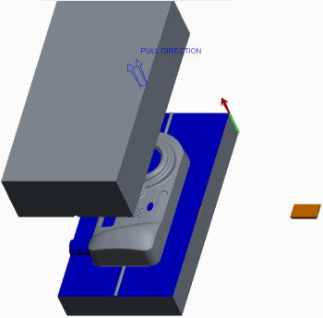

* Type **-100** as the translation value and press ENTER.
* Click **Done** from the menu manager.

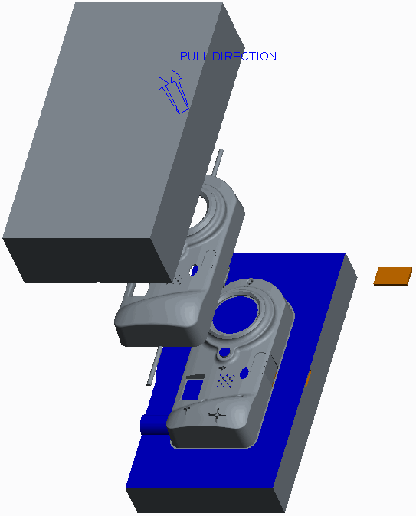

* Click **Done/Return** from the menu manager.
* Click in the background to de-select all items.
* Click **Regenerate Regenerate ** from the Quick Access toolbar.
* Click **Save Save ** from the Quick Access toolbar and click **OK** to save the model.
* Click **File > Manage Session > Erase Current**, then click **Select All Select All ** , and click **OK** to erase the model from memory.

# 2 DESIGN MODEL PREPARATION

#### Module Overview:

It is not uncommon for designers to hand off design models without drafts or ribs because they do not know enough about mold design in order to make decisions about parting surfaces and pull direction, and they may not be comfortable with specifying draft angles or creating ribs. The reference model geometry for a mold model is derived from the corresponding design model geometry. Consequently, the mold designer may have to prepare the design model so that a mold can be created from it. In this module, you learn the basics of mold design and how to prepare a design model for the mold process.

#### Objectives:

After completing this module, you will be able to:

* Define the main components of a mold.
* Specify the names of the various paths used to flow material into the mold.
* Recall the items typically required of a design model to create a robust mold and part.
* Create a robust mold model by creating profile rib features.
* Apply your knowledge of what makes a robust mold by defining draft and splitting it using various techniques.

1. **Understanding Mold Theory**

From a manufacturing point of view, in its simplest form, a mold consists of a *core* and *cavity* which are split at a *parting line*. The core is the convex feature side of the mold that enters an opposing cavity when the mold is closed. The cavity is the concave feature side of the mold into which an opposing core enters when the mold is closed. An example of a mold core and cavity

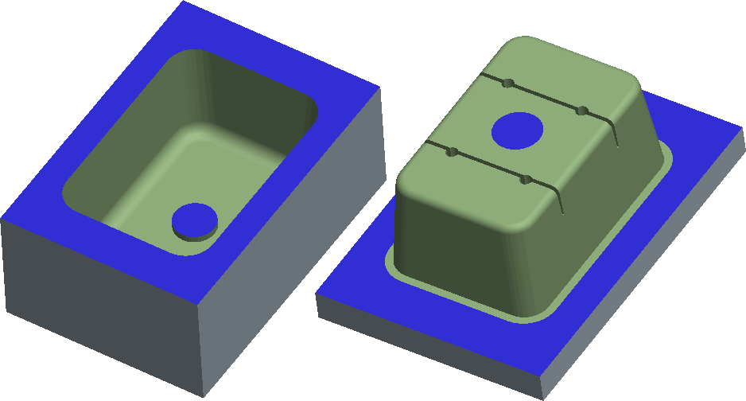

Figure 2 – Mold Core and Cavity

The void between the closed core and cavity is filled with a material such as plastic. This material-filled void becomes the resulting part when it solidifies. For the material to find its way into the void, there must be various chambers and paths created in the mold. These chambers are defined as follows:

* Sprues – The route the plastic material takes from the point where it enters the mold until it reaches the runners. When solidified, it remains attached to the part via one or more runners and is typically removed in finishing.
* Runners and gates – Channels machined into the mold that direct the plastic material from the sprue into the mold cavity.

In Figure 3, you can see the sprue, runners, and gates attached to the four molded pucks.

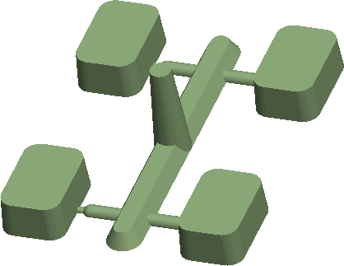

Figure 3 – Sprue and Runner Design

Once the material solidifies, the part can be removed from the mold. To aid in ejecting the part, mold components called *ejector pins* are often designed into the mold. The sizes and arrangement of the pins are selected to minimize the impact on the part design.

### **Understanding CAD Mold Theory**

From a CAD point of view, a designer typically hands off a completed or nearly completed Creo Parametric design model to a mold designer. The mold designer then takes the design model and uses it to create a *Reference model* within Creo Para metric’s Mold mode. The mold designer uses the Reference model to create the resulting mold core and cavity components which create the void of the Reference model. The mold core and cavity components split at a location called the *parting surface*, which the mold designer must determine. Once the mold designer creates the mold components in Creo Para metric’s Mold mode, he or she can use the Expert Mold Base Extension to create the entire mold base layout.

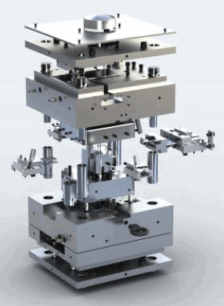

The Expert Mold base Extension, or EMX, uses a 2-D process-driven GUI to guide the mold designer toward the optimal design. It uses a catalog of standard components (DME, HASCO, FUTABA, PROGRESSIVE, STARK, and so on), or customized components. Figure 1 shows a completed mold base that was developed with the Expert Mold base Extension.Mold Design using Creo Parametric focuses only on the creation of the mold

## Preparing Design Models for the Mold Process

Even though the design model you receive may be a valid design model, you may not be able to use the model to create a robust mold. The following items are typically required of the design model to create a robust mold and part:

* Draft — Facilitates the removal of the part from the mold.
* Uniform thickness — Areas of a part that are thicker than others can result in sink zones or warping when cooling occurs.
* Ribs — Add strength and rigidity to the molded part.
* Ejector pin “pads” — Sufficient material is needed for the full diameter of an ejector pin at the location where it pushes against the resulting part to eject it from the mold.

These items may not be present in the design model when you receive it because the design engineer does not know where the parting surface or ejector pins will be located in the mold.

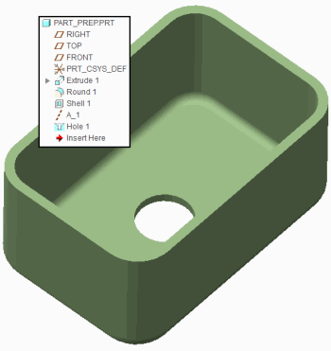

Figure 1 – Original Design Model

Therefore, you must prepare the design model for the mold process by adding the necessary features needed to make a mold from the model.

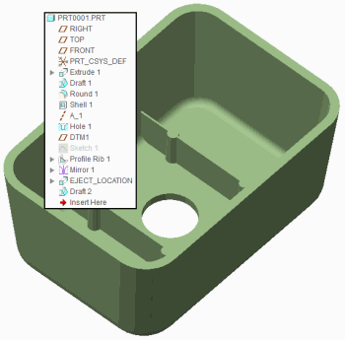

Figure 2 – Design Model Prepared for Molding

### **Guidelines for Proper Design Model Preparation**

The following guidelines indicate how to properly prepare a design model for molding.

* Try to create models that are of uniform thickness to prevent sink zones or warping in the resulting molded part.
* Create ribs that are approximately half the model's wall thickness to prevent sink. Apply draft to the rib walls if they are “vertical” faces. Vertical faces are those that are vertical with respect to how the mold opens. In Figure 2, two ribs have been created and draft has been applied.
* Be aware of the need to accommodate ejector pins in your design model for proper ejection from the mold. Create ejector pin “pads” at these locations in the model where the ejector pins push against the model to eject it. In Figure 2, four ejector pin pads have been created.
* Apply draft in the proper direction at least 0.5 degrees on all “vertical” faces. Draft has been applied to all faces that are vertical with respect to how the mold opens.
* When creating Draft features in Creo Parametric, either reorder them to be created before any related rounds or insert them before the rounds. This practice results in a more robust Creo Parametric model. In Figure 2, the draft has been inserted before the adjacent rounds. components and does not cover the Expert Moldbase Extension.

## Creating Profile Rib Features

Ribs are typically used to strengthen parts. A profile rib feature is similar to an extruded protrusion, except that it requires an open section sketch.

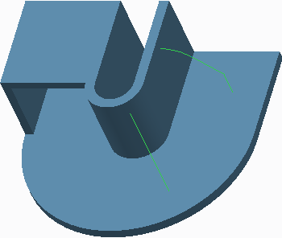

**Figure 1 – Viewing Open Sketches**

The rib also conforms to existing planar or cylindrical geometry when it is extruded. After you select an open section sketch and set a thickness, Creo Parametric automatically creates the profile rib feature by merging it with your model. The system can add material above or below the sketch, and the thickness can be applied on either side, or be symmetric about the sketch.

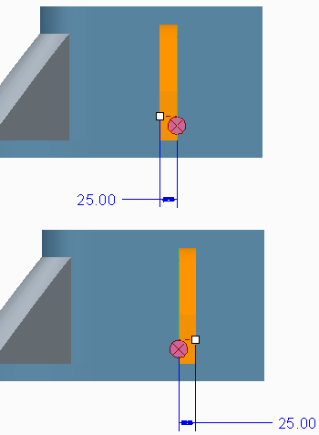

**Figure 2 – Editing the Side that Thickens**

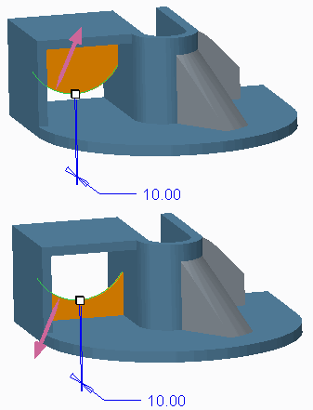

The **Profile Rib Profile Rib ** enables you to create rib features in less time than it would take for you to create and sketch a protrusion.

1. **Creating Drafts Split at Sketch**

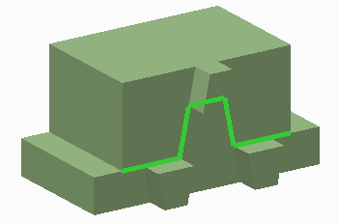

You can specify a sketch to be used as the split object. This enables you to create custom split lines. When you select an existing sketch as the split object, it becomes linked. However, you can unlink the sketch if desired. You can also define a new sketch. If the sketch does not lie on the draft surface, Creo Parametric projects it onto the draft surface in the direction normal to the sketching plane. The sketch in Figure 1 was used as the Split object for the draft in Figure 2.

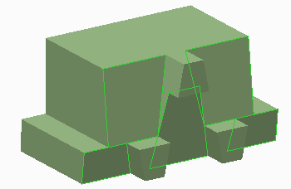

## PROCEDURE - Creating Drafts Split at Sketch

 Draft\Split-Sketch  DRAFT_SPLIT-SKETCH.PRT

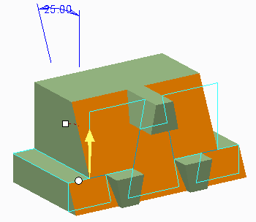**Task 1:** Create a draft split at a sketch.

|  |
| --- |
| 1. Disable all Datum display types. 2. Select **Draft**  from the Draft types drop-down menu.    * Select the large, front surface containing the sketch. 3. Right-click and select **Draft Hinges**.    * Select the top surface of the left rectangular “step.” 4. Drag the angle so the upper draft portion goes into the model. |
|  |
| 1. In the dashboard, select the **Split** tab.    * Select **Split by split object** as the Split option.    * Select sketch SPLIT_SKETCH.    * Select **Draft second side only** as the Side option. 2. Drag the angle so the draft goes into the model. 3. Click **Preview Feature**. |
| 1. Click **Resume Feature**  . 2. In the dashboard, select the **Split** tab.    * Select **Draft first side only** as the Side option. 3. Click **Preview Feature** . |
| 1. Click **Resume Feature**  .In the dashboard, select the **Split** tab. Select **Draft sides independently** as the Side option. Edit both draft angles to **7** so the draft goes into the model. 2. Click **Complete Feature** |

This completes the procedure.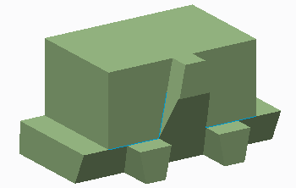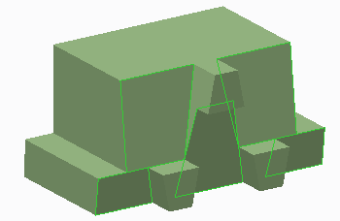

## Creating Drafts Split at Curve

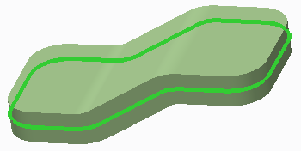

**Figure 1 – The Datum Curve**

You can create a draft that splits at a “waistline” curve. This causes the material at the curve to remain constant. The curve shown in Figure 1 was used as the draft hinge. The draft was then split at this draft hinge to create the resulting geometry in Figure 2.

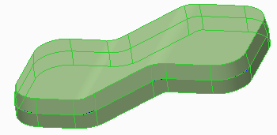

**Figure 2 – Draft Split at Datum Curve**

If you specify a curve as the draft hinge, you must also specify a separate pull direction reference.

1. **Creating Drafts Split at Surface**

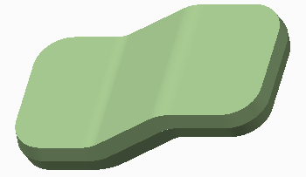

**Figure 1 – Draft Split at Surface**

You can create a draft that splits at a “waistline” surface, causing material at the surface to be added, as shown in Figure 1. This type of draft enables you to select additional draft hinges. To select a second hinge, you must first split the draft surfaces. The model remains the same size at both draft hinge locations. In Figure 2, the selected surface is used as the split object. Once this split object was defined, a second draft hinge was able to be added, as shown in Figure 3.

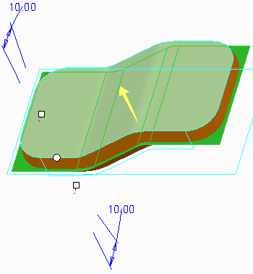

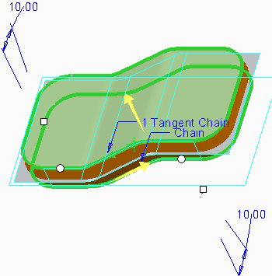

**Figure 3 – Selecting Multiple Draft Hinges**

**3.DESIGN MODEL ANALYSIS**

#### Module Overview:

Creo Parametric enables you to analyze the design model for key elements such as proper draft and thickness before creating the mold model. These tools help you ensure that the design model is acceptable to begin mold creation.

In this module, you perform draft and thickness checks on design models.

#### Objectives:

After completing this module, you will be able to:

* Understand the different types of analyses you can perform on a design model.
* Perform a draft check on a design model.
* Perform a section thickness check on a design model.
* Perform a thickness check on a design model.

# Analyzing Design Models Theory

You can perform analyses on design models before creating the mold model. Analysis tools enable you to ensure that the design model is acceptable for mold creation. You can perform the following types of analyses on design models:

* Draft check

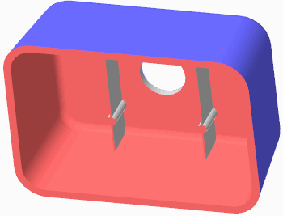

* Thickness check
* Section Thickness check

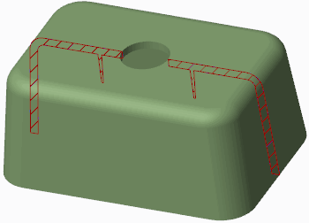

You usually use these analysis tools before the mold is created, but you can also use them at almost any point during the mold process, including:

* Parting line creation – If the parting line location is modified slightly you can perform a draft check to verify that the model is still properly drafted.
* Parting surface creation – Again, if the parting surface is modified you can perform a draft check to verify that the model is still properly drafted.
* Mold component creation – You can perform a thickness check on components other than the design model. You can perform a thickness check on the core or cavity component to verify that it has sufficient thickness to handle the stress during the molding part creation.

# Performing a Draft Check

You can use draft checking to determine whether the design model has the correct surfaces drafted and suitable draft angles to facilitate the mold-opening process as well as the removal of the molding component. To perform the draft check, click **Draft Draft ** from the Analysis group if in Mold mode, or click **Draft Draft ** from the Inspect Geometry group in the Analysis tab if in Part mode.

You must specify the following references to perform a draft check:

* Surface – Specifies the surfaces for which the draft analysis is to be run. You can select surfaces or quilts individually, or select the part node in the model tree to select all solid geometry.
* Direction – Specifies the direction to be used for the draft analysis. Usually, the pull direction is the direction in which the mold opens. If in a mold model, the system automatically uses the pull direction by default, but you can also specify your own direction reference.

You must also specify the following options:

* Draft angle – Enables you to specify the desired draft angle to check for.
* Sample – Enables you to specify how the plot resolution is calculated. Options include Quality, Number, and Step.
* Quality – Adjusts the quality of the plot.

When you perform a Draft analysis, the system produces a color plot of the draft angles. Based on the coloring, you can identify areas that do not have sufficient draft angles, or incorrect direction draft angles.

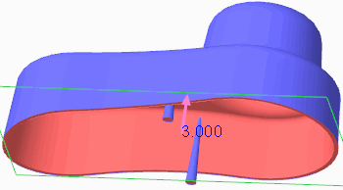

There are two different types of color plots you can display:

* **3-Color Plot 3-Color Plot ** – Displays a three color plot in the graphics window. Sufficient positive draft angles appear in blue, sufficient negative draft angles appear in red, and insufficient angles appear in white.

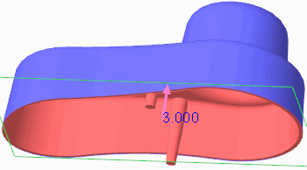

* **Rainbow Plot Rainbow Plot ** – Displays the color scale as a rainbow plot.

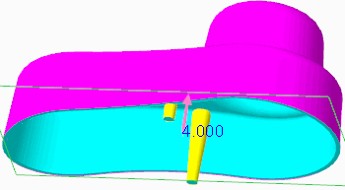

You can specify the number of colors to display, and whether the color scale is shown as continuous or non-continuous

# Performing a Section Thickness Check

### Performing a Section Thickness Check on a Model

You can perform a thickness check on a model by selecting the Analysis tab in the ribbon, and then clicking **Section Thickness Section Thickness ** from the Model Report group. You can measure thickness using either of the following methods:

* Select one or more planes through which the thickness is measured. You can press CTRL to select multiple planar references. 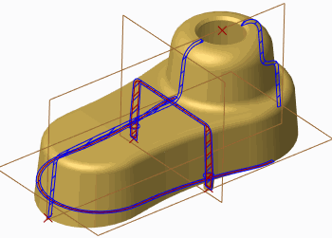

Figure 1 – Displaying Section Thickness Cross-Sections Through Selected Planes

* Select references to create incremental cross-section slices through which thickness is measured.

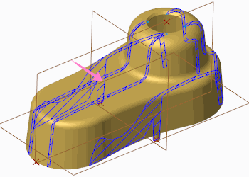

Figure 2 – Displaying Section Thickness Cross-Sections Through Slices

To create these incremental slices, you must specify the following references:

* From slices – This specifies the start point of slicing. You can select either vertices or datum points for this reference.
* To slices – This specifies the end point of slicing. Again, you can select either vertices or datum points for this reference.
* Direction – This specifies the direction of slicing. If necessary, you can click the direction arrow in the graphics window to flip the direction of slicing to point between the from Slices and To Slices references.
* Once you have specified the correct slicing references, you can specify the following options:
* Use number of slices – This specifies the number of slices to be created between the selected references.
* Offset – The incremental offset value that separates each cross-sectional slice.

You can configure the system to perform the following two thickness checks at each specified reference:

* Maximum – Checks for maximum thickness. The system performs a maximum thickness check based on the value you have specified.
* Minimum – Checks for minimum thickness. The system performs a minimum thickness check based on the value you have specified.

The Thickness dialog box displays the results for each thickness cross-section location. When you select a result in the dialog box, the thickness cross-section displays in the graphics window. The Thickness dialog box also indicates whether the thickness at each cross-section surpassed the minimum or maximum thicknesses specified.

### **Performing a Section Thickness Check in a Manufacturing Model**

You can also perform a section thickness check in the mold model by clicking **Section Thickness** from the Analysis group in the Mold tab. Because the section thickness check occurs within the context of an assembly, you must specify the part that the thickness check is to be performed on.Once the part is specified, the thickness check is similar to that of the model analysis thickness check, although the interface is slightly different. You can either select one or more planes through which to measure the thickness, or you can have the system create slices based on selected references. The system can check for both maximum and minimum thickness based on the specified thickness value you provide, and the results appear in the Model Analysis dialog box similar to those of the Thickness dialog box.

# Performing a Thickness Check

You can perform a 3-D thickness check on a part model to check for maximum or minimum thickness violations. The thickness check reduces the time to analyze wall thickness of complicated parts.

The **Thickness Thickness ** option is available in multiple places in the Creo Parametric user interface:

* In Part mode:
* In the Analysis tab, within the Model Report group.
* In Mold mode:
* In the Mold tab, within the Analysis group.
* In the Analysis tab, within the Model Report group.
* In the Analysis tab, within the Mold Analysis group.

In the Measure dialog box, you can measure thickness within all solid geometry or individually selected surfaces. You can specify the following:

* Minimum thickness value – Checks for minimum thickness. The system performs a minimum thickness check based on the value you have specified. Areas that violate the minimum thickness specified (areas where the thickness is less than the specified value) highlight in the model in purple.

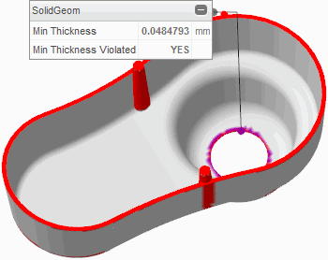

**Figure 1 – Viewing Min and Max Thickness Violations**

* Maximum thickness value – Checks for maximum thickness. The system performs a maximum thickness check based on the value you have specified. Areas that violate the maximum thickness specified (areas where the thickness is more than the specified value) highlight in the model in red.
* Minimum thickness color – Specify a different minimum thickness color than the default purple.
* Neutral color – Specify a different neutral color than the default gray.
* Maximum thickness color – Specify a different maximum thickness color than the default red.
* Tolerance – Specify the allowable error for the calculation.
* Use post-processing – Selecting this check box causes the system to post process the results to improve quality and accuracy.

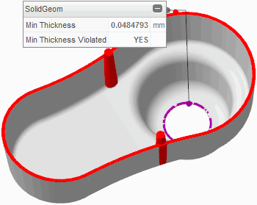

**Figure 2 – Viewing Post Processed Min and Max Thickness Violations**

Minimum thickness results display in the graphics window within an on-screen panel. You can drag this panel as well as collapse it. You can restore it by clicking its on-screen icon. You can also view minimum thickness results by expanding the Results area of the Measure dialog box. You can copy and paste the contents of this Results table to other programs such as spreadsheet applications. You can save the measurement by clicking **Save Analysis Save Analysis ** from the Measure dialog box. Save the measurement as either of the following types:

* Feature – Enables you to save the measurement as a feature in the model tree.
* Analysis – Enables you to save the measurement for future use. You can specify a unique name for the measurement analysis so you can easily identify it at a later time.

You can retrieve the saved analysis by clicking **Saved Analysis Saved Analysis ** from the Manage group in the Analysis tab.

### **Measurement Options**

Within the Measure dialog box, you can edit various options by clicking **Measure Options Measure Options **. The following options are available:

* Units by Model – Units are the same as those of the model.
* Length Units – Specify the desired length units from a drop-down list.
* Decimal Places – Specify the number of decimal places displayed for measurements.
* Show Feature Tab – Displays the Feature tab in the Measure dialog box, enabling you to specify regeneration order as well as create parameters for a given measurement.
* Use automatic compute – Automatically computes the new measurement if different references are selected for measuring.
* Panel display – You can toggle panels to either hide or display them in the graphics window. You can also toggle panels by collapsing them or expanding them.

# 4. MOLD MODELS

**Creating New Mold Models**

A mold model is the model you work on while in Mold Cavity Design mode, or Mold mode. The mold model, which has a file extension of .asm, contains the following:

* A reference model.
* One or more work-pieces that represent the overall size of cavity inserts.
* Several mold components that represent cavity inserts.
* One molding component that represents the product of the molding process.

You can create new mold models within Creo Parametric either by using File > New, or by clicking **New New ** . You can type the name of the mold and decide whether to use a default template or a template at all. Unless you select the Empty template, the new mold displays in the graphics window with some default datum features.

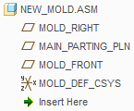

**Figure 1 – New Mold Model Tree**

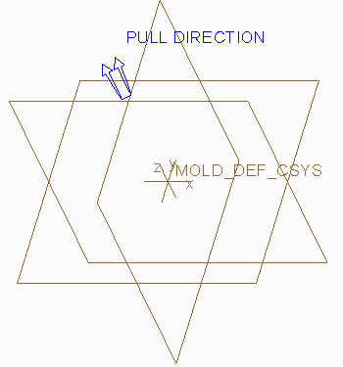

**Figure 2 – New Mold Model**

### **Using Templates**

You should create new mold models using a template. Mold templates are similar to part and assembly templates in that they enable you to create a new mold with predefined general information. Your company has probably created customized templates, as they contain your company's standards. Using a template to create a new mold is beneficial because it means that regardless of who created it, the mold contains the same consistent set of information, including:

* Datums – Most templates contain a set of default datum planes and a default coordinate system, all named appropriately.
* Default Pull Direction – The direction in which the mold opens.
* Layers – When every mold, part, and assembly contains the same layers, it is easier to manage both the layers and items on the layer.
* Units – Most companies have a company standard for units in their molds. Creating every mold with the same set of units ensures that mistakes are not made.
* Parameters – Every mold can have the same standard metadata information.
* View Orientations – Having every mold contain the same standard view orientations aids the molding process.

### **Modifying the Default Pull Direction**

The default pull direction is visible on the model as a double set of arrows, as shown in Figure 2. It is used as a default direction for all mold-specific features and analysis depending on the pull direction. You can toggle the pull direction display on and off by clicking **Pull Direction Display Pull Direction Display ** from the In Graphics toolbar. You can also change the direction of the default pull direction by clicking **Pull Direction Pull Direction ** from the Design Features group in the ribbon. The reference you select causes the pull direction to become perpendicular to that reference. Keep in mind that if you modify the default pull direction within a mold model created using a template, you should rename the datum planes appropriately.

**Analyzing Model Accuracy**

* One of the most important factors affecting the mold design process is model accuracy. Creo Parametric provides the following types of accuracy settings:
* Relative – This type of accuracy is specified as a fraction of the longest diagonal of the bounding box of a model. The default relative accuracy is 0.0012.
* Absolute – This type of accuracy improves the matching of models of different sizes or different accuracies (for example, imported models created on another system). To avoid potential problems when adding new features to a model, it is recommended that you set the reference model to absolute accuracy before adding additional parts to the model. Absolute accuracy is useful when you are doing the following:
* Copying geometry from one mold to another during core operations.
* Designing models for manufacturing and mold design.
* Matching accuracy of imported geometry to its destination model.

You can match the accuracies of a set of models in one of the two following ways:

* Give them all the same absolute accuracies.
* Designate the smallest model as the base model, and assign its accuracy to the other models.

### **Automatically Controlling Accuracy**

You can perform the following steps to automatically set the correct accuracy when creating mold models:

* Set the configuration file option enable absolute_accuracy to yes.
* Create a new mold model. It receives a default (absolute) accuracy value.
* Add the first reference model. If a discrepancy exists between the assembly model accuracy and reference model accuracy, the system issues a warning and prompts you to confirm changing the assembly model accuracy, as shown in Figure 1.

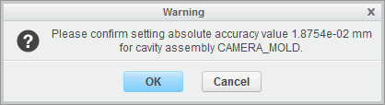

**Figure 1 – Confirmation for Automatically Changing Accuracy**

If you accept, then Creo Parametric switches the assembly model accuracy from relative to absolute, and sets it to the value corresponding to the accuracy of the reference model. If you do not accept, the system warns you that there is an accuracy conflict, and generates a text file with a *.acc file extension in the working directory.

* Create the mold work piece using the automatic work piece creation functionality. The accuracy of the work piece is automatically set to be the same as the accuracy of the assembly model.

### **Implications and Guidelines of Changing Accuracy**

When you change the accuracy of a model you are changing the computational accuracy of geometry calculations. The accuracy of a mold model is relative to the size of the resultant molding component. The valid range for accuracy is 0.01 to 0.0001, and the default value is 0.0012. However, the configuration file option, accuracy_lower_bound, can override the lower boundary of this range. The specified values for the lower boundary must be between 0.000001 and 0.0001. If you increase the accuracy, the regeneration time also increases. Use the default accuracy unless you need to increase it. In general, you should set the accuracy to a value less than half the ratio of the length of the smallest edge on the model to the length of the largest diagonal of a box that would contain the model. Use the default accuracy until you have a reason not to do so.

### **Situations for Changing Accuracy**

The following are situations that may cause you to have to change accuracy:

* Placing a small feature on a model.
* Intersecting two models of very different size. For the two models to be compatible, they must have the same absolute accuracy. To achieve this, estimate each model size, and multiply each by its respective current accuracy. If the results differ, enter a value for the accuracy of the models that yields the same results for each. You might need to increase the mold accuracy of the larger model by entering a smaller decimal number. For example, if the size of the smaller model is 100 and the accuracy is .01, the product of these numbers is 1. If the size of the larger model is 1000 and the accuracy is .01, the product of these numbers is 10. Change the accuracy of the larger model to .001 to yield the same product.

When an accuracy conflict exists, the system warns you in the Message Log and generate a *.acc file that is saved in the working directory. You can view this text file to determine where the conflict exists and modify the accuracies accordingly. The contents of an accuracy file are shown in Figure 2.

Enlarge Image

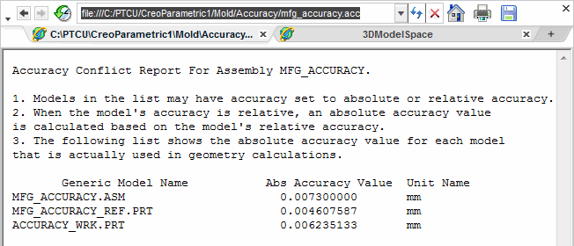

**Figure 2 – Viewing an Accuracy Conflict**

* **Locating the Reference Model**

The first component you typically assemble in the mold model is the reference model. The reference model usually represents the part that is to be molded.

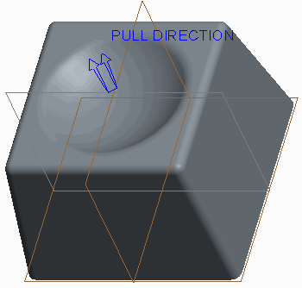

**Figure 1 – Reference Model Located into Mold Model**

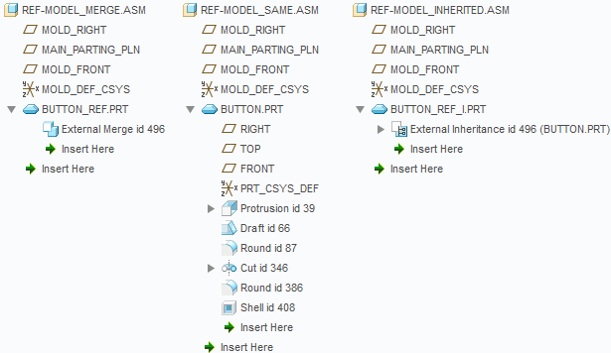

The reference model is needed to imprint corresponding geometry on mold components. The geometry imprinted into the mold components becomes the *mold cavity*. The reference model geometry for a mold model is derived from the corresponding design model geometry. The design model may not always contain all necessary design elements such as drafts, fillets, and shrinkage that are required for the mold design process. Sometimes the design model contains design elements that require post- molding machining. These elements should be changed on the reference model to suit the mold design process.

### **Locating the Reference Model**

Locating the reference model is one of three methods available for inserting the reference model into the mold model, and is the most versatile of the three. The reference model icon that displays in the model tree is different than that of a conventional part model, regardless of the method used to insert it.

You can use **Locate Reference Model Locate Reference Model ** to assemble a pre-existing model as the reference model into the mold model. This option enables you to further select a pre- defined Layout and Orientation for the reference model.

When locating the reference model, you can specify the Reference model type:

* Merge by reference – Creo Parametric copies design model geometry into the reference model using an External Merge feature. Only the geometry, datum planes, and layers are copied from the design model. If a layer with one or more datum planes associated with it exists in a design model, the layer, its name, display status, and the datum planes are copied from the design model to the reference model. Any changes made to the reference model do NOT affect the original design model. The default name for the new reference model created with this method is <MOLD_MODEL_NAME>_REF.PRT. For example, if the mold model is CAMERA_MOLD.PRT, the new reference model is CAMERA_MOLD_REF.PRT. Any changes made to the original design model automatically propagate to the reference model.
* Same model – Creo Parametric uses the design model as the reference model. The reference model is the design model. Therefore, any changes made to this reference model do affect the design model, as you are actually modifying the original design model. As a result, you cannot rename this reference model when it is the same model as the original design model.
* Inherited – The reference model inherits all geometry and feature information from the design model using an External Inheritance feature. You can specify the geometry and the feature data that you want to modify on the inherited reference model without changing the original design model. Inheritance provides greater freedom to modify the reference model without changing the design model. Any changes made to the reference model do not affect the design model. Similar to the Merge by Reference method, the default name for the new reference model created with this method is <MOLD_MODEL_NAME>_REF.PRT. Again, any changes made to the original design model automatically propagate to the reference model.If you have absolute accuracy enabled, the system prompts you to confirm the accuracy change that needs to occur to properly match the mold model accuracy to the reference model accuracy When the reference model is located into the mold model, the resulting geometry in the graphics window looks the same, regardless of the method used to create the reference model. You must expand the model tree to determine the method used.

**iv. Assembling the Reference Model**

### **Reference Model Background**

The first component you typically assemble in the mold model is the reference model.

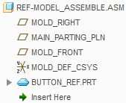

Figure 1 – Viewing the Reference Model in the Model Tree

The reference model usually represents the part that is to be molded. The reference model is needed to imprint corresponding geometry on mold components. The geometry imprinted into the mold components becomes the *mold cavity*.The reference model geometry for a mold model is derived from the corresponding design model geometry. The design model may not always contain all necessary design elements such as drafts, fillets, and shrinkage that are required for the mold design process. Sometimes the design model contains design elements that require post- molding machining. These elements should be changed on the reference model to suit the mold design process.

### **Assembling the Reference Model**

Assembling the reference model is one of three methods available for inserting the reference model into the mold model. The reference model icon that displays in the model tree is different than that of a conventional part model, regardless of the method used to insert it.You can use **Assemble Reference Model Assemble Reference Model ** to assemble a pre-existing model as the reference model into the mold model. This option enables you to use conventional Assembly mode placement constraints to assemble the reference model.

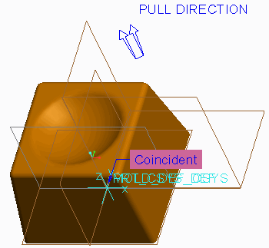

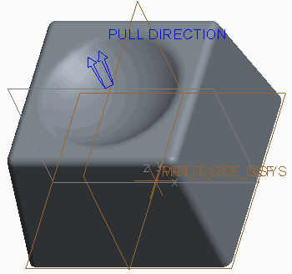

**Figure 3 – Viewing the Assembled Reference Model**

Unlike the Locate Reference Model option, you cannot further specify a Layout and Orientation.

Similar to the Locate Reference Model option, you can specify the Reference model type:

* Merge by reference – Creo Parametric copies design model geometry into the reference model using an External Merge feature. Only the geometry, datum planes, and layers are copied from the design model. If a layer with one or more datum planes associated with it exists in a design model, the layer, its name, display status, and the datum planes are copied from the design model to the reference model. Any changes made to the reference model do NOT affect the original design model. The default name for the new reference model created with this method is <MOLD_MODEL_NAME>_REF.PRT. For example, if the mold model is CAMERA_MOLD.PRT, the new reference model is CAMERA_MOLD_REF.PRT. Any changes made to the original design model automatically propagate to the reference model.
* Same model – Creo Parametric uses the design model as the reference model. The reference model is the design model. Therefore, any changes made to this reference model do affect the design model, as you are actually modifying the original design model. As a result, you cannot rename this reference model when it is the same model as the original design model.
* Inherited – The reference model inherits all geometry and feature information from the design model using an External Inheritance feature. You can specify the geometry and the feature data that you want to modify on the inherited reference model without changing the original design model. Inheritance provides greater freedom to modify the reference model without changing the design model. Any changes made to the reference model do not affect the design model. Similar to the Merge by Reference method, the default name for the new reference model created with this method is<MOLD_MODEL_NAME>_REF.PRT. Again, any changes made to the original design model automatically propagate to the reference model.

If you have absolute accuracy enabled, the system prompts you to confirm the accuracy change that needs to occur to properly match the mold model accuracy to the reference model accuracy.

When the reference model is assembled into the mold model, the resulting geometry in the graphics window looks the same, regardless of the method used to create the reference model. You must expand the model tree to determine the method used.

**V. Creating the Reference Model**

### Reference Model Background

The first component you typically assemble in the mold model is the reference model.

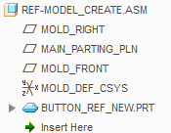

**Figure 1 – Viewing the Reference Model in the Model Tree**

The reference model usually represents the part that is to be molded. The reference model is needed to imprint corresponding geometry on mold components. The geometry imprinted into the mold components becomes the *mold cavity*.The reference model geometry for a mold model is derived from the corresponding design model geometry. The design model may not always contain all necessary design elements such as drafts, fillets, and shrinkage that are required for the mold design process. Sometimes the design model contains design elements that require post- molding machining. These elements should be changed on the reference model to suit the mold design process.

### **Creating the Reference Model**

Creating the reference model is one of three methods available for inserting the reference model into the mold model and offers the least flexibility. The reference model icon that displays in the model tree is different than that of a conventional part model, regardless of the method used to insert it.

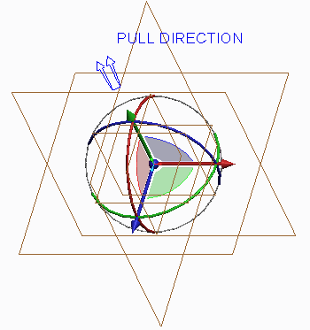You can use **Create Reference Model** to create a new model on-the-fly and assemble it as the reference model into the mold model using conventional Assembly mode placement constrain

This option is similar to creating a new component in Assembly mode. In fact, the same creation options are available:

* Copy from existing – Creates a copy of an existing model. This could be an existing design model or an empty template of your company standards.

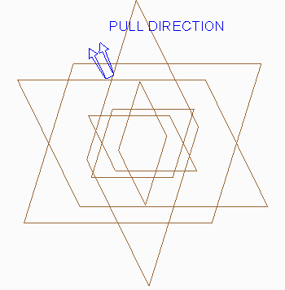

* Locate default datum’s – Creates the model and enables you to locate the default datum’s in the assembly.
* Empty – Creates the model without geometry or datum features.
* Create features – Creates the model using existing assembly references.

With this method you cannot specify the Reference model type. There are also no pre- defined options available for Layout or Orientation, and there are no further locating options or accuracy matching.

**Vi. Redefining the Reference Model**

You can redefine the reference model by selecting **Locate Reference Model Locate Reference Model ** from the Reference Model types drop-down menu in the Reference Model & Work piece group and then clicking Redefine from the menu manager. You can redefine the following items related to the reference model:

* Reference model orientation – You can adjust the reference model origin and orientation within the mold model. You can do this by either adjusting the reference model coordinate system or the mold model's coordinate system.
* Mold cavity layout – You can adjust the quantity and layout of the mold cavities created within the mold model.
* Mold cavity layout orientation – You can adjust the orientation of the mold cavities created within the mold model.

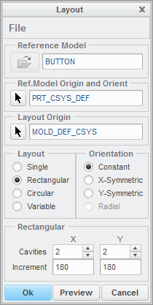

**Figure 1 – Layout Dialog Box when Redefining Reference Model**

### **Switching Reference Model Methods**

If you have located or assembled the reference model using the Same Model method, you cannot redefine the method to switch it to Merge by reference or Inherited. Conversely, if you located or assembled the reference model using either Merge by reference or Inherited, you cannot redefine the method to Same Model. In either of these cases you must delete the reference model from the mold model and recreate it.

You can switch the reference model creation method back and forth between Merge by reference and Inheritance, however. You can do this by editing the definition of the External Merge or External Inheritance feature within the reference model, depending on the type of creation method used. You can then toggle the inheritance on or off in the dashboard. Keep in mind that in switching back and forth you will lose any geometry that was varied in the inheritance feature, and the resulting geometry may change, potentially causing other geometry to fail.

## Vii. Analyzing Reference Model Orientation

You can modify the orientation of the reference model in the mold model. When you select the reference model to be added to the mold model, the system selects a coordinate system from the reference model and assembles it to a coordinate system from the mold model.

### Modifying the Reference Model Orientation

You can modify the reference model orientation within the mold model either by specifying a different mold layout coordinate system or by specifying a different reference model coordinate system.

There are two different methods that you can use to specify a different coordinate system in the reference model:

* Standard – Enables you to select a different, existing, coordinate system in the reference model. A separate window opens that contains the reference model, enabling you to select the coordinate system, as shown in Figure 1.

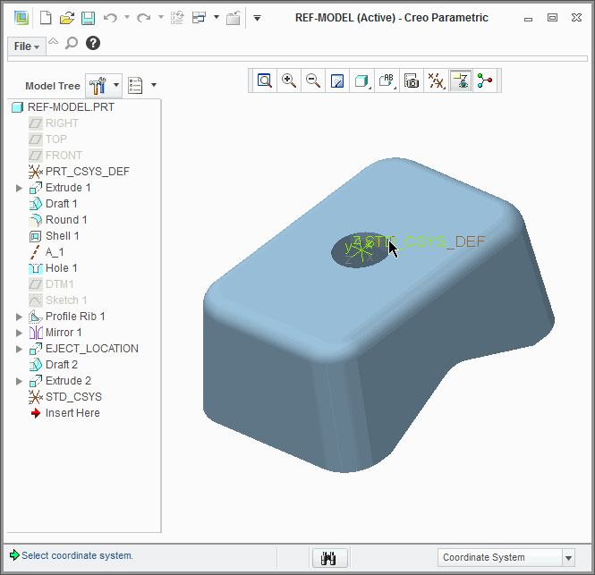

**Figure 1 – Using Standard Orientation**

* Dynamic – A separate window opens that contains the reference model. However, a new coordinate system called REF_ORIGIN is created in the reference model, and you can dynamically reorient this coordinate system so that it will line up properly with the mold layout coordinate system. In the separate window that contains the reference model, the X, Y, and Z-directions of the REF_ORIGIN coordinate system are displayed, and the positive Z-direction is the same as the PULL DIRECTION in the mold model. Also, the Parting Plane displays to show you a surface perpendicular to the pull direction. Figure 2 shows the REF_ORIGIN coordinate system orientation and Parting Plane and the resulting orientation in the mold model.

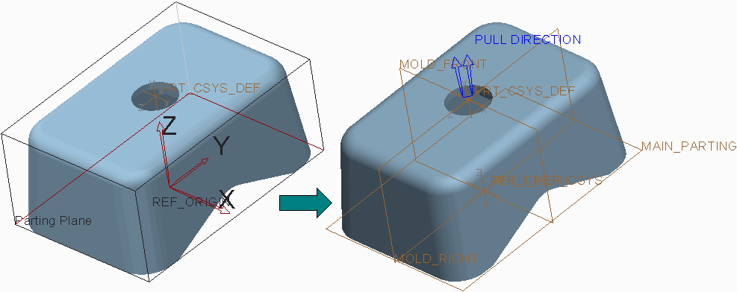

**Figure 2 – Using Dynamic Orientation**

You can dynamically adjust the coordinate system orientation in the reference model window, and the parting plane also adjusts dynamically. The following options are available for adjusting the REF_ORIGIN coordinate system orientation:

* Rotate – Enables you to rotate the REF_ORIGIN coordinate system about the X, Y, and Z axes, either by typing a value or by dragging a slider.
* Translate – Enables you to translate the REF_ORIGIN coordinate system in the X, Y, and Z directions, either by typing a value or by dragging a slider. You can also click Midpoint to automatically translate the parting plane to a midpoint of the model in that direction.

Move to a point – Enables you to move the REF_ORIGIN coordinate system origin to a specified point in the reference model. There are two options available:

* Selection – Enables you to select a vertex, datum point, or other coordinate system as the new coordinate system origin.
* Model center – Moves the coordinate system origin to the model center.

Align an axis – Enables you to align the X, Y, or Z Axis of the REF_ORIGIN coordinate system to a specified datum plane, curve, edge, axis, or other coordinate system.

### Reference Model Dynamic Orientation Options

When you are dynamically reorienting the REF_ORIGIN coordinate system, the following additional options are available within the Reference Model Orientation dialog box:

* Projected area – Determines the area projected onto the Parting Plane as defined by the current orientation of the reference model in the mold model. The Projected Area is calculated based on the current orientation after Update is clicked.
* Undo/Redo – Enables you to undo or redo the last action performed.
* Draft check – Enables a draft angle to be specified and performs a draft check on the reference model's current orientation by clicking Shade. This shades the model like a conventional draft check with the three colors blue, magenta, and yellow.



**Figure 3 – Draft Check**

* Bounding box information – Provides positive and negative distances from the model origin to the edges of the bounding box. This information updates as the part is moved and cannot be edited.

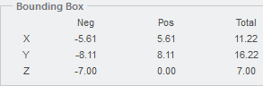

**Figure 4 – Bounding Box Information**

**Viii. Analyzing Mold Cavity Layout**

You can create a mold model that contains multiple cavities. When you create a multiple- cavity layout in the mold model, the system creates a pattern of the reference model to create the multiple cavities.

The following layout options are available:

* Single – Places a single cavity, or single instance, of the reference model in the mold model. A Single cavity layout is shown in Figure 1.

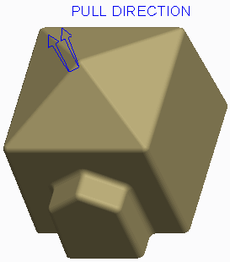

* Rectangular – Places the reference model in a rectangular layout in the mold model. A Rectangular cavity layout is shown in Figure 2.

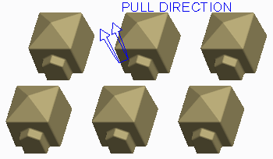

**Figure 2 – Rectangular Cavity Mold Model Layout**

The following options are available for the Rectangular layout:

* Cavities – Specifies the number of cavities, or number of pattern instances of the reference model, in the X and Y directions. You can either edit the number or use the up and down arrows to increase or decrease the number of cavities in each direction.
* Increment – Specifies the distance between origins of reference models in the X and Y directions.

The X and Y directions are determined by the mold model coordinate system's X and Y axes.

* Circular – Places the reference model in a circular layout in the mold model. A Circular cavity layout is shown in Figure 3.

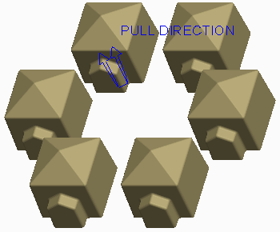

**Figure 3 – Circular Cavity Mold Model Layout**

The following options are available for the Circular layout:

* Cavities – Specifies the number of cavities, or number of pattern instances of the reference model, in the mold model.
* Radius – Specifies the radius value around which the cavities are placed.
* Start Angle – Specifies the angular distance in degrees about the mold model's Z-axis that the first reference model's origin is placed. You can specify a negative value.
* Increment – Specifies the angular distance between cavities in degrees.
* Variable – Enables you to place the reference model according to a user-defined pattern table.

**iX. Analyzing Variable Mold Cavity Layout**

You can create unique cavity layouts using the Variable layout option. When you select the Variable option, the existing cavity layout is converted to the Variable format, and the Variable table appears in the Layout dialog box. Each pattern instance (reference model) displays in the left-most column, and the variables that vary orientation are displayed in the right columns, as shown in the figures. At this point, you can adjust the orientation for each pattern member independently of the others.

The following orientation options are available for each pattern instance in the Variable table:

* **Reference Rotation Reference Rotation ** — Rotates the reference model (pattern instance) about its origin.
* **X-Translation X-Translation ** — Translates the reference model along its positive or negative X- axis.
* **Y-Translation Y-Translation ** — Translates the reference model along its positive or negative Y- axis.
* **Layout Rotation Layout Rotation ** — Rotates reference model about mold layout origin.

Of these four options, the Y-Translation and Layout Rotation options are not always available, depending upon which layout was converted to Variable. The Layout Rotation option is only available for a layout converted from Circular, as shown in Figure 1. The Y-Translation option is only available for a layout converted from Single or Rectangular, as shown in Figure 2.

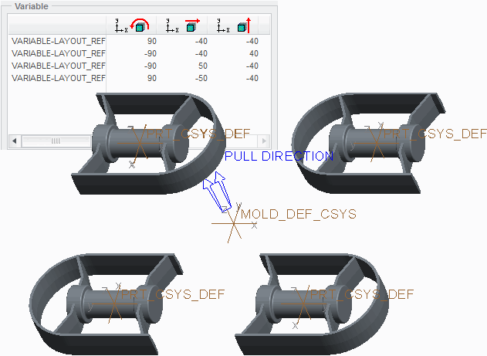

**Figure 2 – Variable Cavity Converted from Single Layout**

Additional Variable cavity layout options include the following:

* Highlight — When this check box is selected, any pattern instance selected in the Variable table highlights in the graphics window.
* Add — Enables you to add a new pattern instance to the layout. The new pattern instance member is inserted immediately following the pattern instance that is selected when the Add button is clicked.
* Remove — Enables you to remove an existing pattern instance from the layout. To remove a pattern instance, select it in the Variable table and click Remove.

**X. Analyzing Mold Cavity Layout Orientation**

You can adjust the orientation of the cavities in a multi-cavity layout. Examples of reasons why cavity adjustment may be necessary include the following:

* More optimum layout for sprue and runner placement is required.
* More uniform cooling of parts is needed.
* Manufacturing feasibility of the mold design layout.

Consider each of the mold cavity layouts and their respective options for orientation.

### **Modifying Layout Orientation in a Single Cavity**

Because there is only a single cavity, no further orientation adjustments are available. The Orientation options become grayed out in the Layout dialog box. Rather, you can adjust the cavity orientation in the layout by switching coordinate systems or dynamically adjusting the REF_ORIGIN coordinate system.

### **Modifying Layout Orientation in a Rectangular Cavity**

The following Orientation options are available for the Rectangular cavity layout:

* Constant – Cavities are arranged to all point in the same direction.
* X-Symmetric – Cavities are mirrored about the mold model's X-axis. That is, the cavities are arranged so that they appear in the same orientation when looking out from a plane that runs along the mold model's X-axis. X-Symmetric orientation is shown in the left image of Figure 1.

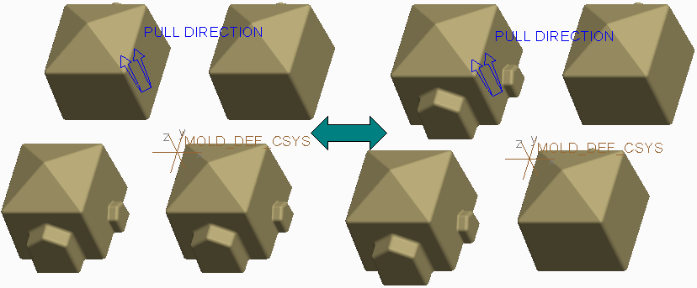

**Figure 1 – Rectangular Layout, X-Symmetric versus Y-Symmetric Orientation**

* Y-Symmetric – Cavities are mirrored about the mold model's Y-axis. That is, the cavities are arranged so that they appear in the same orientation when looking out from a plane that runs along the mold model's Y-axis. Y-Symmetric orientation is shown in the right image of Figure 1.

### **Modifying Layout Orientation in a Circular Cavity**

The following Orientation options are available for the Circular cavity layout:Constant – Cavities are arranged to all point in the same direction, as shown in the left image of

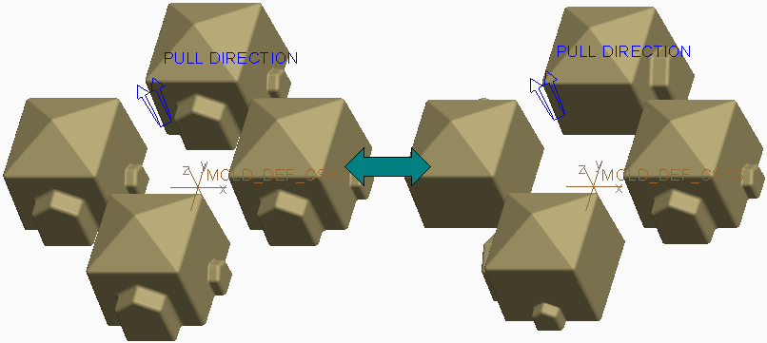

**Figure 2 – Circular Layout, Constant versus Radial Orientation**

* Radial – Cavities are fanned about the mold model's origin. That is, the cavities are arranged so that they appear in the same orientation when looking out radially from the mold model origin. Radial orientation is shown in the right image of Figure 2.

**Xi. Calculating Projected Area**

You can calculate the projected area of the reference model to help calculate the clamping force needed to keep a mold set closed during operation. To calculate the projected area, you can click **Projected Area Projected Area ** from the Analysis group. This opens the Measure dialog box. In the Measure dialog box, you must specify the following items:

* Entity – Specifies the entity that is to be projected. You can select the following entity types:
* All Ref Parts – This is the default Entity selection.
* Surface
* Quilt
* Facets
* Projection Direction – Specifies the direction that the Entity is projected. You can specify any of the following projection direction references:
* Default Pull Direction – This is the default Projection Direction.
* None
* Plane – Enables you to select a plane that the direction is perpendicular to.
* Line/Axis – Enables you to select a line or axis as the direction.
* Coordinate System – Enables you to select a coordinate system. Once you select the coordinate system, you must specify which coordinate axis defines the direction.
* View Plane – Uses the current viewing plane as the projection reference.

Once you have defined the entity and projection direction, you can click Compute to calculate the projected area of the entity.

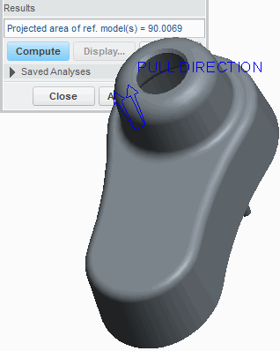

**Figure 1 – Calculating Projected Area**

The selected entity is projected onto an imaginary plane that is perpendicular to the projection reference, as shown in Figure 2.

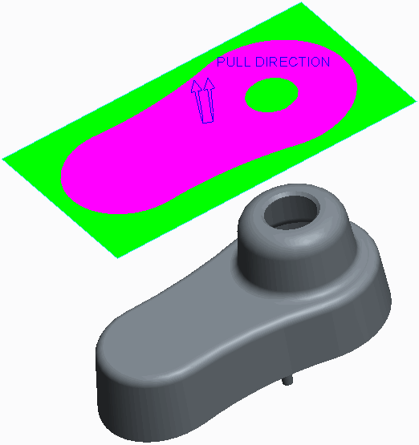

**Figure 2 – Illustration of Projected Area The area of this projection is** **calculated.**

# exercise: Creating the Shower Head Mold Model

**Before you begin**

To avoid naming conflicts, it is recommended you save your work, click **File** > **Close** until no models display, then click **File** > **Manage Session** > **Erase Not Displayed**.

Click **File** > **Manage Session** > **Set Working Directory** and navigate to the **PTCU\CreoParametric3\Mold\Shower-Head_Create** folder and click **OK**

Click **File** > **Open** and double-click **SHOWER_HEAD.PRT**.

#### Objectives

* Create a new mold model.
* Assemble the reference model.
* Modify the mold cavity layout.

#### Scenario

In this exercise, you create a new shower head mold model by assembling a multi-cavity reference model. You have already analyzed the design model and verified that the model is sufficient for molding.

#### 1. Task 1. Inspect the shower head model that is to be molded.

* Enable only the following Datum Display types: 
* Spin the design model and inspect it.

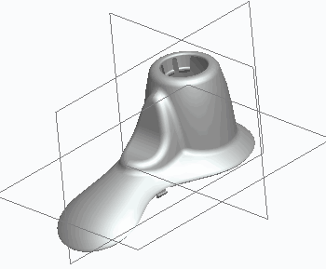

* Close Click **Close** from the Quick Access toolbar.

#### 2. Task 2. Create a new shower head mold model.

1. Click **New New ** from the Quick Access toolbar.

* Select **Manufacturing** as the Type.
* Select **Mold cavity** as the Sub-type.
* Type **shower_head_mold** as the Name.
* Clear the **Use default template** check box and click **OK**.

1. In the New File Options dialog box, select **mmns_mfg_mold** as the Template.

* Click **OK**.

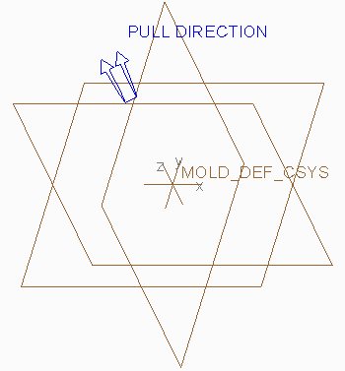

#### Task 3. Create and assemble the reference model.

1. Click **File > Options** and select the **Configuration Editor** category.

* Click **Add**.
* Type **enable_absolute_accuracy** in the Option name field.
* Select **yes** as the Option value and click **OK > OK**.

1. Select **Locate Reference Model Locate Reference Model ** from the Reference Model types drop-down menu in the Reference Model & Work-piece group to assemble the reference model.
2. In the Open dialog box, double-click SHOWER_HEAD.PRT to open it.
3. In the Create Reference Model dialog box, select **Inherited** as the Reference model type and click **OK**.
4. In the Layout dialog box, click **Reference Model Origin Reference Model Origin ** and click **Dynamic** from the menu manager.
5. In the Reference Model Orientation dialog box, select **Rotate** as the Coordinate System Move option, and select **Y** as the Axis.

* Type **-180** as the Value and click **OK**.

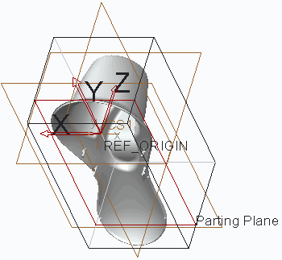

1. In the Layout dialog box, select **Rectangular** as the Layout.

* Edit the Number of Cavities in the X and Y directions to **2**, if necessary.
* Edit the X Increment to **120**.
* Edit the Y Increment to **250**.
* Click **Preview**.

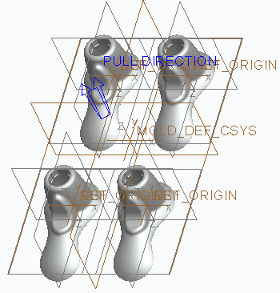

In the Layout dialog box, edit the Orientation to **X-Symmetric**.

* Edit the Y Increment to **150**.
* Click **OK**.

1. Click **OK** from the Warning dialog box to accept the accuracy change.
2. Click **Done/Return** from the menu manager.
3. Disable **Plane Display Plane Display  **.

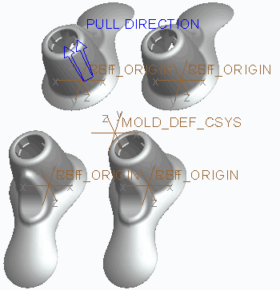

1. Click **Save Save ** from the Quick Access toolbar and click **OK** to save the model.
2. Click **File > Manage Session > Erase Current**, then click **Select All** and **OK** to erase the model from memory.

# 5. WORK PIECES

#### Module Overview:

Once you have created the mold model, you can create and assemble the work-piece. The work-piece represents the full volume of all the mold components that are needed to create the completed mold model. You can also apply style states to the work piece to make them transparent within the mold model.In this module, you learn how to create and assemble work-pieces in a mold model.

#### Objectives:

After completing this module, you will be able to:

* Explain the different display styles you can apply to components when creating style states.
* Create a work piece automatically.
* Create a custom automatic work-piece.
* Create and assemble a work-piece manually.
* Reclassify mold model components.

1. **Creating Display Styles**

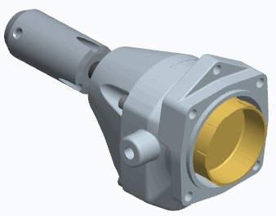

**Figure 1 – Original Model**

The display of models in a Creo Parametric session are controlled by the four following display options: Wire frame, Hidden Line, No Hidden, and Shaded. You can also assign display styles to individual components in an assembly that can be used regardless of those overall session settings. Use the Style tab in the view manager to create display styles for your assembly. You can assign one of the following display styles to components in an assembly:

* Wire frame – Shows front and back lines equally.
* Hidden Line – Shows hidden lines in ghost tones.
* No Hidden – Does not show lines behind forward surfaces.
* Shaded – Shows the model as a shaded solid.
* Transparent – Shows the model as a transparent solid.
* Blank – Does not show the model.

You can apply existing display styles to sub-assemblies using the By Display tab. When you select a sub-assembly from the model tree, the available display styles for that sub- assembly display in the By Display tab, enabling you to specify the desired one. You can also modify component display styles without using the view manager. You can select desired models in the graphics window, model tree, or search tool and click the Model Display group drop-down menu and select Component Display Style to assign a display style to the selected models. You can store these temporary edits with a new display style or update them to an existing one. After you define the default style, it appears each time the model is opened.

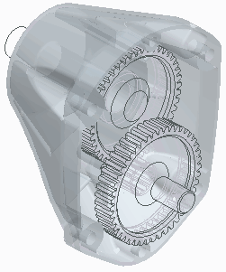

**Figure 2 – Viewing a Display Style**

### **Uses of Display Styles**

You use display styles to do the following:

* Increase system performance by either blanking components from display or limiting the number of components being calculated for hidden line display.
* Create and save display settings used in presentations or other common situations where it is helpful to change the display of components within an assembly.

**Creating a Work piece Automatically**

Once you assemble the reference model into the mold model, you typically create and assemble the work piece next. The work piece is a model that represents the full volume of all the mold components (cavity, core, and inserts) that are needed to create the final mold model. The work piece icon that displays in the model tree is different than that of a conventional part model and the reference model, which is shown in Figure 1.

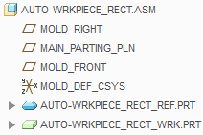

The work piece displays transparent green in the graphics window.

To automatically create a work piece, select **Automatic Work piece Automatic Workpiece ** from the Work piece types drop-down menu. The work piece is automatically assembled to the specified Origin coordinate system using the **Coincident** assembly constraint, and the accuracy is automatically set to match that of the reference model.

To create an automatic work piece, you must specify the following items:

* Mold Origin – The Mold Origin is a mold model coordinate system from which directions are determined for work piece creation.
* Shape – The shape determines the shape of the work piece. The system creates a work piece with the minimum dimensions that the reference model fits in, within the specified shape. The following options are available:

1.Standard Rectangular – This creates a rectangular work piece using **Create Rectangular Work piece** , which is shown in Figure 2.

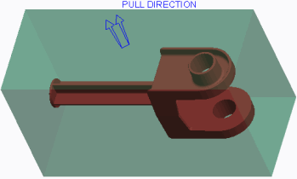

**Figure 2 – Standard Rectangular Work piece**

2. Standard Round – This creates a round-shaped work piece using **Create Round Work piece Create Round Workpiece **, which is shown in Figure 3.

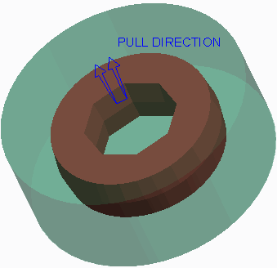

**Figure 3 – Standard Round Work-piece**

3.Custom – Custom creates a custom-shaped work piece using **Create Custom Work piece Create Custom Workpiece **.

* Units – This specifies the system of units for the work piece. You can select inches or millimeters.
* Offsets – This enables you to specify the offset values to add to the dimensions of the work piece, based on the mold origin. The offsets depend on the shape of the work piece that you have selected. You can specify each offset individually, or specify all offsets uniformly. The following offset options are available:
* X-direction – This adds material in the positive or negative X-direction. This offset is available for only the Standard Rectangular shape and some custom shapes.
* Y-direction – This adds material in the positive or negative Y-direction. This offset is available for only the Standard Rectangular shape and some custom shapes.
* Z-direction – This adds material in the positive or negative Z-direction.
* Radial – Radial adds material in the positive radial direction.
* Uniform Offsets – This adds material in the positive and negative X-, Y-, and Z- directions, and Radial, where applicable.
* Overall Dimensions – The overall dimensions get updated when you specify offset values. However, you can also specify the overall dimensions, and the offset values get updated automatically. You can manually specify the X and Y dimensions for rectangular and custom work-pieces, and the Diameter for rounded work-pieces, to customize the work-piece size. You can manually specify the Z Cavity and Z Core dimensions for all work-pieces to customize the size.
* Translate Work-piece – This enables you to specify the translation values for the X- and Y-directions to position the work-piece around the reference model.

You can modify the default Work-piece Name. The Work-piece Name is the name of the work-piece component as it displays in the model tree. By default, its name is of the format *<MOLD-MODEL-NAME>_WRK*, which is shown in Figure 1.

**Creating a Custom Automatic Work-piece**

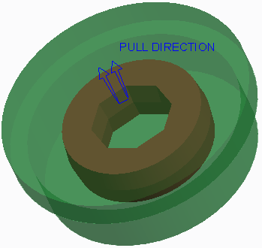In addition to a Standard Rectangular and Standard Round automatic work-piece, you can also create a custom work piece. A custom automatic work-piece enables you to add flanges to the top and bottom of the work-piece. It also enables you to add rounds or chamfers to the vertical work-piece edges.

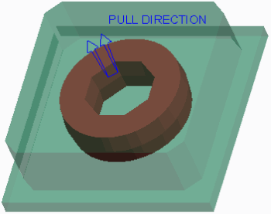

**Figure 2 – chamf_CHAMF_xy_bot_flange Custom Work-piece**

The process is the same as creating a rectangular or round work-piece.

To create a custom automatic work-piece, you can use the **Create Custom Work-piece Create Custom Workpiece ** option in the Automatic Work-piece dialog box, and then select the desired shape in the drop-down list below it. The default shape for a custom work-piece is BLOCK_XY_FLANGES, as shown in Figure 1.

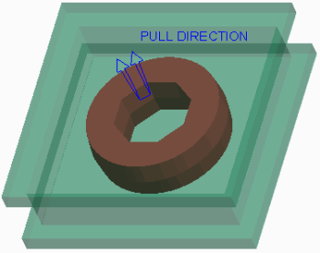

Figure 1 – block_xy_flanges Custom Work piece However, the following shapes are also available:

* BLOCK_00_FLANGES
* BLOCK_00_BOT_FLANGE
* BLOCK_CHAMF_00_FLANGES
* CHAMF_CHAMF_00_BOT_FLANGE
* BLOCK_ROUND
* BLOCK_ROUND_00_TOP_FLANGE
* BAR_FLANGES
* BAR_BOT_FLANGE
* BLOCK_00_TOP_FLANGE
* BLOCK_CHAMF
* BLOCK_CHAMF_00_TOP_FLANGE
* BLOCK_CHAMF_00_BOT_FLANGE
* BLOCK_ROUND_00_FLANGES
* BLOCK_ROUND_00_BOT_FLANGE
* BAR_TOP_FLANGE

You can use the offsets available for the rectangular and round automatic work-piece for a custom work-piece.

## Creating and Assembling a Work-piece Manually

### Creating a Work-piece Manually

You can create a work-piece manually using either of the following methods:

* Create the work-piece within the mold model by selecting **Create Work-piece** from the Work-piece types drop-down menu in the Reference Model & Work-piece group. The Component Create dialog box appears, and you must provide the name of the work-piece component as it displays in the model tree.

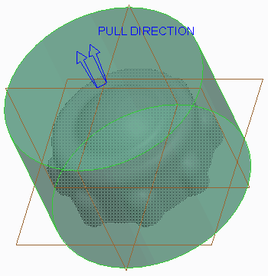

**Figure 2 – Creating a Work-piece within the Mold Model**

* Create the work-piece outside the mold model as a conventional part model.

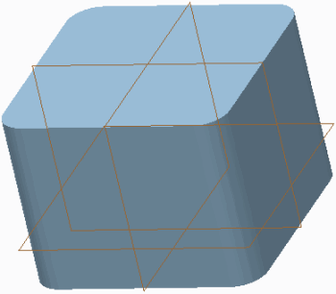

**Figure 1 – Part Mode**

When the part model is needed as the work-piece in the mold model, you can assemble it as a component into the mold model and designate it as the work-piece.

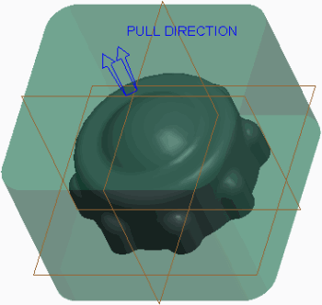

When creating the work-piece manually, you can use any of the conventional part modeling feature techniques available when creating a regular part model. For example, you can use Extrude features, Revolve features, Hole features, Sweep features, and Blend features.

Assembling a Manually Created Work-piece

If the work-piece is created in the mold model, it is already designated as the work-piece upon its creation. It must then be properly assembled into the mold model. If you create a part model outside of the mold and want to use it as the work-piece in a mold model, you must assemble it into the mold model and designate it as the work-piece. You can do this by selecting **Assemble Work-piece Assemble Workpiece ** from the Work-piece types drop-down menu in the Reference Model & Work-piece group.

You can assemble the workpiece into the mold model using any of the available assembly constraints including **Default** , **Coincident** , **Distance Distance **, **Angle Offset Angle Offset **, **Parallel** , and **Normal Normal **.Default Coincident Parallel 

### Considerations When Creating and Assembling a Work-piece Manually

Keep the following in mind when creating and assembling a work-piece manually:

* If you manually create a work-piece and assemble it into the mold model, you need to match the work-piece accuracy to that of the reference model.Keep the location of where the work-piece is split in mind. You can create a datum plane or coordinate system at this location to aid in the assembly process later. It is a best practice to create an automatic work-piece whenever possible. When an automatic work-piece is created, Creo Parametric automatically sets the accuracy of the work-piece model to that of the reference model. If a manual work-piece is created and assembled into the mold model, you must manually modify the work-piece accuracy so that it matches the reference model.
* **Reclassifying and Removing Mold Model Components**

### Reclassifying Mold Model Components

You can switch the classification of components within the mold model.

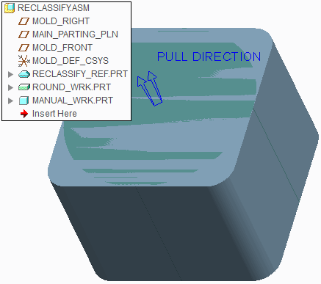

**Figure 1 – Mold Model Before Reclassification**

Reclassifying mold components is a great way to switch which component is used as the work-piece. Each of the following component types can be reclassified to any of the other type

* Work-piece — The mold model uses the selected component as a work-piece. In Figure 2, the rectangular mold base component has been reclassified as a work-piece.

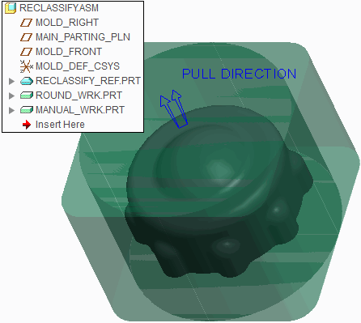

**Figure 2 – Mold Base Component Reclassified to a Work-piece**

* Mold Base Component — The mold model uses the selected component as a mold base component. In Figure 3, the round workpiece has been reclassified as a mold base component.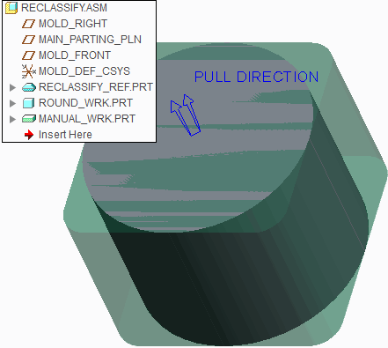

**Figure 3 – Mold Model After Reclassification**

* Mold Component — The mold model uses the selected component as a mold component.

The following are some points to keep in mind when reclassifying mold model components:

* You cannot reclassify the reference model.
* You cannot reclassify a different model to become a reference model.
* The mold model can contain multiple work-pieces. In Figure 2, a mold base component has been reclassified as a work-piece, causing there to be two work-pieces in the mold model.

### Removing Mold Model Components

You can remove components from the mold model in any of the following ways:

* Select the component, right-click, and select **Delete**  .
* Select the component, and press DELETE.
* Select the component and select **Delete**  from the Delete types drop-down menu in the Operation group.

**6. MOLD VOLUME CREATION**

#### Module Overview:

Once the reference model and work-piece have been assembled into the mold model you must create mold volumes within the mold model. Mold volumes are surfaces that locate a closed volume of space in the work-piece, and are ultimately used to create the final mold core, cavity, and slider components.

In this module, you learn which mold volumes are in a mold model and how to create them.

#### Objectives:

After completing this module, you will be able to:

* Understand and explain some of the basic surfacing terms.
* Understand what mold volumes are and explain their characteristics.
* Sketch mold volumes.
* Create sliders using boundary quilts.
* Sketch sliders.
* Create a reference part cutout.
* Sketch lifter and insert mold volumes.
* Replace surfaces and trim to geometry.

## Surfacing Terms

Surface modeling terms are used throughout this course. Therefore, they are important to understand.

* Surface – Surfaces are infinitely thin, non-solid features used to aid in the design of highly complex and irregular shapes. Notice that surfaces are shown using orange and purple highlighting on the edges when viewed in wireframe display, as in Figure 1.

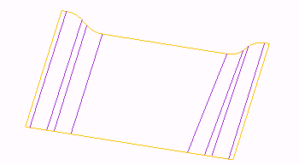

**Figure 1 – Viewing a Surface**

* Orange denotes outer or one-sided edges.
* Purple denotes inner or two-sided edges, since they border two surface patches. In Creo Parametric, the term surface can be used for any of the following:
* Quilts – A quilt may consist of a single surface or a collection of surfaces. A quilt

represents a patchwork of connected surfaces. A multi-surface quilt contains information describing the geometry of all the surfaces that compose it, and information on how these surfaces are joined or intersected, such as the models shown in Figure 1 and Figure 2.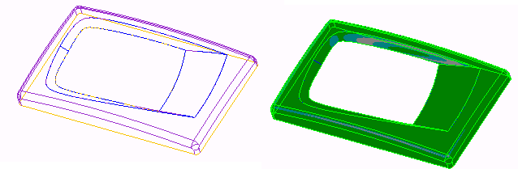

**Figure 2 – Surface Quilt**

* Surface Patch – If you create a surface feature, which is made of several segments, the surface is created with multiple patches, as in Figure 1.
* 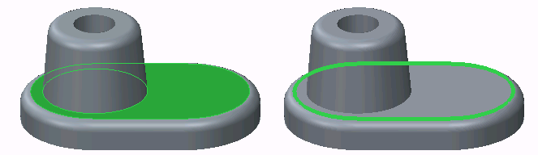Solid Surfaces – A face of a solid feature, such as the solid model shown in Figure 3.
* Datum Planes – A planar datum feature that extends infinitely but is represented by a rectangular border.
* Edge – An edge is the boundary of a solid, as in Figure 3 or a surface, as in Figure 4.

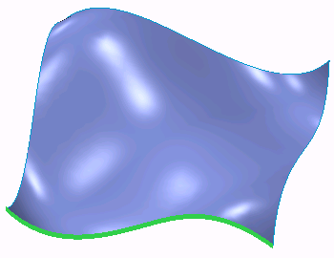

**Figure 4 – Surface Edge**

Surface edges can be one-sided or two-sided depending on the presence of adjacent surface geometry.

## Understanding Mold Volumes

A mold volume consists of surfaces that locate a closed volume of space within the workpiece. Because the mold volume is comprised of surfaces, it has no solid material. Creating mold volumes is an intermediate step to creating the final extracted mold components. Mold volumes are ultimately used to create the final solid extracted mold components. Figure 2 shows three different mold volumes.

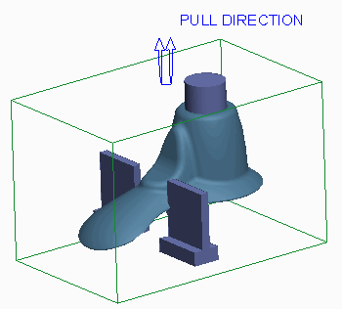

Because the mold volumes are surfaces, they appear magenta when the model display is set to something other than shading, as shown in Figure 3.

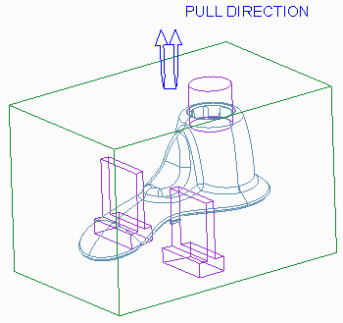

**Figure 3 – Mold Volumes No Hidden**

The following is some general information regarding mold volume creation:

* A mold volume can add or remove material.
* A mold volume is created as an assembly level protrusion or cut within the mold model.
* You can sketch mold volumes.
* A mold volume can be trimmed or split using other surfaces.
* Mold volume creation is an iterative process. You can create mold volumes at any time after the work-piece is assembled but before the final solid mold components are extracted.

A mold volume displays in the model tree with a different icon than that of the reference model and workpiece, as shown in Figure 1.

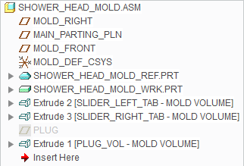

### **Renaming Mold Volumes**

When you create a mold volume, it is a best practice to rename it to something that helps you recognize it within the model tree. To rename a mold volume, you can click **Properties**  from the Controls group after starting the mold volume creation tool. You can also right-click in the graphics window and select Properties. This causes the Properties dialog box to appear, which enables you to edit the mold volume name. In Figure 1, notice that the mold volumes have been renamed.

### **Applying Finishing Features**

You can add draft and round features to a mold volume in the same manner in which you add to any other solid part. This enables you to customize the mold volume. It is used to create the solid mold component.

## Sketching Mold Volumes

You can create a mold volume by sketching its shape.

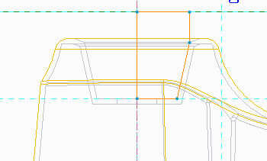

**Figure 1 – Sketching a Mold Volume**

Consider the following guidelines when sketching mold volumes:

* The mold volume is a set of surfaces.
* You can use most sketch-based features within Mold mode to create a mold volume. Feature tools you can use include:
* **Extrude** — Extrudes a sketch section to a specified depth in the direction normal to the sketching plane.Extrude 
* **Revolve Revolve ** — Revolves a sketched section by a specific angle around an axis of rotation.
* **Sweep Sweep ** — Sweeps a sketched section along a specific trajectory. Create constant section sweeps or variable section sweeps.
* Blend tool — Creates a straight or smooth blended volume by connecting several sketched sections.
* **Swept Blend Swept Blend ** — Sweeps a blend section along a specified trajectory.
* Use Quilt — Creates a volume by referencing a surface or quilt.
* Depending on the tool used and the desired mold volume, it can be beneficial to use the workpiece surfaces as sketching planes for the mold volumes.
* The sketch must be closed.

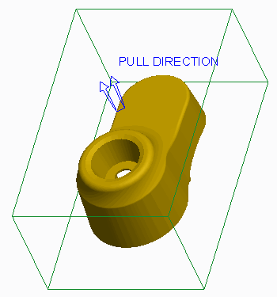

**Figure 2 – Mold Model with No Mold Volumes**

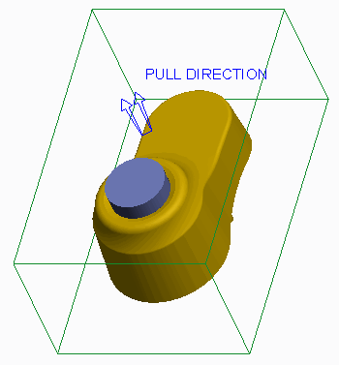

**Figure 3 – Mold Model with Mold Volume**

1. **Creating Sliders using Boundary Quilts**

### What is a Slider?

A slider is a mold component that helps account for undercuts in the reference model geometry. Undercuts are features in the reference model that would prevent a conventional core-and-cavity mold from opening after the molded part has solidified. Sliders “slide” in from the sides to account for these undercuts to keep the mold from locking when opening and closing, or destroying the part. The action of these sliders is called *side action*.

### **Creating Sliders using Boundary Quilts**

In Creo Parametric, a slider is a special type of mold volume that can be used to ultimately create the slider mold component. One of the ways you can create sliders in Creo Parametric is by using boundary quilts. To create a slider mold volume using boundary quilts, you must select **Mold Volume**  from the Mold Volume types drop-

down menu in the Parting Surface & Mold Volume group and then click **Slider** from the Volume Tools group. This launches the Slider Volume dialog box. The Slider Volume dialog box displays the reference part found in the mold model. If the mold model contains more than one reference model, you must specify which one is to be used for the calculation. You can also specify the pull direction. The system utilizes the mold model's pull direction as the default Pull Direction, but you can specify a different pull direction by selecting any of the following references:

* Plane — Makes the pull direction perpendicular to the specified plane.
* Curve, Edge, or Axis — Makes the pull direction follow the selected curve, edge, or axis.
* Coordinate System — Makes the pull direction follow the specified axis of the selected coordinate system.

Once the pull direction has been defined, you can click **Calculate Undercut Boundaries Calculate Undercut Boundaries ** from the Slider Volume dialog box. This causes the system to perform a geometry check for undercut areas in the reference model. The system performs the check by shining a light on the reference model in the pull direction. The areas where light does not reach are the undercuts, which are also known as black volumes. These areas would cause the mold to lock on opening or closing. Therefore, a slider is required in these areas.

The system creates boundary quilts in the areas where the undercuts occur and displays them in the Exclude column of the Slider Volume dialog box. You can select each boundary quilt and perform the following operations on each quilt:

* Mesh — Meshes the boundary surface in the graphics window. In Figure 1, the boundary surface is meshed.

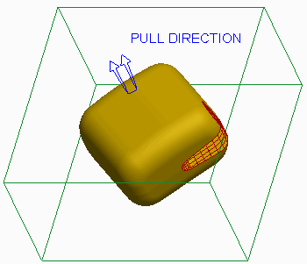

**Figure 1 – Meshing a Boundary Quilt**

* Shade — Shades only the boundary surface in the graphics window, temporarily hiding all other geometry.

You can then add each quilt that you want to become a slider mold volume to the Include column of the Slider Volume dialog box. The system automatically extrudes the slider mold volume based on the boundary quilt. A completed slider mold volume is shown in Figure 2.

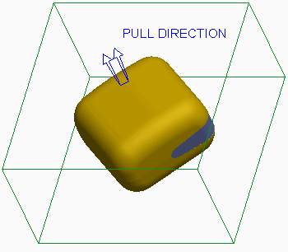

**Figure 2 – Slider Mold Volume**

### **Specifying the Projection Plane**

Optionally, you can specify a projection plane for each slider mold volume. The system extends the extruded slider volume up to the specified projection plane, in the direction normal to the plane. In Figure 3, the right surface of the workpiece was specified as the projection plane.

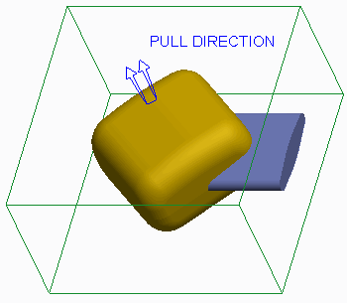

1. **Sketching Slider Mold Volumes**

You can also sketch slider mold volumes. The following are reasons to sketch slider mold volumes:

* Shape – When calculated undercut boundaries are used, the resulting slider mold volume takes on the shape of the undercut geometry. If the shape is not desired for manufacturing, or it cannot be manufactured, a slider mold volume can be sketched to account for the undercut geometry. In Figure 1, the shape created by calculating undercut boundaries is not as conducive to manufacturing as the sketched slider mold volume in Figure 2.

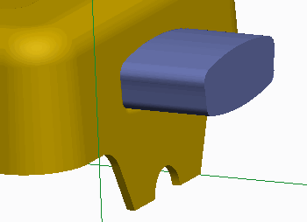

**Figure 1 – Undesired Slider Result**

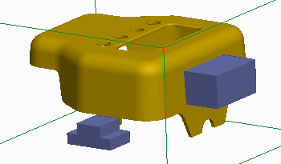

**Figure 2 – Sketched Slider Mold Volumes**

* Size – Since the slider mold volume created by calculating undercut boundaries takes on the shape of the undercut, the slider mold volume may be too small for manufacturing, as shown in Figure 3.

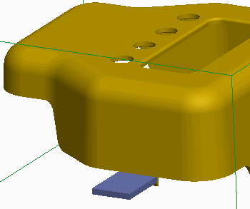

**Figure 3 – Slider Volume too Small**

Consequently, you can sketch a larger slider mold volume that accounts for the undercut, as shown in Figure 2.

* Result – Depending on the reference model geometry, sometimes the slider mold volume obtained by calculating undercut boundaries cannot be created, or the slider mold volume does not entirely account for undercut geometry. In Figure 1, the slider does not properly account for the round feature, and thus a sketched mold volume was created in Figure 2.

### **Guidelines for Sketching Sliders**

When creating slider mold volumes using sketch-based features, consider the following guidelines:

* You can still initially calculate the undercut boundaries for the reference model even when you are sketching the slider mold volumes. The analysis helps you determine the locations in the mold model where sliders will be required and helps ensure that you have accounted for all undercut geometry.
* Ensure that the sketch you create accounts for the entire undercut geometry. That is, make sure that the entire undercut geometry is contained within the resulting sketched slider mold volume. It can be beneficial to utilize the sides of the undercut geometry as sketching references.
* Because the slider is simply a special type of mold volume, you can use any sketch- based feature that is available for sketching the conventional mold volume on the slider mold volume.
* Because the slider is a mold volume, the sketch must be closed.

1. **Creating a Reference Part Cutout**

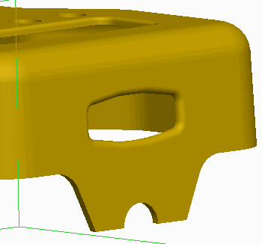

**Figure 1 – Reference Model**

You can create a reference part cutout on a mold volume by selecting **Reference Part Cutout Reference Part Cutout ** from the Trim To Geometry types drop-down menu in the Volume Tools group. A reference part cutout enables you to remove any overlapping reference model geometry from the mold volume. The volume of the reference model is subtracted from the mold volume. This is a very useful feature because the mold volume will then match the reference model geometry. A reference part cutout enables you to create a mold volume that completely encompasses the desired area of the reference model and then create a reference part cutout feature.

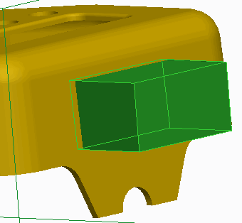

**Figure 2 – Mold Volume Created**

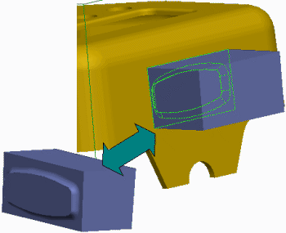

**Figure 3 – Reference Part Cutout Created**

Creating a reference part cutout is not a requirement when creating mold volumes. The reference model geometry is automatically cut out of the mold volumes when the volumes are split (this happens later in the process). Creating a reference part cutout is a great method to determine if the reference geometry can successfully be cut out during the split process. It can also help you visualize whether or not you have created a mold volume that captures the desired reference model geometry.

The reference part cutout option is only available if you are creating a volume or if you are redefining the volume. The resulting reference part cutout feature displays in the model tree as a feature called *Refpart Cutout id*. However, the mold volume for which the trim was applied is also displayed in the model tree as shown in Figure 4:

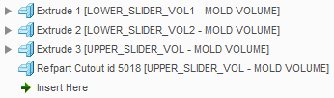

**Figure 4 – Reference Part Cutout in Model Tree**

### Reference Part Cutout Tips

Consider the following tips when creating a reference part cutout for a mold volume:

* Without creating additional modifications to the volume after the reference part cutout, the system makes the reference part cutout option unavailable. Therefore, you cannot cut out a volume twice.
* When more than one reference part is present, the system prompts you to select one.

1. **Sketching Lifter Mold Volumes**

A lifter is another mold component that helps account for undercuts of the inside of the reference model geometry.

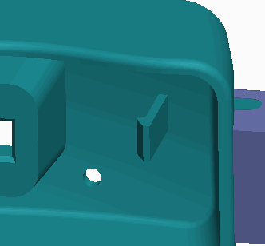

**Figure 1 – Viewing the Undercut**

Because mold components are ultimately created from mold volumes, you can use sketch-based features to create lifter mold volumes in the mold model.

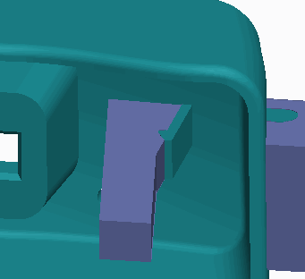

**Figure 2 – Lifter Created to Account for Undercut**

A lifter is usually attached to the moving side of the mold. It moves at an angle to free the plastic that comprises the undercut inside the model. Due to their function, lifters are normally long and narrow.

# Exercise: Sketching Lifter Mold Volumes

#### Procedure Setup:

**Objectives**

To avoid naming conflicts, it is recommended you save your work, click **File** > **Close** until no models display, then click **File** > **Manage Session** > **Erase Not Displayed**.

Click **File** > **Manage Session** > **Set Working Directory** and navigate to the **PTCU\CreoParametric3\Mold\Volume_Lifter** folder and click **OK**

Click **File** > **Open** and double-click **LIFTER2.ASM**.

* Sketch a lifter volume.

#### Scenario

Sketch a lifter mold volume that accounts for the undercut in the mold model.

**1. Task 1. Sketch a lifter mold volume that accounts for the undercut in the mold model.**

1. Enable only the following Datum Display types.
2. Select LIFTER_WRK.PRT.
3. In the ribbon, select the **View** tab.
4. Click the Model Display group drop-down menu and select **Component Display Style > Wire-frame**.
5. Select the **Mold** tab.
6. Spin the model, as shown, and notice the undercut.

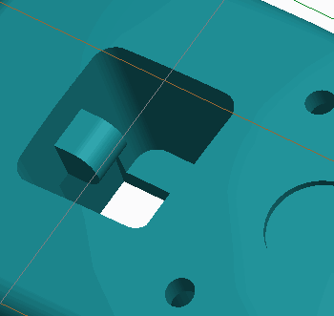

**Figure 1**

1. Select **Mold Volume**  from the Mold Volume types drop-down list in the Parting Surface & Mold Volume group.
2. Properties Click **Properties** from the Controls group, edit the mold volume Name to **LIFTER_VOL2**, and press ENTER.
3. Select datum plane MOLD_RIGHT as the Sketch Plane and click **Extrude Extrude ** from the Shapes group.
4. Click **Sketch View Sketch View ** from the In Graphics toolbar.
5. Select **Hidden Line Hidden Line ** from the Display Style types drop-down menu.

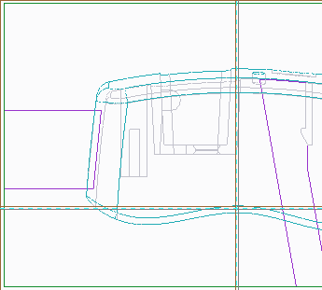

**Figure 2**

1. Enable only the following Sketcher Display types: .
2. Click **References References ** from the Setup group and select the bottom of the work-piece, the angled line at the bottom edge of the tab, the rounded edge of the tab, and the right edge of the hole as references.

* Click **Close**.

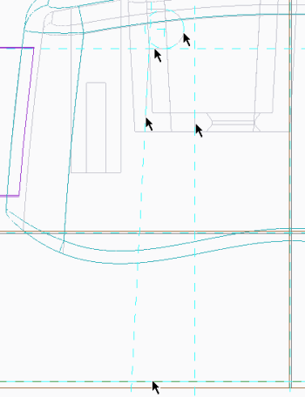

1. Click **Line Chain** and sketch the shape on the references.Line Chain 

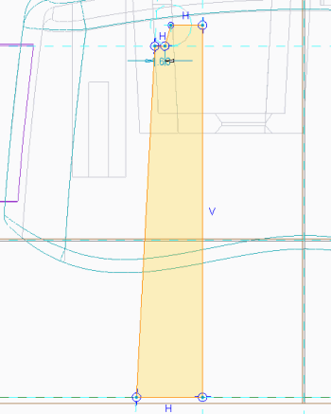

1. Select **Shading Shading ** from the Display Style types drop-down menu.
2. Zoom in on the top of the sketch.
3. Click **Centerline Centerline ** and sketch a vertical centerline through the vertex that is second from the left.
4. Dimension the sketch as shown.

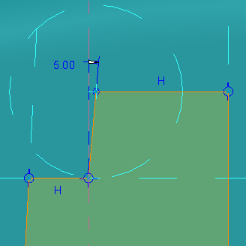

1. Disable **Plane Display Plane Display  **.

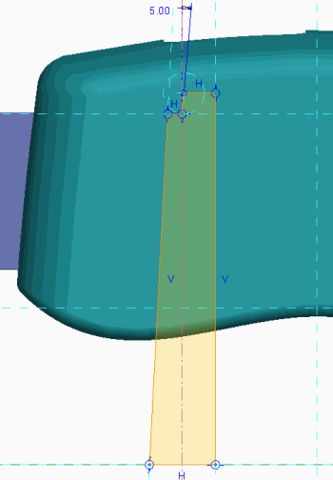

1. Click **OK** .OK 
2. In the dashboard, edit the depth to **To Selected** .To Selected 

* Spin the model so that you can view its underside and select the surface to extrude to.

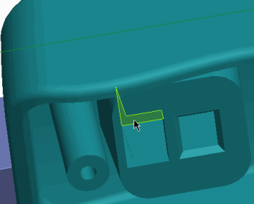

1. In the dashboard, select the **Options** tab.

* Edit the Side 2 Depth to **To Selected** and select the surface to extrude to.To Selected 

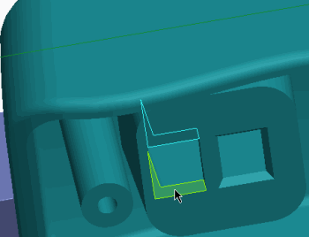

1. Click **Complete Feature** .Complete Feature 
2. Spin the model, as shown, and notice that the lifter accounts for the undercut.

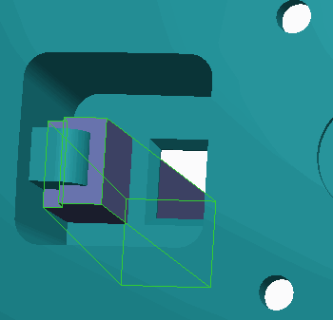

**Figure 9**

1. Select **Reference Part Cutout Reference Part Cutout ** from the Trim Geometry To types drop-down menu in the Volume Tools group.
2. Click **OK** from the Controls group.OK 

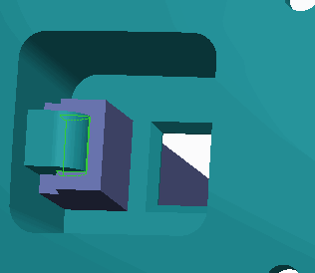

**Figure 10**

1. Select LIFTER_REF.PRT, right-click, and select **Hide Hide **.
2. Spin the model and view the lifter mold volume.

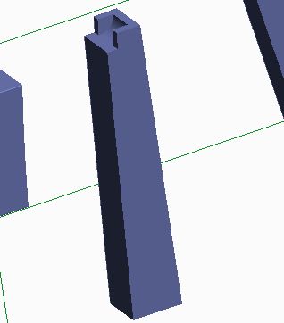

**Figure 11**

1. Click **Save Save ** from the Quick Access toolbar.
2. Click **File > Manage Session > Erase Current**, then click **Select All** and **OK** to erase the model from memory.

**This completes the exercise.**

1. **Replacing Surfaces and Trimming to Geometry**

### Replacing Surfaces

You can replace a single-mold volume surface with a quilt surface by clicking the Editing group drop-down menu and selecting **Replace** . You can use the Replace option to add volume, remove volume, or simultaneously add and remove volume. In Figures 2 and 3, the bottom mold volume surface was replaced with the surface quilt.

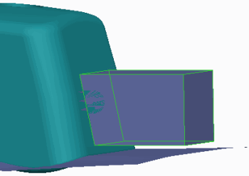

**Figure 2 – Mold Volume Before Surface Replace**

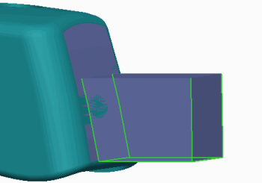

**Figure 3 – Mold Volume After Surface Replace**

By default, the mold volume is “consumed” by the replaced surface feature. That is, the mold volume is not visible, but still exists previously in the model tree.When using the Replace option, there is one option available in the Replaced Surface dialog box:

* Keep quilt – This enables the quilt selected for the replace to remain visible after the replace is created. In Figure 3, the quilt was not kept after the surface replace was created.

The Replace option is only available if you are creating a volume or if you are redefining the volume. The resulting replaced surface feature appears in the model tree as a feature called *Replaced Surface id*.

You can trim surfaces to other geometry in the mold model by selecting **Trim To**

**Geometry** from the Trim To Geometry types drop-down menu in the Volume Tools group.

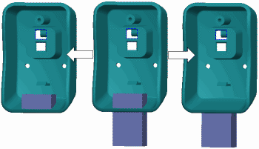

**Figure 1 – Trimming a Volume to Geometry**

The Trim To Geometry option is only available if you are creating a volume or if you are redefining the volume. The resulting trim to geometry feature appears in the model tree as a feature called *Trim To Geom id*. However, the mold volume for which the trim was applied is also displayed in the model tree. You can trim to geometry as an alternative to extracting a mold volume up to a surface. However, trimming to geometry has more powerful capabilities than just this use. Trimming can only remove volume, not add it.

When trimming surfaces to geometry, you must specify the following:

* Ref Type – Ref Type specifies what the system uses as the trimming entity. You can specify one of the following:
* Part – This uses a part for trimming.
* Quilt – This uses a quilt for trimming.
* Plane – This uses a plane surface or datum plane for trimming.
* Reference – Reference enables you to specify the item whose geometry will be used for trimming. The item that you can select depends on the Ref Type that was specified. Essentially, the Ref Type acts like a filter for the Reference selection.
* Direction – This enables you to select a trim feature direction. A direction arrow points in the direction that volume will be trimmed at the reference. You can select the following references:
* Plane – Plane makes the direction perpendicular to the specified plane.
* Curve, Edge, or Axis – These make the direction follow the selected curve, edge, or axis.
* Coordinate System – This makes the direction follow the specified axis of the selected coordinate system.
* Trim Type – Trim Type enables you to specify which side of the trimming reference will be used when trimming the mold volume. You can select either of the following:
* **Trim By Last Reference**– This trims the item by the last reference surface.
* Offset – This offsets the trimming reference in the direction currently specified before trimming the geometry.

1. **Sketching Insert Mold Volumes**

An insert is another mold component that is typically used as a cost-saving measure. The mold uses the same core and cavity, but one insert is swapped for another. Different inserts can be used to create different shapes. Thus, you can use the same mold to create similar parts simply by switching inserts. In Figure 1, an insert needs to be created for a square cut in the bottom inset of the reference model.

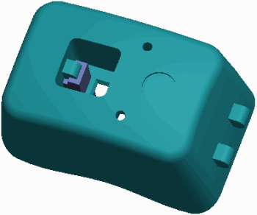

**Figure 1 – Viewing the Reference Model**

The resulting insert mold volume is shown in Figure 2.

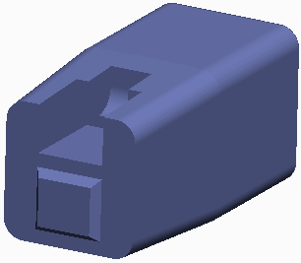

**Figure 2 – Viewing the Completed Insert**

However, the model could have a design variation where, rather than a square cut in the bottom, there is a round cut in the bottom, which is shown in Figure 3.



**Figure 3 – Design Variations That Can Use Same Core and Cavity**

In this case, you can create a different insert mold volume, while you use the same core and cavity. You can also use inserts in areas that are difficult to machine.Because mold components are ultimately created from mold volumes, you can use sketch-based features to create insert mold volumes in the mold model.

# 7. PARTING SURFACE CREATION

#### Module Overview:

In addition to using the Skirt Surface tool to help you automatically generate the parting surface, you can also use the Shadow Surface tool to automatically create a parting surface. You can also use a series of other tools to manually create the different parts of the parting surface. The different parts can be merged together to form the final parting surface.

In this module, you learn about the shadow surface and various manual parting surface tools.

#### Objectives:

After completing this module, you will be able to:

* Explain the various tools you can use to edit and manipulate surfaces.
* Merge surfaces.
* Create a shadow surface.
* Create a parting surface manually.
* Create saddle shutoff surfaces.
* Create fill surfaces.
* Extend curves.
* Fill loops.
* Create shut offs by closing all loops, by selecting loops, and by capping surfaces.

1. **Analyzing Surface Editing and Manipulation Tools**

When working with surfaces, it is often necessary to edit and manipulate quilts to achieve your desired design intent. You can use the following tools to edit and manipulate surfaces.Extending Surfaces You can extend a quilt using either of the following methods:

* **Extend Original Surface Extend Original Surface ** — Extends the surface boundary edge chain along the original surface. This option has three additional options that determine how the extension is created:
* Same — Creates the extension of the same type as the original surface (for example, plane, cylinder, cone, or spline surface). The original surface is extended past its selected boundary edge chain, and does not create an additional surface patch. This is the default extend option.
* Tangent — Creates the extension as a ruled surface that is tangent to the original surface. With this option an additional surface patch is created.
* Approximate — Creates the extension as a boundary blend between the boundary edges of the original surface and the edges of the extension. This method is useful when extending the surface up to a vertex that does not lie along a straight edge. With this option an additional surface patch is created.
* **Extend Surface To Plane Extend Surface To Plane ** — Extends the boundary edge chain up to a specified plane in the direction normal to this plane. With this option an additional surface patch is created.

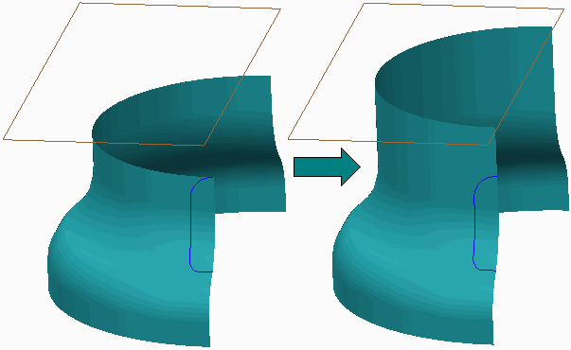

**Figure 1 – Extending a Surface to Plane**

### **Trimming Surfaces**

A surface trim is analogous to a solid cut, except that it trims away a portion of a surface. You can create a surface trim as an extrude, revolve, sweep, blend, and so on. You can also trim a selected surface quilt using other geometry such as planes, quilts, and curves or edges.

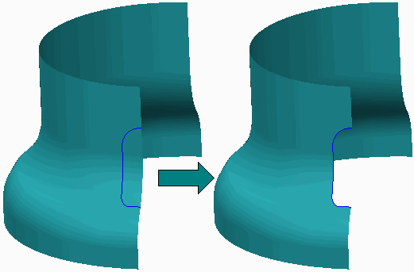

**Figure 2 – Trimming a Quilt using Geometry**

Once you have specified the surface to be trimmed and the entity to do the trimming, you must specify which side is to be kept. You can opt to keep one side, the other side, or both sides.

### **Copying and Pasting Surfaces**

Copying and pasting surfaces enables you to create an overlay of a surface so that you can then perform manipulations to the copied surface. You can copy and paste any surface or surface set, either from a quilt or a solid. You can use either CTRL+C and CTRL+V or the **Copy**  and **Paste**  icons from the Operations group in the ribbon. You should only use the Copy functionality in situations where you do not have proper references to create the parting surfaces. The copy functionality can result in a lot of surface features, especially when you are working with a complex design.

### **Offsetting Surfaces**

You can create a surface quilt offset a distance value from another quilt or a solid surface. The offset surface remains dependent on the original surface. When offsetting surfaces, you can specify the fit type as either Normal to Surface, Automatic Fit, or Controlled Fit.

### **Mirroring Surfaces**

You can transform a surface quilt by mirroring it. To mirror a quilt, select the quilt and click **Mirror**, specifying a reference plane for the mirror. A new surface feature is created.

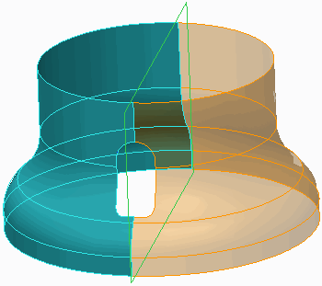

**Figure 3 – Mirroring a Quilt**

### **Merging Surfaces**

You can merge two or more intersecting or adjacent quilts to create surfaces with 2-sided edges. Merging surfaces is covered more in depth in other topics.

1. **Merging Surfaces**

You can merge two or more intersecting or adjacent quilts. Merging a quilt makes it select able as a single entity for other operations, and is required for operations such as creating solids from quilts.

Remember the following:

* Surfaces are shown using orange and purple highlighting on the edges.
* Orange denotes outer or one-sided edges.
* Purple denotes inner or two-sided edges because they border two surface patches. Therefore:
* Merging a surface results in the creation of two-sided edges from one-sided edges. In

Figure 2, the adjacent quilt surface edges are separate, one-sided edges, as they display in orange.

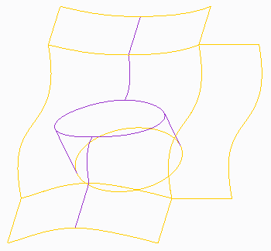

**Figure 2 – Surfaces Edge Display of Separate Quilts**

In Figure 3, the quilts have been merged to form two-sided, purple edges.

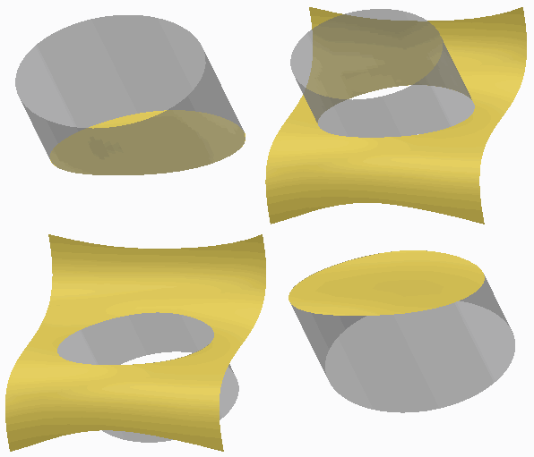

**Figure 1 – Surface Merge Keep Options**

* Merged surface edges appear in purple.

### **Merge Options**

There are two types of merge operations, used for different surface geometry:

* Intersect – Primarily used for intersecting quilts, when a trimming effect is desired, although it can be used on adjacent quilts. The Intersect option provides up to two flip arrows, enabling four possible geometry outcomes, as shown in Figure 1.

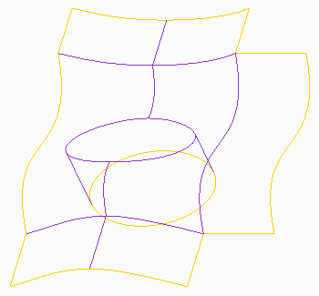

Figure 3 – Surface Edge Display of Merged Quilts Intersect is the default merge option.

* Join – Recommended for use on adjacent quilts. Join can also be used to join surfaces

when no trimming effect is desired. For example, you could join two surfaces that meet in a “T,” without having to decide which sides to keep.

1. **Creating a Shadow Surface**

A shadow surface is another type of parting surface you can create automatically.

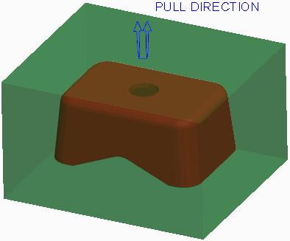

The Shadow Surface tool drapes a parting surface on top of the reference part geometry.

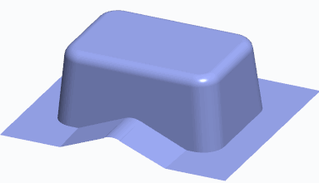

**Figure 2 – Viewing a Shadow Surface**

The following are prerequisites for creating a shadow surface:

* The work-piece must be visible (it cannot be hidden or blanked).
* The model must be completely drafted.

### **Comparison of Shadow Surfaces and Skirt Surfaces**

Because both skirt surfaces and shadow surfaces can be used to automatically create a parting, consider the following comparisons:

* The skirt surface requires a silhouette curve while a shadow surface does not.
* The skirt surface may have vertical surfaces because the silhouette curve determines the upper or lower loop of the non-drafted sections. Since the shadow surface does not use a silhouette curve, a design model must be fully drafted.
* With the skirt surface, you can exclude segments that fail. The shadow surface has no option to exclude failed segments.
* There is no extension control with the shadow surface. You cannot extend curves, specify tangent conditions, or modify extension directions.

### **Shadow Surface Options**

The following options are available when creating a shadow surface:

* Boundary Reference – Defines the outer limits of the shadow surface. Depending on the reference model and work-piece, you may have to specify the work-piece as the boundary reference.
* Direction – Specifies the direction that the shadow surface is draped onto the reference model. By default, the direction is opposite that of the pull direction.
* Clip Plane – Specifies the location where the shadow surface stops.
* Loop Closure – Specifies the loops that the shadow surface closes. By default, the system closes all inner loops of the reference model, but you can select specific loops if desired.
* ShutOff Ext – Enables you to specify the amount of extension toward the boundary references that the shadow surface will undergo before stopping, extending in the pull direction, and finally stopping at the boundary references.

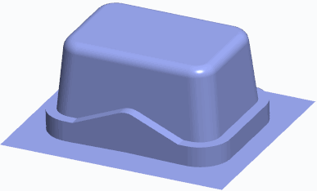

**Figure 3 – Specifying a ShutOff Extension**

When the shadow surface extends outward, it stops either at the boundary references or a shutoff extension, whichever it encounters first. If the selected boundary falls outside of the boundary references, the shadow surface will stop at the boundary references. There are two methods available for specifying the shutoff extension location:

* ShutOff Dist – Specifies a uniform offset value around the reference model perimeter that the shadow surface will extend.
* Boundary – Enables you to specify your own boundary that the shadow surface will extend out to. You can use either of the following two methods to specify the boundary:
* Select – Enables you to select an existing sketch as the boundary.
* Sketch – Enables you to sketch the boundary on-the-fly by specifying the sketch plane, reference plane, and reference direction.

Regardless of which boundary method is used, the boundary must form a closed loop. It is not necessary for the boundary to be located on a specific sketching plane or even a sketching plane that is perpendicular to the pull direction. However, the boundary is ultimately extended in the pull direction, so if the boundary is created on a plane that is not normal to the pull direction, you may not get the expected result.

* Draft Angle – Used in conjunction with the ShutOff Extension option, the draft angle option drafts the Z-direction surfaces of the shutoff extension by the specified draft angle value. Specifying a draft angle is optional.
* ShutOff Plane – Used in conjunction with the ShutOff Extension option, the shutoff plane is the planar reference that the shutoff extension extends to. The shutoff plane is optional for a shadow surface, but it is a required reference if a shutoff extension is defined.
* Shadow Slides – Enables you to specify mold volumes to attach to the reference model. The resulting shadow surface drapes over the specified mold volumes. Like the reference model, the mold volume must be fully drafted to successfully create the shadow surface.

# Exercise: Creating Parting Surfaces using Shadow Surfaces

#### Procedure Setup:

To avoid naming conflicts, it is recommended you save your work, click **File** > **Close** until no models display, then click **File** > **Manage Session** > **Erase Not Displayed**. Click **File** > **Manage Session** > **Set Working Directory** and navigate to the **PTCU\CreoParametric3\Mold\Mouse_Part-Surf_Shadow** folder and click **OK** Click **File** > **Open** and double-click **MOUSE_MOLD.ASM**.

**Objectives**

* Create parting surfaces using the Shadow Surface feature.
* Create parting surfaces by using basic surface creation tools.
* Modify surfaces by using various editing tools.

#### Scenario

In this exercise, you use manual surface creation techniques to create parting surfaces in the mouse mold model.

#### 1. Task 1. Create the first parting surface.

* Disable all Datum Display types.
* Orient to the 3D view orientation.
* Click **Parting Surface Parting Surface ** from the Parting Surface & Mold Volume group.
* Rename the parting surface feature by doing the following:
* Click in the graphics window.
* Right-click and select **Properties**.
* Type **INSERT** as the Name of the parting surface and press ENTER.
* Click the Surfacing group drop-down menu and select **Shadow Surface**.
* In the Shadow Surface dialog box, double-click **Direction**.
* As oriented, select the top workpiece surface.

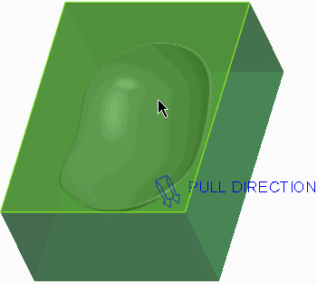

* Click **Okay** from the menu manager.
* Click **Preview** from the Shadow Surface dialog box.
* Click **Repaint Repaint ** from the In Graphics toolbar.

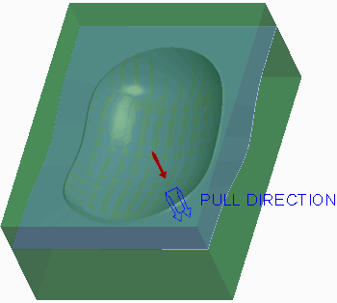

* In the Shadow Surface dialog box, double-click **ShutOff Ext**.
* In the menu manager, click **Boundary > Select > One By One**.
* Zoom in on the reference model, press CTRL, and select the four inner edges.

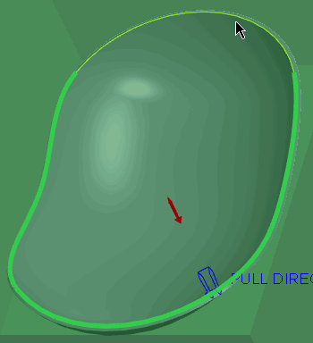

* Click **Done** from the menu manager.
* In the Shadow Surface dialog box, double-click **ShutOff Plane**.Plane 
* Click **Plane** from the Datum group.
* As oriented, select the top workpiece surface.
* Drag the datum plane down and edit the Translation value to **25.4**.

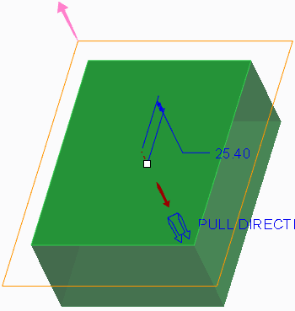

* Click **OK** from the Datum Plane dialog box.
* Click **Done/Return** from the menu manager.
* Click **OK** from the Shadow Surface dialog box.
* Orient to the **Standard Orientation**.
* Click in the graphics window to de-select all features.

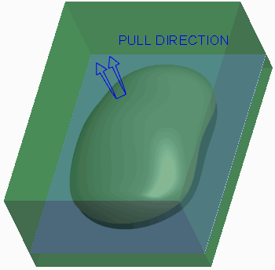

**Figure 5**

#### 2. Task 2. Create an extruded surface.

* Click **Extrude Extrude ** from the Shapes group.
* Query-select the bottom side of the work-piece as the Sketch Plane.
* Click **References References ** and select datum plane MOLD_FRONT as an additional reference.
* Click **Close**.

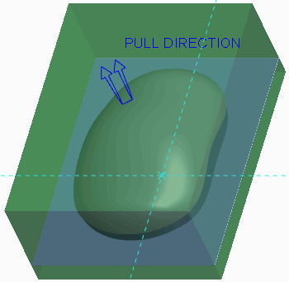

* Enable only the following Sketcher Display types: .Center Rectangle 
* Select **Center Rectangle** from the Rectangle types drop-down menu in the Sketching group and sketch a rectangle symmetric about both references.
* Click **One-by-One One-by-One ** and edit the horizontal dimension to **190.5** and the vertical dimension to **254**.

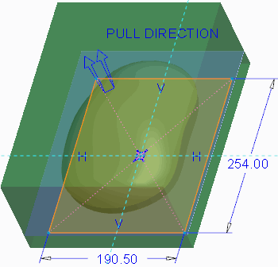

* Click **OK**
* Right-click the depth handle and select **To Selected**.
* Select the flat surface as the depth reference.

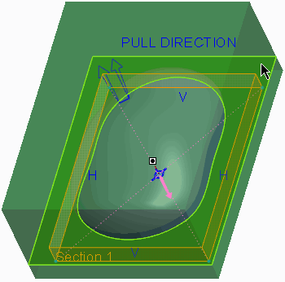

* Click **Complete Feature** .
* Orient to the 3D view orientation to inspect the surface you have created.

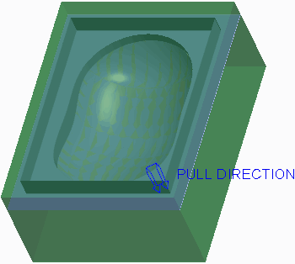

* Orient to the **Standard Orientation** when finished.

#### 3. Task 3. Merge the two surfaces.

* Select the shadow surface quilt.

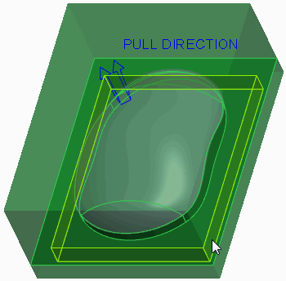

* Press CTRL and query-select the extruded surface quilt.
* Click **Merge** from the Editing group.Merge 
* In the dashboard, select the **Options** tab.
* Verify that the **Intersect** option is selected as the merge type.
* In the dashboard, click **Change First Quilt Side Change First Quilt Side ** as necessary until the correct final geometry displays, as shown.

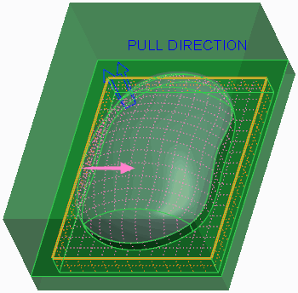

1. Click **Complete Feature** .Complete Feature 
2. Click **OK** from the Controls group.OK 

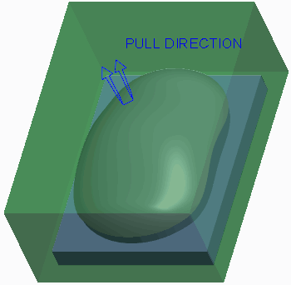

#### 4. Task 4. Create the second parting surface.

* Click **Parting Surface Parting Surface **.
* Rename the parting surface feature by doing the following:
* Click **Properties Properties ** from the Controls group.
* Type **MAIN** as the Name of the parting surface and press ENTER.

1. Click the Surfacing group drop-down menu and select **Shadow Surface**.

* Click **OK**.

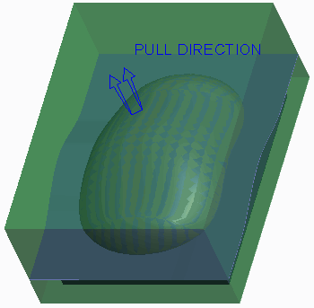

* Click **OK** .OK 
* Click **Save Save ** from the Quick Access toolbar.
* Click **File > Manage Session > Erase Current**, click **Select All** , and click **OK** to erase the model from memory.Select All 

1. **Creating a Parting Surface Manually**

Sometimes the silhouette curve and skirt surface features do not provide you the desired parting surface shape.

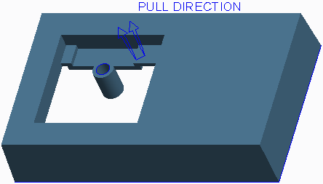

**Figure 1 – Mold Model Before Manual Parting Surfaces Created**

You can create the parting surface manually in these types of circumstances. You may also use a combination of a skirt surface and manual parting surface for a mold model. The skirt surface can be used for the parting surface in the locations where the proper geometry has been created, and a manual parting surface can be created in areas where the skirt surface does not provide the desired shape. To create a parting surface manually, you can click **Parting Surface**  from the Parting Surface & Mold Volume group and then use the various basic and advanced surface creation techniques. Each of the surfaces created belongs to the parting surface feature. You can also use the various editing and manipulation tools on the surfaces. After all surfaces have been created for a given loop area in the mold model, you must use **Merge**  to merge the surfaces together before completing the parting surface feature.

In Figure 2, a total of three surfaces were created to close the loop and create the parting surface.

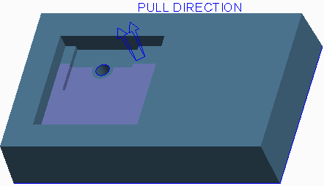

**Figure 2 – Manual Parting Surface Created**

Two surfaces are fill surfaces, and the third surface is an extruded surface. Once all three surfaces were created they were merged together. At this point the silhouette curve could be used to create the outer loop of the parting surface and to fill the hole shutoff in the boss.

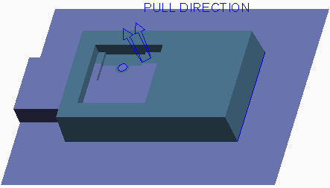

**Figure 3 – Skirt Surface Used to Generate Other Parting Surface**

## Creating Saddle Shutoff Surfaces

To handle a saddle shutoff within the part, you must create the surfaces which represent the shutoff faces. A saddle shutoff is a bit more challenging than the parting line surface or a face shutoff because you generally need several surfaces to form the required shape. Typically, you create the saddle surface and then create the face surfaces.

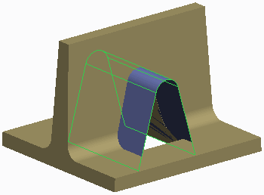

**Figure 1 – Saddle Surface Created**

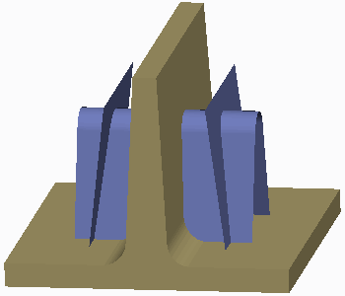

**Figure 2 – Face Surfaces Created**

You can extrude or revolve the surfaces, or use more advanced geometry creation methods like blended surfaces, depending on the desired geometry. You can even copy existing surfaces and paste them. You can then manipulate these surfaces by extending, trimming, and offsetting them if needed. Once the saddle surface and face surfaces have been created, you must merge the surfaces together to form the required shape.

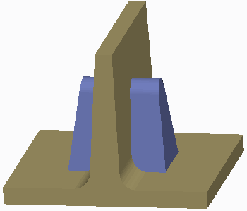

**Figure 3 – Final Saddle Shutoff**

1. **Creating Fill Surfaces**

During parting surface creation, you can fill a sketch to create a planar surface.

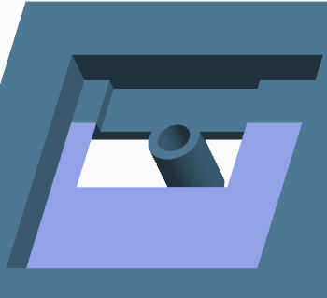

**Figure 1 – Creating a Fill Surface**

You can either select the sketch first and then start the Fill tool, or start the Fill tool and then select the sketch. If you select the sketch first and then start the Fill tool, the feature is automatically completed.

The following are important points about the sketches used by the Fill tool:

* The sketch must be a sketched curve, and it can be either an internal or external sketch.
* The sketch must be closed. However, it can contain multiple loops.
* The sketch can be any shape. That is, it can contain either tangent or non-tangent entities.
* The sketch may reference other geometry.

Because you are using the Fill tool to fill gaps in the reference model during parting surface creation, you will often be referencing other geometry, whether edges or surfaces of the reference model or work-piece, or edges of other parting surfaces. Usually the resulting planar surface is part of a larger parting surface, and thus the filled surface must be merged with the other portions of the parting surface.

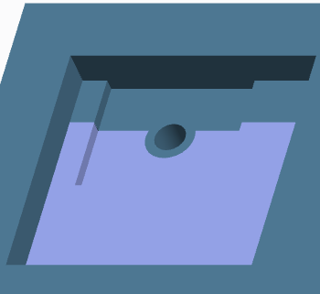

**Figure 3 – Final Parting Surface Created**

1. **Extending Curves**

You can select curves or edge chains on the reference model to extend and create a parting surface. You must specify the reference model so that the system can identify which curves are available for selection. You must also specify the boundary reference (usually the work-piece) to instruct the system on how far to extend the specified curves.

The following extension directions are available for the selected curves:

* Normal to the Pull Direction – All specified curves are extended normal to the pull direction.

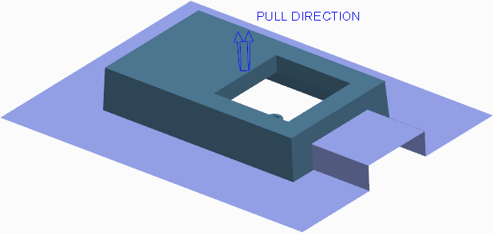

**Figure 1 – Extending Curves Normal to Pull Direction**

There are two additional options you can select from when curves extend normal to the pull direction:

* Perpendicular to reference model – The specified curves extend normal to the pull direction and perpendicular to the adjacent reference model surfaces.
* Perpendicular to boundary – The specified curves extend normal to the pull direction and perpendicular to the surfaces of the defined boundary reference model (usually the workpiece).
* Parallel to the Pull Direction – All specified curves are extended parallel to the pull direction.
* 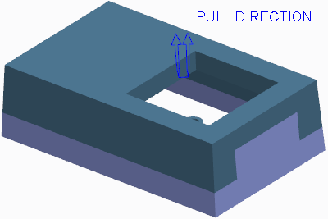Tangent to the Model – All specified curves are extended tangent to the adjacent reference model surfaces

**Figure 2 – Extending Curves Tangent to the Model**

* Under Defined Direction – All specified curves extend normal to the direction reference you specify.

Optionally, you can enable the system to create surface transitions across gaps in the extended edges.You can also define multiple extensions for a given operation. You can define one set of edges to be extended in a specific direction and define a different set of edges to be extended in a different direction.

### **Shut Off Types**

When extending edges, you can choose to add a shut off if desired within the Shut Off tab of the dashboard. The following shut off types are available:

* Boundary – The default type, the Boundary type extends the edges in the specified direction, out to the defined boundary reference model.
* Distance – Enables you to specify a distance outward that the curves extend from the reference model before they stop and extend in the pull direction. With the Distance shut off type, you can also specify a Shut Off Plane. Rather than extending the curves in the pull direction out to the workpiece boundary, the curves instead stop at the defined shut off plane reference.

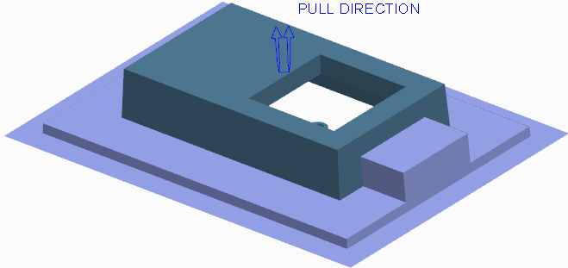

**Figure 3 – Adding a Distance Shut Off**

Additionally, you can draft the surfaces extended in the pull direction by specifying a draft angle.

* To a Reference – Enables you to specify a sketch that the curves extend from the reference model before they stop and extend in the pull direction. With the To a Reference type, you can also specify a Shut Off Plane. Rather than extending the curves in the pull direction out to the workpiece boundary, the curves instead stop at the defined shut off plane reference. Additionally, you can draft the surfaces extended in the pull direction by specifying a draft angle.

1. **Filling Loops**

You must fill any closed loops in the reference model with a surface that acts as the parting surface for the given loop. You can use the **Fill Loops**  tool to manually specify the reference chain that forms the loop to be filled.

The following types of fill loop surfaces can be created:

* Surface – The system fills in the specified loop with a surface.

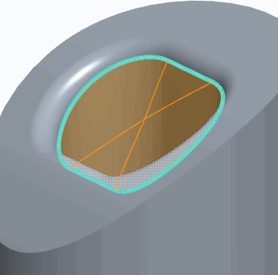

**Figure 1 – Surface Loop Type**

Depending on the surrounding contours, the resulting surface may not suffice for a parting surface.

* Fit a mid-plane – The system creates a planar surface at the midpoint of the selected loop references. The surface is created parallel to the surface or datum plane you specify.

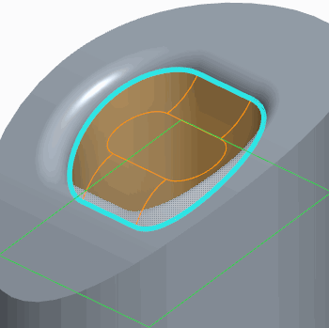

**Figure 2 – Fit a Mid-Plane Loop Type**

The shape of this surface is based on the loop shape. You can also specify an offset from the references.

* Fit a mid-plane automatically – The system creates a planar surface at the midpoint of the selected loop references, normal to the pull direction.

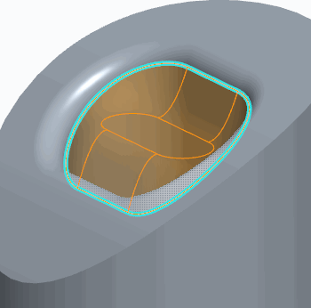

* Fit a mid-surface – The system creates a planar surface at the midpoint of the selected

loop references. The surface is created through the selected surface. The selected surface does not need to be planar. You can specify an offset from the references.

* Extend to plane – The system extends the selected loop reference edges up to the selected planar surface and caps the end.
* Extend to surface – The system extends the selected loop reference edges up to the selected surface and caps the end. The capped end shape takes on that of the selected surface, which does not need to be planar.

1. **Creating Shut Offs**

You must fill any loops in the reference model with a surface that acts as the parting surface for the given loop. You can use the **Shut Off**  to fill both open and closed holes in the reference model.To create the shut off, you must specify the following:

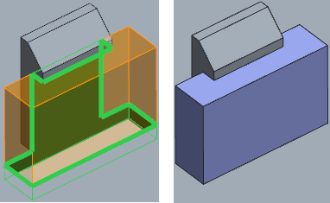

**Figure 1 – Creating a Shut Off**

* Reference Surfaces – Specifies the surfaces that define the perimeter of the loops you wish to close.
* Shut Off Loops – Enables you to select the edges of the specified reference surfaces that define the desired loop.

### **Closing All Internal Loops**

You can select the Close all internal loops check box to automatically fill all closed holes within the selected reference surfaces.

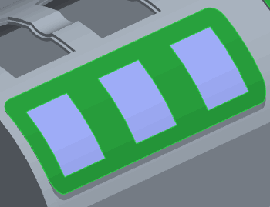

**Figure 2 – Closing All Internal Loops**

When this option is selected, it is not necessary to select the shut off loop edges. If desired, you can also exclude individual holes from the shut off operation.

### **Capping Open Loops**

The Shut Off tool enables you to also fill open loops in the reference model by specifying a cap surface. The cap surface closes the open loop so that it can be filled with the parting surface.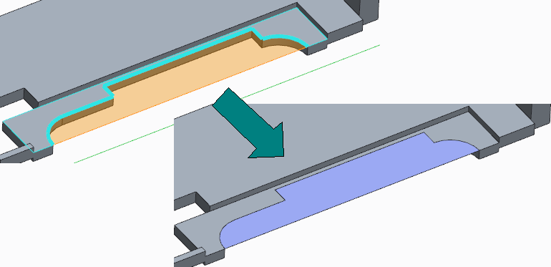

The specified cap surface(s) must pass through the ends of the open loop. If a surface is not available, you can create a datum plane to define the cap surface.

# Exercise: Creating Parting Surfaces Manually

**Before you begin**

To avoid naming conflicts, it is recommended you save your work, click **File** > **Close** until no models display, then click **File** > **Manage Session** > **Erase Not Displayed**.

Click **File** > **Manage Session** > **Set Working Directory** and navigate to the **PTCU\CreoParametric3\Mold\Mouse_Parting-Surface** folder and click **OK**

Click **File** > **Open** and double-click **MOUSE_MOLD.ASM**.

#### Objectives

* Create parting surfaces by extending curves.
* Create parting surfaces using the Fill feature.
* Create parting surfaces using basic surface creation tools.
* Modify surfaces using various editing tools.

#### Scenario

In this exercise, you use manual surface creation techniques to create parting surfaces in the mouse mold model.

#### 1. Task 1. Create the first parting surface.

1. Disable all Datum Display types.
2. Click **Parting Surface** from the Parting Surface & Mold Volume group.
3. Rename the parting surface feature by doing the following:

* Click **Properties Properties ** from the Controls group.
* Type **MAIN** as the Name of the parting surface and press ENTER.

1. Copy the top three rounded surfaces of the mouse mold by doing the following:

* Right-click to query and select the MOUSE_REF.PRT model in the graphics window.

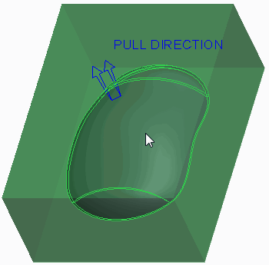

1. Select the top surface, press CTRL, and query-select the two remaining surfaces, as shown.

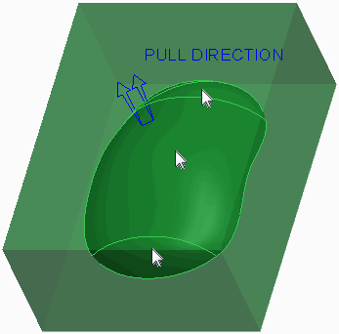

1. Press CTRL+C and press CTRL+V.
2. Click **Complete Feature** .Complete Feature 
3. Click in the graphics window to de-select all features.
4. Extend the edges of the reference model by doing the following:

* Click **Extend Curve** from the Surfacing group.
* Press CTRL and select the four edges of the reference model.
* Notice the angled edges between the four surfaces in the preview.

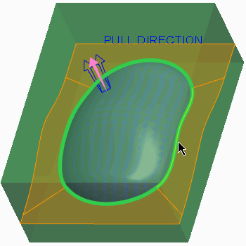

1. In the dashboard, select the **References** tab.
2. Notice that the Boundary Reference is the workpiece.

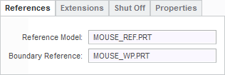

**Figure 4**

1. In the dashboard, select the **Extensions** tab.
2. Select **Perpendicular to boundary** as the extension type.
3. Notice that the edges of the four surface extensions are now perpendicular to the workpiece (boundary reference) surfaces.

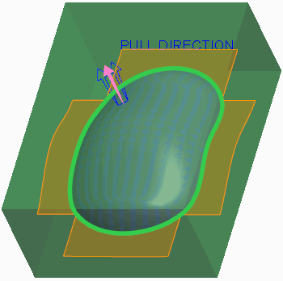

1. In the dashboard, select the 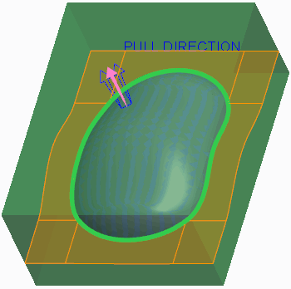**Create Transitions** check box.
2. Click **Complete Feature** .Complete Feature 
3. Click in the background to de-select all geometry.
4. In the model tree, right-click MOUSE_WP.PRT and select **Hide Hide **.
5. From the In Graphics toolbar, select **No Hidden** from the Display Style types drop- down menu.
6. Notice that the two surfaces are not joined to each other.

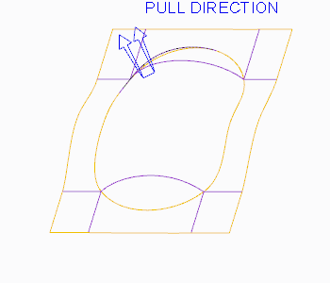

**Figure 7**

1. Select the rounded quilt from the three copied surfaces.
2. Press CTRL and select the quilt created from the extended curves.
3. Click **Merge Merge ** from the Editing group.
4. Click **Complete Feature** .Complete Feature 

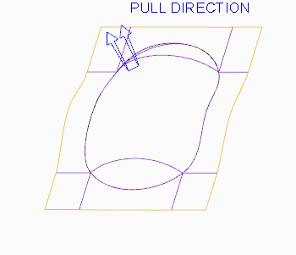

**Figure 8**

1. Select **Shading** from the Display Style types drop-down menu.Shading 
2. Click **OK** from the Controls group.OK 

#### 2. Task 2. Create the second parting surface.

1. In the model tree, select **Copy 1**, right-click, and select **Hide Hide **.
2. Orient to the 3D view orientation.
3. Click **Parting Surface Parting Surface **.
4. Rename the parting surface feature by doing the following:

* Click in the graphics window.
* Right-click and select **Properties**.
* Type **INSERT** as the Name of the parting surface and press ENTER.

1. Copy the three rounded surfaces on the underside of the mouse mold by doing the following:

* Select the MOUSE_REF.PRT model in the graphics window.

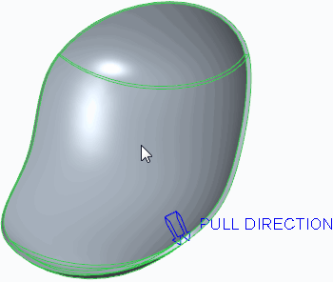

1. Select the top surface, press CTRL, and query-select the two remaining surfaces, as shown.

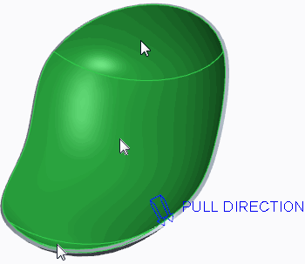

1. Press CTRL+C and press CTRL+V.
2. Click **Complete Feature** .Complete Feature 
3. Click in the graphics window to de-select all features.
4. Extend the edges of the reference model by doing the following:Extend Curve 

* Click **Extend Curve** .
* Press CTRL and select the four inner edges of the reference model.

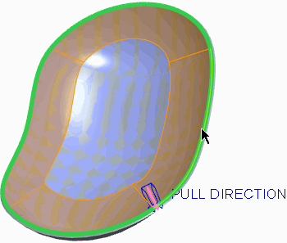

1. In the dashboard, select **Parallel to the Pull Direction** from the Direction drop-down list.

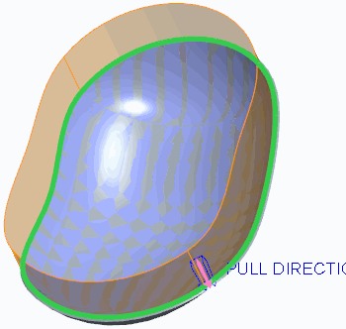

1. Click **Complete Feature** .Complete Feature 
2. Select the rounded quilt from the three copied surfaces.
3. Press CTRL and select the quilt created from the extended curves.
4. Click **Merge Merge ** from the Editing group.
5. Click **Complete Feature** .Complete Feature 

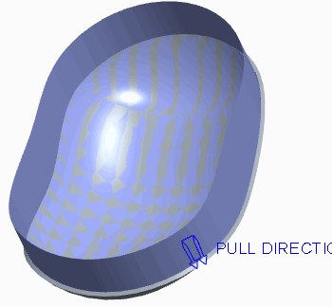

1. Right-click MOUSE_WP.PRT and select **Unhide**.
2. Click in the background to de-select all geometry.
3. Click **Fill Fill ** from the Surfacing group.Datum Plane 
4. Click **Datum** from the dashboard and click **Plane** .
5. As oriented, select the top workpiece surface.
6. Drag the datum plane down and edit the Translation value to **25.4**.

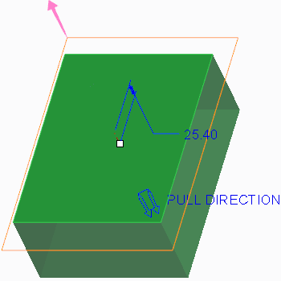

1. Click **OK**.
2. Click **Resume Feature Resume Feature ** from the dashboard.
3. Enable only the following Sketcher Display types: .Project 
4. Click **Project** from the Sketching group.
5. Select all four top edges of the workpiece.

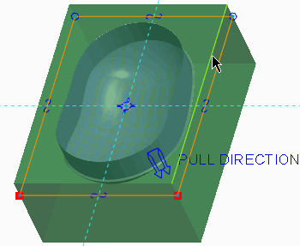

1. Click **OK** .OK 

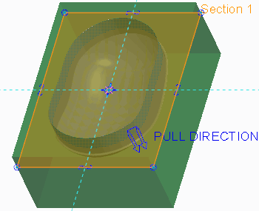

1. Click **Complete Feature**
2. In the model tree, press CTRL and select **Merge 2** and **Fill 1**.
3. Click **Merge** .
4. Click **Complete Feature** .Complete Feature 

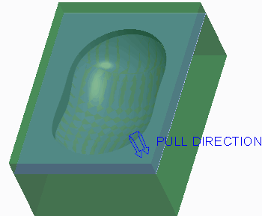

#### 3. Task 3. Create an extruded surface.

1. Click **Extrude**  from the Shapes group.
2. As oriented, select the top work-piece surface as the sketching plane.

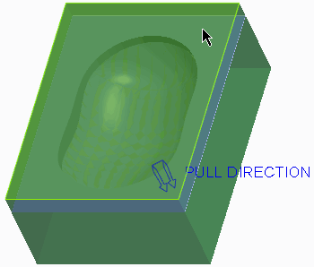

**Figure 18**

1. Select **Center Rectangle** from the Rectangle types drop-down menu in the Sketching group.
2. Sketch the rectangle so that its center is located on the coordinate system reference.
3. Click **One-by-One**  from the Operations group.
4. Edit the rectangle width to **190.5** and the rectangle height to **254**.

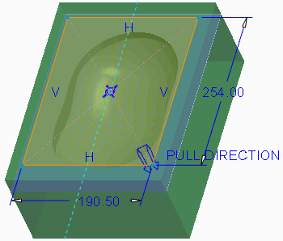

1. Click **OK**
2. Right-click the depth handle and select **To Selected**.
3. Select the fill surface as the depth reference.

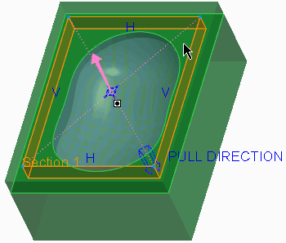

1. Click **Complete Feature**
2. Click in the graphics window to de-select all features.
3. In the model tree, press CTRL and select **Merge 3** and **Extrude 1**.
4. Click **Merge**.
5. Click **Complete Feature**.

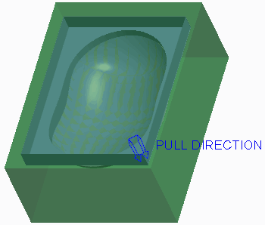

1. Click **OK** from the Controls group.OK 
2. Orient to the **Standard Orientation**.

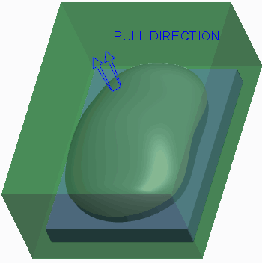

1. In the model tree, right-click **Copy 1** and select **Unhide**



1. Click **Save**  from the Quick Access toolbar.
2. Click **File > Manage Session > Erase Current**, click **Select Al** , and click **OK** to erase the model from memory.Select All 

**This completes the exercise.**

**8. SPLITTING MOLD VOLUMES**

#### Module Overview:

After the necessary mold volumes and parting surfaces have been created, you must split the work piece and mold volumes at the parting surface into the final core, cavity, and slider volumes, as well as any other volumes that are to become mold components in the final mold. In this module, you learn how to split the work-piece and mold volumes, as well as how to blank and unblank mold items in the mold model.

#### Objectives:

After completing this module, you will be able to:

* Split the workpiece.
* Split mold volumes.
* Split volumes using multiple parting surfaces.
* Blank and unblank mold items.
* Use split classification to generate resulting mold volumes.

## Splitting the Work-piece

You can split or divide the work-piece with the All Wrkpcs split option by using a parting surface or a mold volume. When the work-piece split is performed, Creo Parametric calculates the total volume of the work-piece and creates a mold volume from it. The system then subtracts, or trims, the reference model geometry and any mold features such as gates, runners, and sprues from the work piece volume and creates a Refpart Cutout feature in the model tree (this Refpart Cutout feature displays in the model tree differently than a reference part cutout operation that is performed on a mold volume).The remaining mold volume is then split at the specified parting surface or mold volume.

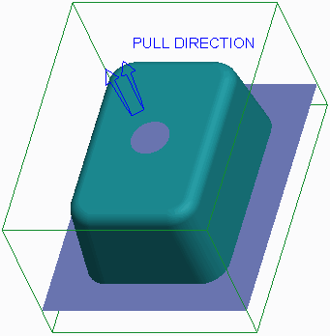

The system trims the amount of workpiece volume to one side of the parting surface or mold volume and turns that volume into its own mold volume. If applicable, the system also trims the amount of workpiece volume on the other side of the parting surface or mold volume and turns that volume into its own mold volume. A simple mold model containing only a core and cavity is a typical example. One of the mold volumes becomes the core, and the other the cavity.

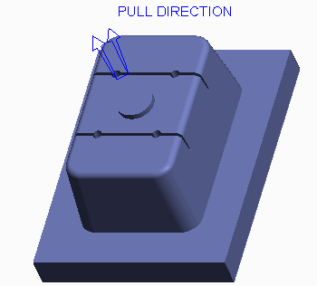

**Figure 2 – Split Mold Model Core Volume**

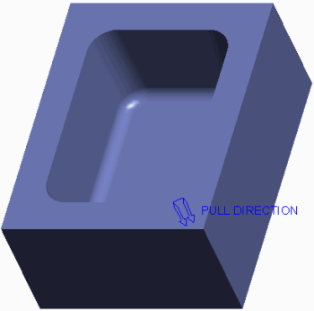

**Figure 3 – Split Mold Model Cavity Volume**

### One Volume or Two?

For each split operation you must determine how many resultant mold volumes are to be created by specifying one of the following options :

* Two Volumes — Splits the work-piece into two mold volumes.
* One Volume — Splits the work-piece into a single mold volume, discarding the other portion. You must specify which portion you want included in the mold volume. You can do this using the Island List. The Island List enables you to select which portion to include in the new volume. When you cursor over an island in the list, the corresponding geometry highlights blue in the graphics window. Regardless of how many volumes are created, the system prompts you to name each one. You can determine the volume to be created by shading it. The system hides all the other volumes at this time, and creates a mold volume with the name you specify.

### **Work-piece Splitting Guidelines**

Consider the following guidelines when splitting the work-piece:

* A split operation in a mold model using the All Wrkpcs option is typically only performed one time.
* Splitting a work-piece does not modify its geometry. Whenever a work-piece is split, the system copies the volume occupied by the work-piece and creates a mold volume from it.
* If you split a work-piece by a parting surface, the system modifies the existing volume. That is, a volume is split and either one or two volumes are created in place of the original volume.
* Splitting the work-piece with parting surfaces ensures that these solid mold components add up to the desired volume, with no extra or missing pieces.
* If you split the work-piece by a parting surface, the parting surface must completely intersect the work-piece.
* If you split a work-piece by another volume, the original volumes are not modified. Rather, the original volumes are copied and then split. For example, if you use the Mold Volume, Two Volumes option and split mold volume A using mold volume B, there will be a total of four mold volumes after the split: original volumes A and B, and new volumes C and

D. One of the new mold volumes C or D will be identical to the splitting mold volume B. As a result, you should use the One Volume option when splitting by a mold volume. This way, when you split mold volume A with mold volume B, you end up with a total of three mold volumes: original volumes A and B, and new volume C. New volume C is equivalent to volume A minus volume B. Using the One Volume option avoids redundant volumes and keeps the number of mold volume features down in the model tree.

* Name all resultant mold volumes appropriately, as this will help you determine which mold volumes to create solid mold components from later on. For example, if the mold volume will become the core mold component, name it “core_vol”.

1. **Splitting Mold Volumes**

You can split an existing mold volume in a mold model using the Mold Volume split option. This option is only available if the workpiece has already been split, or if you have sketched a mold volume slider, insert, or lifter, for example. Unlike the All Wrkpces option, when a mold volume is split, the system does not create a reference part cutout in the model tree.

When you specify the Mold Volume option, the system uses the Search Tool to perform a search for all quilts (mold volumes) in the mold model. You must specify the desired quilt (mold volume) to be split from the list of results found. You should not modify the parameters of the Search Tool to obtain different results.

A mold model containing sliders, inserts, or lifters needs to undergo multiple split operations because multiple mold components will be created from the mold model.

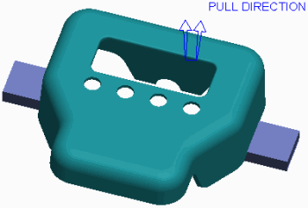

**Figure 1 – Mold Model and Slider Volumes**

### One Volume or Two?

For each split operation you must determine how many resultant mold volumes are to be created by specifying one of the following options:

* Two Volumes — Splits the mold volume into two mold volumes.
* One Volume — Splits the mold volume into a single mold volume, “discarding” the other portion. You must specify which portion you want included in the mold volume. This is done using the Island List. The Island List enables you to select which portion is to be included in the new volume. When you hover over an island in the list, the corresponding geometry highlights blue in the graphics window.

Regardless of how many volumes are created, the system prompts you to name each one. You can determine the volume to be created by shading it. The system hides all the other volumes at this time, and creates a mold volume with the name you specify.

### **Creating Intermediate Mold Volumes**

Depending on the mold model and its complexity, not every mold volume created will be used to create a final solid mold component. It may be necessary to create “intermediate”, or temporary mold volumes during splitting operations. For example, if you split the workpiece into the core and cavity volumes, but the core volume must further be split to remove a slider volume, you create an intermediate core volume.

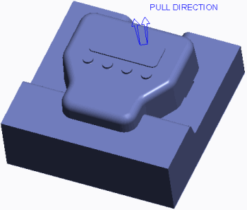

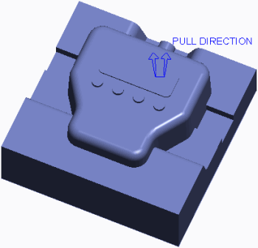

### **Mold Volume Splitting Guidelines**

Consider the following guidelines when splitting mold volumes:

* When you split a volume by a parting surface, the volume is split at the parting surface and either one or two volumes are created in place of the original volume.
* When you split a volume by another volume, the original volumes are not modified. Rather, the original volumes are copied and then split. For example, if you use the Mold Volume, Two Volumes option and split mold volume A using mold volume B, there will be a total of four mold volumes after the split: original volumes A and B, and new volumes C and D. One of the new mold volumes C or D will be identical to the splitting mold volume B. As a result, you should use the One Volume option when splitting by a mold volume. This way, when you split mold volume A with mold volume B, you end up with a total of three mold volumes: original volumes A and B, and new volume C. New volume C is equivalent to volume A minus volume B. Using the One Volume option avoids redundant volumes and keeps the number of mold volume features down in the model tree.
* When you split the mold volume by a parting surface, the parting surface must completely intersect the mold volume.
* Name all resultant mold volumes appropriately, as this will help you determine which mold volumes to create solid mold components from later on. For example, if a mold volume is used as an intermediate mold volume, name it “temp_mold_vol1”, or something similar so you know later on that it will not be used to create a solid mold component.

# Splitting Mold Volumes

**Before you begin**

To avoid naming conflicts, it is recommended you save your work, click **File** > **Close** until no models display, then click **File** > **Manage Session** > **Erase Not Displayed**.

Click **File** > **Manage Session** > **Set Working Directory** and navigate to the **PTCU\CreoParametric3\Mold\Split-Volumes** folder and click **OK**

Click **File** > **Open** and double-click **SPLIT-VOLUMES.ASM**.

#### 1. Task 1. Split the workpiece and mold volumes of a mold model.

* Disable all Datum Display types.
* Select the SPLIT-VOLUMES_WRK.PRT.
* In the ribbon, select the **View** tab.
* Click the Model Display group drop-down menu and select **Component Display Style > Wireframe**.
* Select the **Mold** tab.
* 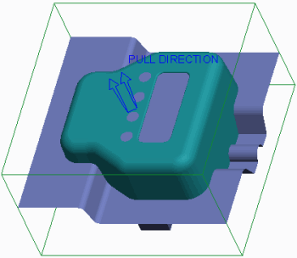Notice the skirt parting surface and the two slider mold volumes in the graphics window and model tree.
* Select **Volume Split** from the Mold Volume types drop-down list in the Parting Surface & Mold Volume group.
* Click **Two Volumes > All Wrkpcs > Done** from the menu manager.
* Notice that the workpiece has been filled with a mold volume.
* Select the parting surface from the graphics window and click **OK** from the Select dialog box.

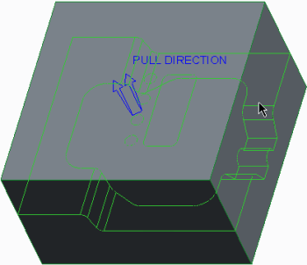

* Click **OK** from the Split dialog box.
* Click **Wireframe** from the In Graphics toolbar.

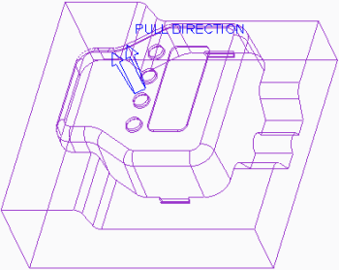

* Notice that the volume will be the core of the mold, but that it has not taken the slider volumes into account.
* In the Properties dialog box type **TEMP-CORE_VOL1** and press ENTER.
* In the Properties dialog box, click **Shade**.
* Spin the model and notice that this volume will be the cavity of the mold.

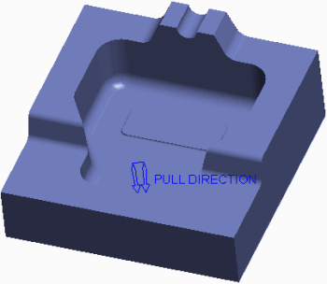

* In the Properties dialog box, type **CAVITY_VOL** and press ENTER.
* Orient to the **Standard Orientation**.
* In the model tree, right-click SPLIT ID 7286 [CAVITY_VOL-MOLD VOLUME] and select **Hide** .
* Click **Volume Split** and click **One Volume > Mold Volume > Done** from the menu manager.
* In the Search Tool dialog box, select the TEMP-CORE_VOL1 quilt and click **Add Item**
* Click **Close**.
* Query-select the front slider volume and click **OK** from the Select dialog box.

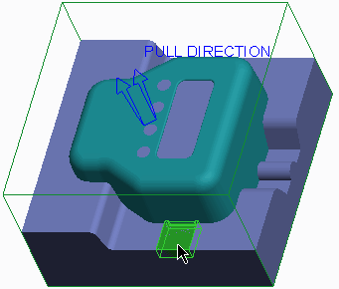

* In the menu manager, select the **Island 1** check box and click **Done Sel**.

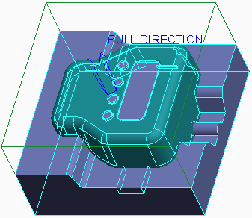

* Click **OK** from the Split dialog box.
* In the Properties dialog box, click **Shade** and notice the slider volume has been trimmed from the temporary core volume.
* Type **TEMP-CORE_VOL2** and press ENTER.

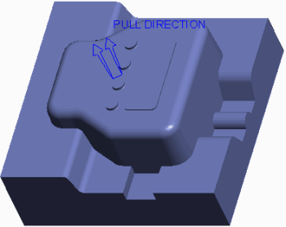

* Click **Volume Split** and click **One Volume > Mold Volume > Done**.
* In the Search Tool dialog box, select the TEMP-CORE_VOL2 quilt and click **Add Item**
* Click **Close**.
* Query-select the rear slider volume and click **OK** from the Select dialog box.

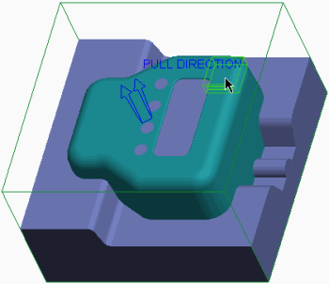

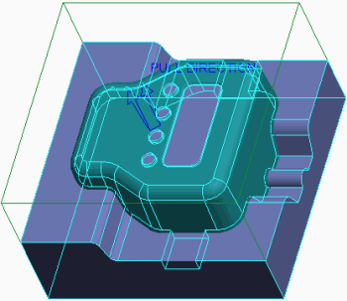

* Click **OK** from the Split dialog box.
* In the Properties dialog box, click **Shade** and notice that the slider volume has been trimmed from the final core volume.
* Type **CORE_VOL** and press ENTER.

1. **Splitting Volumes using Multiple Parting Surfaces**

You can use multiple parting surfaces to split volumes in two different ways:

* You can use multiple parting surfaces to split a work-piece or mold volume into multiple mold volumes. You can use one parting surface for one split operation, and specify a different parting surface for a second split operation.

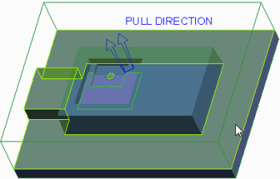

Of course you must also specify the workpiece or mold volume to split and the names of the first and, if applicable, second volumes.

* Sometimes the shape of the reference model and the parting surfaces created require that you specify more than one parting surface during a single split operation. In these circumstances, you can press CTRL in order to select multiple parting surfaces. You can also select multiple mold volumes to split a workpiece or mold volume in a split operation.

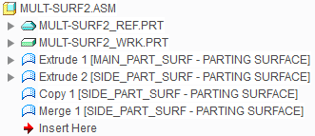

**Figure 1 – Model Tree Containing Two Parting Surfaces**

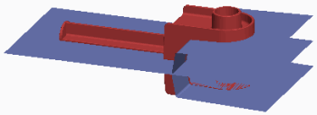

**Figure 3 – Viewing Multiple Parting Surfaces**

1. **Blanking and Unblanking Mold Items**

You can blank and unblank mold items at any time during your work in Mold mode. Blank and unblank functionality is similar to hide and unhide functionality. However, unlike the hide-unhide functionality, you do not have to save the blank-unblank status. It is retained for you automatically. Additionally, when a mold item is comprised of multiple features, such as a manually created parting surface, you can blank or unblank the entire parting surface in one operation, rather than having to hide or unhide individual features.

The following items can be blanked and unblanked:

* **Parting surface Parting surface ** — Enables you to blank/unblank any parting surface in the mold model.
* **Volume Volume ** — Enables you to blank/unblank any mold volume, such as sliders, cores, and cavities.
* **Component** — Enables you to blank/unblank the reference model, workpiece, or any other mold component.Component 

You can blank and unblank mold items using the following methods:

* Click **Mold Display** , in the View tab, to access the Blank and Unblank dialog box. You can also press CTRL+B to access the dialog box. The Filter Tree in the dialog box enables you to see only the mold item types you want to blank or unblank. You can filter by parting surfaces, volumes, or components. If you click **Parting surface Parting surface **, for example, you will see only the parting surfaces available for selection in the dialog box. When a Component filter option is activated, a series of check boxes becomes available, enabling you to further filter the components displayed in the Blank-Unblank dialog box. The following component items can further be filtered:
* Work-piece
* Ref Model
* Mold Component
* Mold Base Comp
* Gen Assembly
* Molding

The Blank and Unblank dialog box contains a Blank and Unblank tab. Items listed in the Blank tab are those that are visible in the graphics window but available for blanking. If you select an item and click Blank, the item is moved to the Unblank tab of the dialog box. Similarly, the Unblank tab displays all items that are blanked in the graphics windo

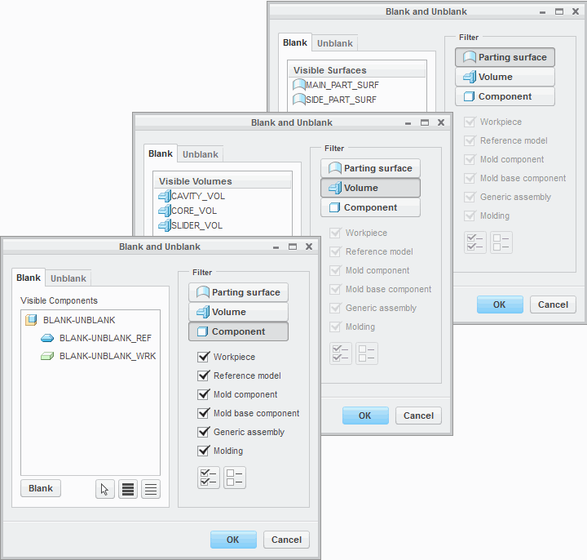

**Figure 1 – Blank and Unblank Dialog Boxes**

* Select items from the model tree, then right-click and select Blank or Unblank. If the mold item is comprised of numerous features, which can occur for a mold volume or manually created parting surfaces, you must select the first feature to blank or unblank the item. The Blank and Unblank menu selection is only available for the first feature of the mold item.
* Select items from the graphics window, then right-click and select Blank or Unblank.

### **Blanking and Unblanking Requirements**

Consider the following blanking and unblanking criteria for items in a mold model:

* When splitting the workpiece or mold volume, the parting surface or mold volume used to do the splitting must be unblanked.
* In order to split the workpiece, it must be unblanked. If the workpiece is blanked, the All Wrkpcs split option is grayed out in the menu manager.

1. **Analyzing Split Classification**

When you split a volume, depending upon the shape of the work-piece, the shape of the reference model, and the shape of the parting surface, the split may create several individual closed volumes. When you create a split using the Two Volumes option, each of these volumes must end up as part of one volume or the other. Similarly, when you create a split using the One Volume option, each of these volumes must end up as part of the new volume, or left to remain in the old volume. Each one of these individual closed volumes occupies an island of space within the mold model. You must specify which islands of space should belong together, or be included, in the resultant mold volume. The process of determining which islands should be included in the resultant mold volume is called *classifying*.Each of the islands displays in the menu manager Island List. When you hover over a given island in the menu manager, its corresponding volume of space highlights in blue in the graphics window, as shown in Figure 2.

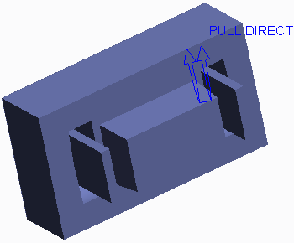

**Figure 3 – Resultant Mold Volume**

Each of the islands you select from the Island List are included together to comprise the resultant mold volume. The islands that are not selected either end up in the other mold volume (in the case of a Two Volumes split) or discarded (in the case of a One Volume split).A One Volume split always creates a situation where you must classify the islands to be included in the resultant volume. The reason for this is that regardless of whether you split by a parting surface or by another volume, you must specify which side of the split you want to be included in the resultant volume. You also must classify islands when you specify multiple parting surfaces or mold volumes when splitting a volume. Classifying islands in a mold model enables you to create simpler manual parting surfaces. In Figure 1, a flat parting surface was used to create the slider mold volume shown in Figure 3.

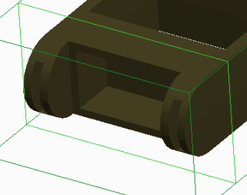

**Figure 1 – Viewing Reference Part Geometry**

This was done by classifying the islands properly, as shown in Figure 2.

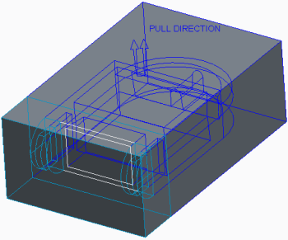

**Figure 2 – Classifying Islands**

Rather than creating a flat parting surface, you can create a parting surface which completely conforms to the interior of all the cuts in the reference model. You can then split the workpiece using this more complex parting surface and not have to classify islands. The parting surface would look like this:

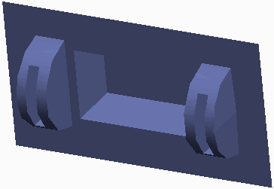

# Exercise: Splitting the Shower Head Mold

**Before you begin**

To avoid naming conflicts, it is recommended you save your work, click **File** > **Close** until no models display, then click **File** > **Manage Session** > **Erase Not Displayed**.

Click **File** > **Manage Session** > **Set Working Directory** and navigate to the **PTCU\CreoParametric3\Mold\Shower-Head_Split** folder and click **OK**

Click **File** > **Open** and double-click **SHOWER_HEAD_MOLD.ASM**.

#### Objectives

* Split the workpiece and split mold volumes.

#### Scenario

In this exercise you split the shower head mold model workpiece, and further split the mold volumes to account for the slider and insert volumes.

#### 1. Task 1. Split the workpiece.

* Disable all Datum Display types.
* Select **Volume Split** from the Mold Volume types drop-down menu in the Parting Surface & Mold Volume group.
* In the menu manager, click **One Volume > All Wrkpcs > Done**.
* Select the plug volume from the graphics window and click **OK** from the Select dialog box.

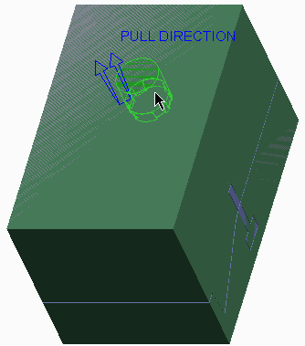

* In the menu manager, select the **Island 1** check box and click **Done Sel**.

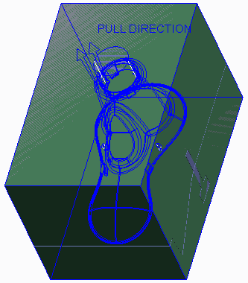

* Click **OK** from the Split dialog box.
* In the Properties dialog box, click **Shade**.
* Type **TEMP-MOLD_VOL1** and press ENTER.

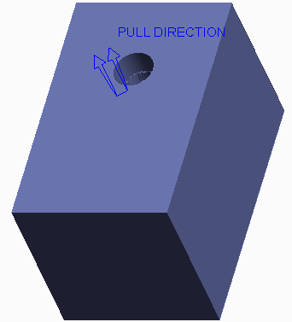

* Select SHOWER_HEAD_MOLD_WRK.PRT, right-click, and select **Blank**.
* 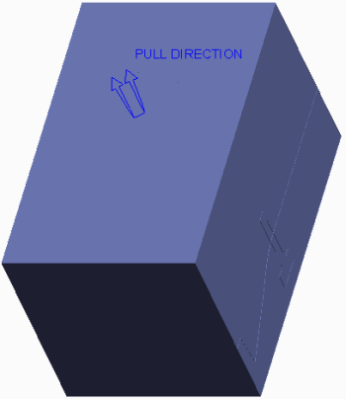

#### 2. Task 2. Split the remaining mold volumes.

* Click **Volume Split**
* In the menu manager, click **One Volume > Mold Volume > Done**.
* In the Search Tool, select TEMP-MOLD_VOL1 as the volume to split and click **Add Item** .Add Item 
* Click **Close**.
* Press CTRL and query-select the SLIDER_LEFT_TAB and SLIDER_RIGHT_TAB mold volumes.

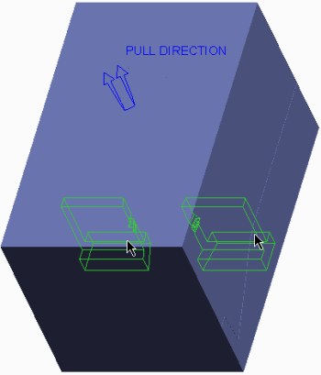

* Click **OK** from the Select dialog box.
* In the menu manager, select the **Island 1** check box and click **Done Sel**.

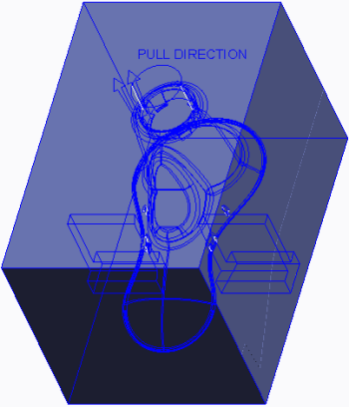

* Click **OK** from the Split dialog box.
* In the Properties dialog box, click **Shade**.
* Type **TEMP-MOLD_VOL2** and press ENTER.

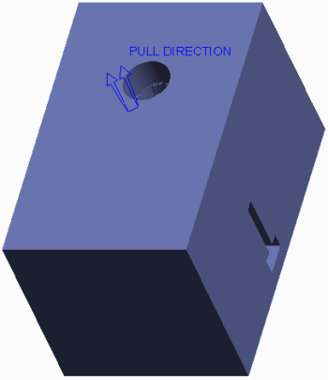

* Click **Volume Split**
* In the menu manager, click **Two Volumes > Mold Volume > Done**.
* In the Search Tool, select TEMP-MOLD_VOL2 as the volume to split and click **Add Item** .Add Item 
* Click **Close**.
* Query-select the skirt parting surface and click **OK** from the Select dialog box.

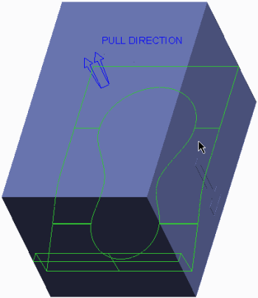

* Click **OK** from the Split dialog box.
* In the Properties dialog box, click **Shade**.
* Type **CORE_VOL** and press ENTER.

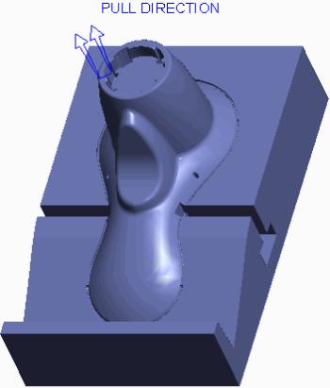

* In the Properties dialog box, click **Shade**.
* Spin the model to inspect it.

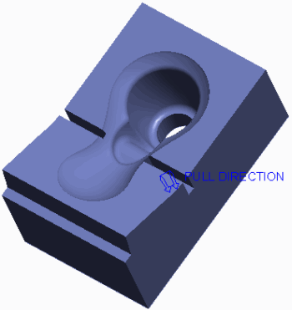

* In the Properties dialog box, type **CAVITY_VOL** and press ENTER.
* Orient to the **Standard Orientation**.
* Press CTRL+B to access the Blank-Unblank dialog box.
* In the Blank and Unblank dialog box, select the **Blank** tab.
* Select **Parting surface Parting surface ** as the Filter.
* Select PART_SURF_1 and click **Blank**.
* Select **Volume Volume ** as the Filter.
* Select TEMP-MOLD_VOL1 and click **Blank**.
* Select **Component** as the Filter.Component 
* Select SHOWER_HEAD_MOLD_REF and click **Blank**.
* Click **OK**.

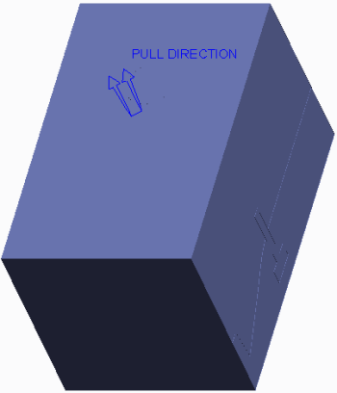

* Click **No Hidden**  and inspect the mold model.

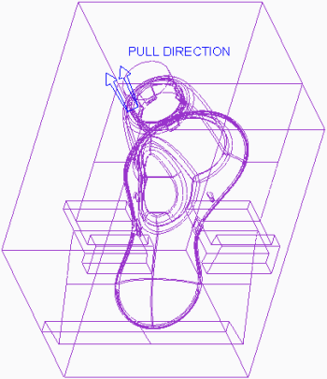

* Click **Shading** .
* Click **Save**  from the Quick Access toolbar.
* Click **File > Manage Session > Erase Current**, then click **Select All** and **OK** to erase the model from memory.Select All 

**This completes the exercise.**

# Exercise: Splitting the Mouse Mold

**Before you begin**

To avoid naming conflicts, it is recommended you save your work, click **File** > **Close** until no models display, then click **File** > **Manage Session** > **Erase Not Displayed**.

Click **File** > **Manage Session** > **Set Working Directory** and navigate to the **PTCU\CreoParametric3\Mold\Mouse_Split** folder and click **OK**

3. Click **File** > **Open** and double-click **MOUSE_MOLD.ASM**.

#### Objectives

* Split the work-piece and split mold volumes.

#### Scenario

In this exercise, you split the mouse mold model work-piece, and further split the mold volumes to account for the core insert volume.

#### 1. Task 1. Split the workpiece.

* Disable all Datum Display types.
* Select **Volume Split** from the Mold Volume types drop-down menu in the Parting Surface & Mold Volume group.
* In the menu manager, click **Two Volumes > All Wrkpcs > Done**.
* Select the main parting surface from the graphics window and click **OK** from the Select dialog box.

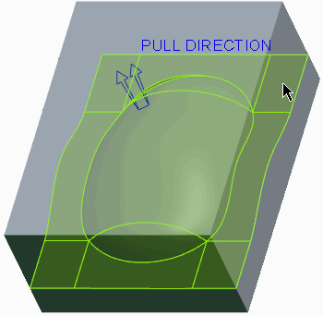

* Click **OK** from the Split dialog box.
* In the Properties dialog box, click **Shade**.
* Type **TEMP-MOUSE_CORE_VOL** and press ENTER.

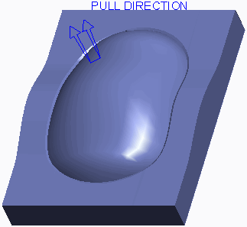

* In the Properties dialog box, click **Shade**.
* Spin the model and inspect the mold volume.

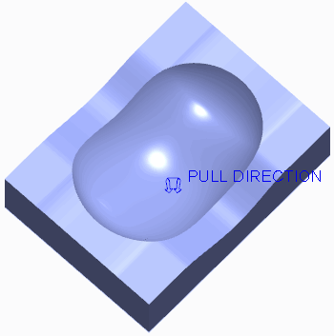

* In the Properties dialog box, type **MOUSE_CAVITY_VOL** and press ENTER.
* Orient to the **Standard Orientation**.
* Select MOUSE_WP.PRT, right-click, and select **Blank**.

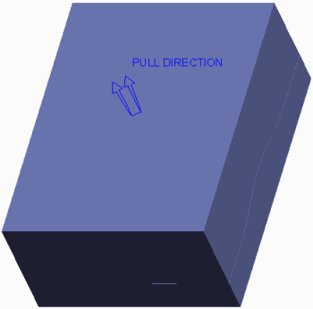

#### 2. Task 2. Split the core into mold volumes. .

* Click **Volume Split**
* In the menu manager, click **Two Volumes > Mold Volume > Done**.
* In the Search Tool, select TEMP-MOUSE_CORE_VOL as the volume to split and click **Add Item**
* Click **Close**.
* Query-select the insert parting surface.

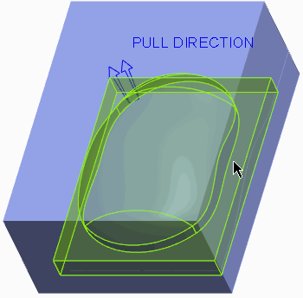

* Click **OK** from the Select dialog box.
* Click **OK** from the Split dialog box.
* In the Properties dialog box, click **Shade**.
* Type **MOUSE_CORE_INSERT_VOL** and press ENTER.

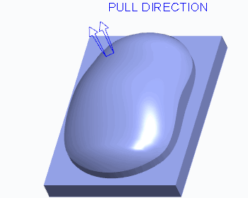

* In the Properties dialog box, click **Shade**.
* Type **MOUSE_CORE_OUTER_VOL** and press ENTER.

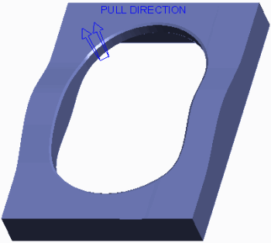

#### 3. Task 3. Blank mold model items.

#### 1.Press CTRL+B to access the Blank and Unblank dialog box.

* In the Blank and Unblank dialog box, select the **Blank** tab.
* Select **Parting surface Parting surface ** as the Filter.
* Select the MAIN parting surface and click **Blank**.
* Select **Component** as the Filter.Component 
* Select MOUSE_REF and click **Blank**.
* Click **OK**.

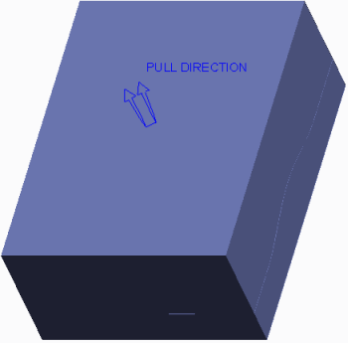

* Click **No Hidden**  and inspect the mold model.

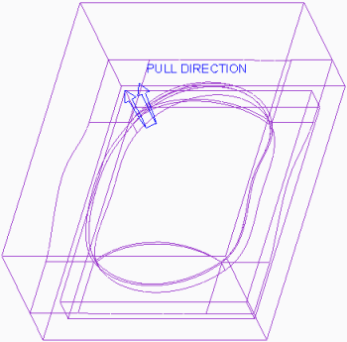

* Click **Shading** .
* Click **Save**  from the Quick Access toolbar.
* Click **File > Manage Session > Erase Current**, then click **Select All** and **OK** to erase the model from memory.Select All 

**This completes the exercise.**

**9. MOLD COMPONENT EXTRACTION**

#### Module Overview:

Once the proper mold volumes have been created and split, you can now create the mold components. You create mold components by filling the mold volumes with material. This process is called extracting, and it automatically converts the mold volumes into fully functional solid parts.In this module, you learn how to extract the final solid mold components from mold volumes.

#### Objectives:

After completing this module, you will be able to:

* Extract mold components from mold volumes.
* Apply start models to mold components.

## Extracting Mold Components from Volumes

Once the mold volumes are created and the workpiece and mold volumes are split, you can create the final mold components. You can produce mold components by filling the previously defined mold volumes with solid material. This process, performed using the **Cavity insert**  option, is called *extracting*. Extracted parts can be core and cavity pieces as well as sliders, inserts, core pins, and so on.

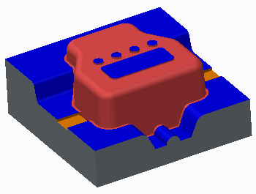

**Figure 1 – Extracted Core Mold Component**

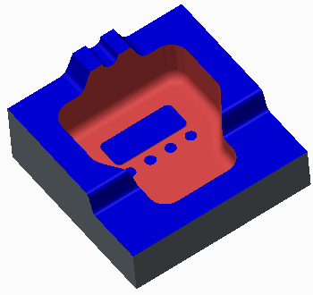

**Figure 2 – Extracted Cavity Mold Component**

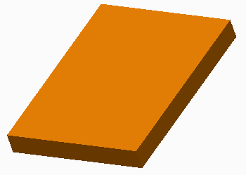

**Figure 3 – Extracted Slider Mold Component**

The system does not automatically create mold components from every mold volume found in the mold model. Recall that you may have created temporary mold volumes during the split process to create your desired mold volumes. Consequently, you must specify which mold volumes will be extracted into mold components. When the mold components are extracted and created, the corresponding mold volumes are automatically blanked from the graphics window. The extracted mold components are created in the mold model, and each component contains an *Extract* feature that contains the solid geometry. The extract feature cannot be redefined, but these components are fully functional parts. You can retrieve them in Part mode, and add new features to them. To save the extracted mold components, you must save the mold model before erasing it from memory or exiting your current Creo Parametric session. By default, the extracted mold components are named the same as the volumes from which they were extracted.Extracted mold components maintain a parent/child relationship with their mold volumes. Therefore, the mold components automatically update when changes are made to the mold volumes. While the mold volumes are assembly features in the mold model, the mold components are assembly components in the mold model.

### **Color-Coding of Extracted Mold Components**

By default, the extracted mold components are created in the default Creo Parametric gray color. However, the surfaces of the extracted mold components may also display in three other potential colors:

* Reference model color – The mold components’ surfaces that touch the reference model are color-coded the same as the reference model. In the figures, the reference model color is red.
* Blue – Steel-to-steel contact between tooling component shutoffs.
* Orange – Steel-to-steel contact between slider mold component surfaces and mold plates, cores, or cavities. It is important to note that only the slider mold volumes created by calculating undercut boundaries, become orange when the mold components are extracted. Sketched sliders and other components have blue surfaces at their steel-to- steel contact points.

1. **Applying Start Models to Mold Components**

You can apply an existing start model template to components when extracting them from mold volumes in the mold model. This is done in the Advanced section of the Create Mold Component dialog box. As a best practice, you should create extracted mold components using a start model template. Using a start model template when extracting mold components provides you with the following benefits.

* Datums – Includes a set of default datum planes and a default coordinate system
* Layers
* Parameters
* View Orientations

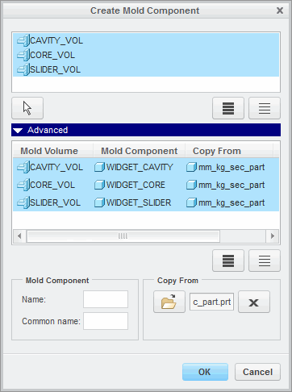

**Figure 2 – Renaming Mold Components and Applying Start Model**

These are the same benefits that you gain from using a start model template when creating new part models.

### **Renaming Mold Components**

By default, extracted mold components are named the same as the mold volume from which they are extracted. You can rename the mold component name in the Advanced section of the Create Mold Component dialog box.

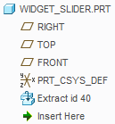

**Figure 1 – Extracted Mold Component Model Tree**

This section displays the specified mold volumes that you extract. In one column the mold volume name is displayed, and in another column the corresponding mold component name is displayed. As a best practice you should rename the mold components with names that are unique to the mold and to the type of component being extracted. For example, a mold volume named cavity_vol should have its corresponding mold component renamed to widget_cavity, or it should be renamed according to your company's standards. Extracted mold components are not volumes, so the “vol” suffix should be removed. Also, mold components are part models. Therefore, each part model should be given a unique name.

# Exercise1: Extracting Shower Head Mold Components

To avoid naming conflicts, it is recommended you save your work, click **File** > **Close** until no models display, then click **File** > **Manage Session** > **Erase Not Displayed**.

Click **File** > **Manage Session** > **Set Working Directory** and navigate to the **PTCU\CreoParametric3\Mold\Shower-Head_Extract** folder and click **OK**

Click **File** > **Open** and double-click **SHOWER_HEAD_MOLD.ASM**.

#### Objectives

* Extract solid mold components from mold volumes.

#### Scenario

In this exercise, you extract the solid mold components for the shower head mold.

#### 1. Task 1. Extract the mold components.

1. Disable all Datum Display types.
2. Select **Cavity insert**  from the Mold Component types drop-down menu in the Components group.Select All 

|  |  |  |
| --- | --- | --- |
| 3. | In the Create Mold Component dialog box, click **Select All** | . |
| ▪  ▪ | Press CTRL and click TEMP-MOLD_VOL1 to de-select it.  Click **Advanced** to expand it. |  |

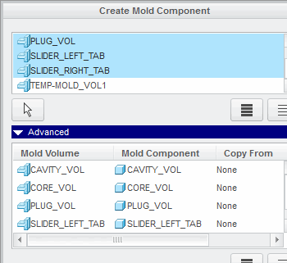

1. In the Advanced section of the Create Mold Component dialog box, select mold volume CAVITY_VOL.

* Edit the Mold Component Name to **CAVITY** and press ENTER.
* Select mold volume CORE_VOL.
* Edit the Mold Component Name to **CORE** and press ENTER.
* Select mold volume PLUG_VOL.
* Edit the Mold Component Name to **PLUG** and press ENTER.

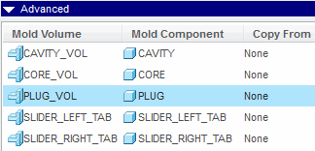

**Figure 2**

1. In the Advanced section of the Create Mold Component dialog box, click **Select All**.Select All 

* Click **Copy From Copy From **.
* In the Choose template dialog box, double-click MM_KG_SEC_PART.PRT.
* Click **OK**.

1. Notice the five newly created mold components in the model tree.

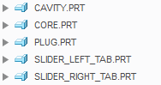

1. In the model tree, right-click CORE.PRT and select **Open**.
2. Notice the Extract feature in the model tree.
3. Spin the CORE.PRT and inspect it.
4. Notice the surfaces that are blue.
5. Notice the surfaces that are reference model color.

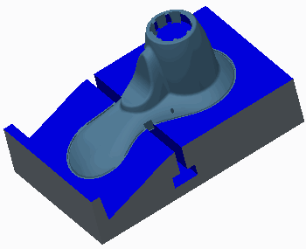

1. Click **Close** from the Quick Access toolbar to return to the mold model.
2. In the model tree, right-click CAVITY.PRT and select **Open**
3. Again, notice the Extract feature in the model tree.
4. Spin the CAVITY.PRT and inspect it.
5. Again, notice the surfaces that are blue.
6. Again, notice the surfaces that are reference model color.

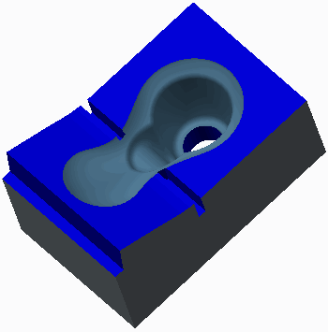

1. Click **Close** to return to the mold model.
2. Click **Save**  from the Quick Access toolbar.
3. Click **File > Manage Session > Erase Current**, then click **Select All** and **OK** to erase the model from memory.

# Exercise2:Extracting Mouse Mold Components

**Before you begin**

To avoid naming conflicts, it is recommended you save your work, click **File** > **Close** until no models display, then click **File** > **Manage Session** > **Erase Not Displayed**.

Click **File** > **Manage Session** > **Set Working Directory** and navigate to the **PTCU\CreoParametric3\Mold\Mouse_Extract** folder and click **OK**

Click **File** > **Open** and double-click **MOUSE_MOLD.ASM**.

#### Objectives

* Extract solid mold components from mold volumes.

#### Scenario

In this exercise, you extract the solid mold components for the mouse mold.

#### 1. Task 1. Extract the mold components.

1. Disable all Datum Display types.
2. Select **Cavity insert**  from the Mold Component types drop-down menu in the Components group.
3. In the Create Mold Component dialog box, click **Select All**

* Click **Advanced** to expand it.

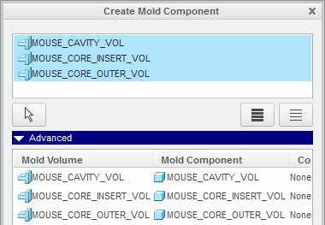

1. In the Advanced section of the Create Mold Component dialog box, select mold volume MOUSE_CAVITY_VOL.

* Edit the Mold Component Name to **MOUSE_CAVITY** and press ENTER.
* Select mold volume MOUSE_CORE_INSERT_VOL.
* Edit the Mold Component Name to **MOUSE_CORE_INSERT** and press ENTER.
* Select mold volume MOUSE_CORE_OUTER_VOL.
* Edit the Mold Component Name to **MOUSE_CORE_OUTER** and press ENTER.

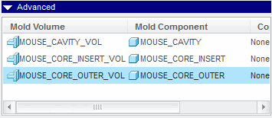

**Figure 2**

1. In the Advanced section of the Create Mold Component dialog box, click **Select All**

* Click **Copy From Copy From **.
* In the Choose template dialog box, double-click MM_KG_SEC_PART.PRT.
* Click **OK**.

1. Notice the three newly created mold components in the model tree.

Graphic

**Figure 3**

1. In the model tree, right-click MOUSE_CORE_INSERT.PRT and select **Open**
2. Notice the Extract feature in the model tree.
3. Notice the surfaces that are blue.
4. Notice the surfaces that are reference model color.

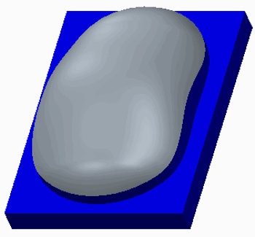

1. Click **Close** from the Quick Access toolbar to return to the mold model.
2. In the model tree, right-click MOUSE_CAVITY.PRT and select **Open** .
3. Again, notice the Extract feature in the model tree.
4. Spin the MOUSE_CAVITY.PRT and inspect it.
5. Again, notice the surfaces that are blue.
6. Again, notice the surfaces that are reference model color.

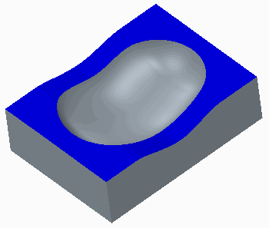

1. Click **Close** to return to the mold model.
2. Click **Save**  from the Quick Access toolbar.
3. Click **File > Manage Session > Erase Current**, then click **Select All** and **OK** to erase the model from memory.

**10. FILLING AND OPENING THE MOLD**

#### Module Overview:

In this module, you learn how to create the mold result (also known as the molding) after extracting mold components. You create the molding by simulating the filling of the mold cavity with molten material through mold features such as sprues, runners, and gates. You can then simulate the mold opening process in order to check the correctness of your design. Draft and interference checks can be performed to verify proper mold opening.

#### Objectives:

After completing this module, you will be able to:

* Create a molding.
* Simulate the mold opening sequence.
* Check draft on mold components during the opening of the mold.
* Check interference on mold components during the opening of the mold.
* View mold information.

## Creating a Molding

When a mold is filled, molten plastic is injected into the sprue, and it then travels through the runners and gates to fill the mold cavity. The solidified result is known as the *molding*. There can be only one molding part in the model at a time.

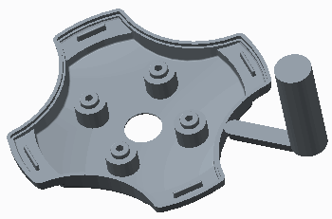

**Figure 1 – Molding Part**

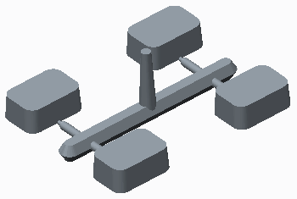

**Figure 2 – Another Molding Part**

Creo Parametric enables you to simulate the filling of the mold cavity and generate the molding. In addition to the mold cavity, the sprues, runners, and gates are also filled to generate the final molding. The molding part is created by using the following molding formula:

* Molding = sum of all current workpiece geometry - assembly level cuts that intersect the workpiece (waterlines, for example) - all extracted parts (sliders and cores, for example) - ejector pin clearance holes

The molding part is created in the mold model, and it contains a single *Molding* feature that contains the solid geometry.

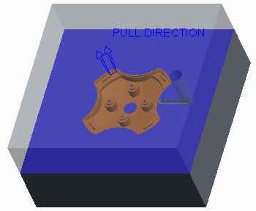

**Figure 3 – Mold Model**

The molding feature cannot be redefined, but the part is a fully functional part. You can retrieve it in Part mode and perform various operations on the molding part such as removing excess material using Pro/NC, calculating mass properties, and also generating a mesh for flow analysis. To save the molding part, you must save the mold model before erasing it from memory or exiting your current Creo Parametric session.

The molding part maintains a parent/child relationship with the mold components and assembly level features. Therefore, the molding automatically updates when changes are made to the mold components or assembly level features. For example, if the sprue diameter is increased, the molding part automatically updates to reflect the larger diameter.

1. **Opening the Mold**

You can simulate the mold opening process to determine whether your final design matches your original design intent. The mold opening process is a series of steps, containing one or more moves. You can specify moves for any component, or member, of the mold model except the reference model and the work piece. It is convenient to blank the reference model, work piece, and all mold volumes, as well as the parting lines and surfaces before opening the mold.

In order to simulate the mold opening process, you must define the following:

* Define Move — An instruction to move one or more members of the mold model. When defining a move, you must specify the following items:
* The members to be moved.
* The direction reference of the movement. You can select a linear edge, axis, or plane to indicate the direction. When the direction reference is specified, an arrow indicates the positive direction.
* The offset value. The members move the amount specified in the direction of the reference specified. The members move parallel to the edge or axis, or normal to the plane. You can specify a positive offset value or a negative offset value to move the member in the opposite direction.
* Define Step — A collection of defined moves for opening the mold.

You can also perform the following operations on the mold opening simulation:

* Delete — Enables you to delete an existing step.
* Delete All — Enables you to delete all existing steps.
* Modify — Enables you to modify an existing step by adding or deleting moves from the step.
* Modify Dim — Enables you to modify the offset value of a given move. You must regenerate the mold model in order for the new value to take effect.
* Reorder — Enables you to switch the order of existing steps. You can specify the step you want reordered, then select the step that you want it to become.
* Explode — Enables you to simulate the mold opening by stepping through the sequence, in order, one step at a time. Members included in the moves of the step are translated according to the specified offsets. You can continue to step through all the steps in the sequence. A message in the message window indicates when all components in the mold model have been successfully exploded. You can also animate the entire opening sequence.

### **Rules for Defining a Move**

You must remember the following rules when defining moves:

* Each step may contain several moves that are performed simultaneously.
* A member can be included in only one move per step.
* A move may contain several members, but they are all offset in the same direction and by the same value.

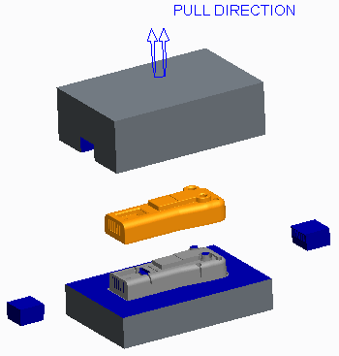

**Figure 1 – Fully Opened Mold**

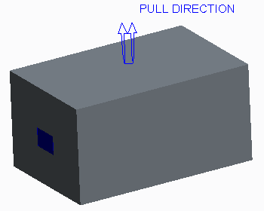

**Figure 2 – Closed Mold**

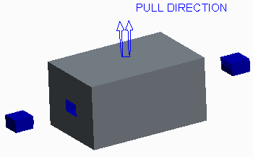

**Figure 3 – Partially Open Mold**

1. **Draft Checking a Mold Opening Step**

You can perform draft checking on mold components during the mold opening sequence.

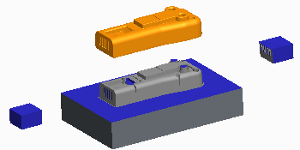

**Figure 1 – Opened Mold**

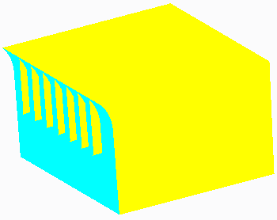

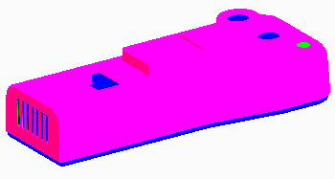

**Figure 3 – Draft Check on the Molding**

You can use draft checking to determine whether the mold components have the correct surfaces drafted and suitable draft angles in order to facilitate the mold opening process.In order to perform a draft check, you must first specify on which step of the opening sequence you want to perform the draft check. You must also specify the following items to perform a draft check during the mold opening sequence:

* Pull Dir – Specifies the pull direction to be used for the draft check. You can specify the pull direction using either of the following methods:
* Specify – Enables you to select a pull direction. You can filter the pull direction reference by plane, coordinate system, curve, edge, or axis and specify the proper reference. You can also flip the pull direction to the opposite side of the reference.
* Move Num – Enables you to specify a pull direction reference by specifying a move number in the step.
* Draft Angle – Enables you to specify the desired draft angle to check.
* One Side/Both Sides – Enables you to specify whether the draft check is performed on one or both sides of the direction reference.
* Full Color/Three Color – Enables you to specify whether the display is shown using the full color spectrum or with three colors.
* Part or surface to check for drafting – Once you have specified the pull direction and draft angle, you must specify a part to check for drafting or a surface to check for drafting.

1. **Interference Checking a Mold Opening Step**

Creo Parametric enables you to check moving parts for interference with a static part for each move you define. After you have defined a move, you must select a static part to check for interference with the current part that you have defined for the move. Areas that are interfering either have their curves highlighted, as shown in Figure 1 or, if interference curves cannot be found, the resulting interference is highlighted by a red point, as shown in Figure 2.

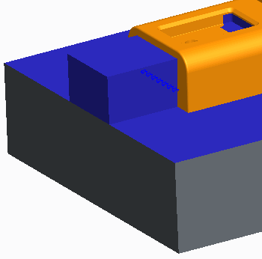

**Figure 1 – Interference Curves**

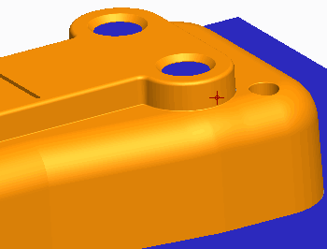

**Figure 2 – Interference Point**

You can delete the move and try another method of opening the mold to prevent the interference of parts. You may have to redefine your mold components.

1. **Viewing Mold Information**

You can view information about your mold model any time you are in Mold mode by clicking the Analysis group drop-down menu and selecting **Mold** . You can view the following types of information about the mold:

* BOM – Displays a bill of materials of all components found in the mold model.
* Components – Displays information on all the components in the mold model, including reference models, workpiece, extracted components, and the molding.
* Cavity layouts – Displays information on all cavity layouts. You can view the coordinate system references used for placement of the cavity, the layout type, the number of cavities in respective directions, the names and locations of each cavity, and the overall workpiece size.
* Split volumes – Displays all volumes created in the mold model as a result of split operations. You can view the mold volume name, its display status in the mold model, and its feature ID.

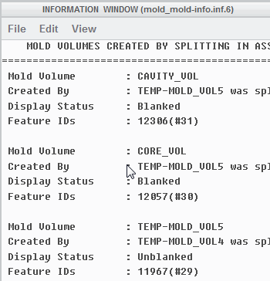

**Figure 2 – Viewing Split Volumes Information**

* Created volumes – Displays information on all sketched mold volumes in the mold model. You can view the mold volume name, its display status in the mold model, and its feature ID.

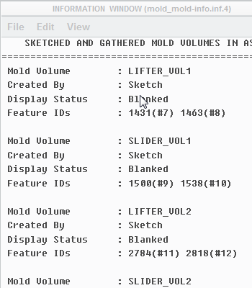

* Parting surface – Displays information on all parting surfaces created in the mold model. You can view the parting surface name, its display status in the mold model, and its feature ID.
* Split – Displays all the split operations performed in the mold model. You can view the parent and child feature ID's of the split, the parting surface used, and the resulting volumes created.
* Last volume – Displays the last created volume in the mold model. You can view the mold volume name, how it was created, its display status in the mold model, and its feature ID.
* Shrinkage – Displays any shrinkage applied to the reference model. If the mold model contains more than one reference model, you must specify for which reference model you want shrinkage information. You can view the coordinate system specified for the shrinkage, the shrinkage formula used, and the shrink factors used.

You can specify whether you want the output displayed in an Information window within Creo Parametric, whether you want it written to a file, or both.

# Excercise1:Opening the Shower Head Mold Model

**Before you begin**

To avoid naming conflicts, it is recommended you save your work, click **File** > **Close** until no models display, then click **File** > **Manage Session** > **Erase Not Displayed**.

Click **File** > **Manage Session** > **Set Working Directory** and navigate to the **PTCU\CreoParametric3\Mold\Shower-Head_Open** folder and click **OK**

Click **File** > **Open** and double-click **SHOWER_HEAD_MOLD.ASM**.

#### Objectives

* Create moldings.
* Define steps and moves to simulate the mold opening process.
* Perform a draft check during the mold opening process.
* Perform an interference check during the mold opening sequence.
* Resolve an interference in the mold component geometry.

#### Scenario

In this exercise, you create the molding and also simulate the mold opening process in the shower head mold model.

#### 1. Task 1. Create the molding.

* Disable all Datum Display types.
* Click **Create Molding Create Molding ** from the Components group.
* Type **Shower_Head_Molding** as the name and press ENTER.
* Press ENTER to accept the Mold Part Common Name.

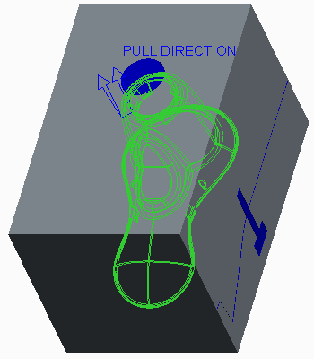

Figure 1

1. Notice that the molding is created.

#### 2. Task 2. Simulate the opening of the mold.

1. Click **Mold Opening Mold Opening ** from the Analysis group to simulate the mold opening process.
2. Click **Define Step > Define Move** from the menu manager.
3. Select PLUG.PRT as the member for the first move.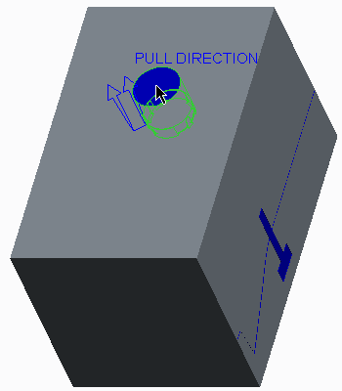
4. Click **OK** in the Select dialog box.
5. Select the left, vertical edge to define the move direction.

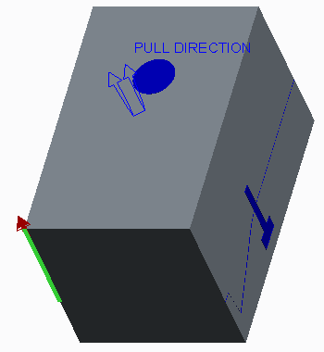

**Figure 3**

Type **320** as the movement value and press ENTER.

1. Click **Define Move** from the menu manager.
2. Select CAVITY.PRT as the member for the second move.

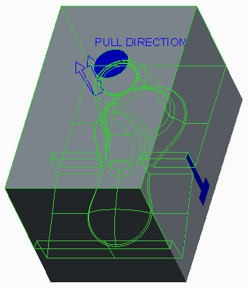

**Figure 4**

1. Click **OK** in the Select dialog box.
2. Select the left, vertical edge to define the move direction.

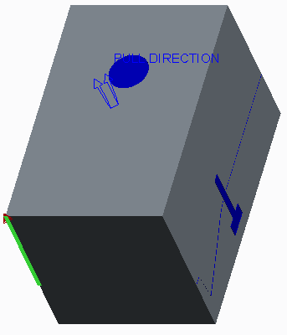

1. Type **230** as the movement value and press ENTER.
2. Click **Done** from the menu manager.

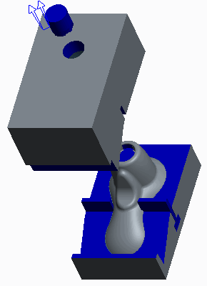

1. Click **Define Step > Define Move** from the menu manager.
2. Select SLIDER_RIGHT_TAB.PRT as the member for the first move.

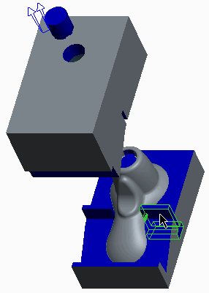

**Figure 7**

1. Click **OK** in the Select dialog box.
2. Select the front, horizontal edge to define the move direction.

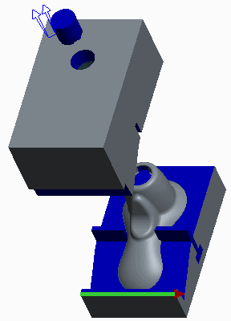

1. Type **130** as the movement value and press ENTER.
2. Click **Define Move** from the menu manager.
3. Select SLIDER_LEFT_TAB.PRT as the member for the second move.

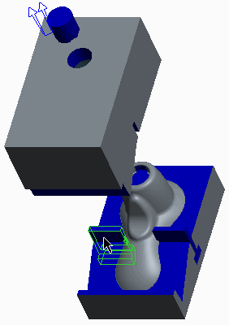

1. Click **OK** in the Select dialog box.
2. Select the front, horizontal edge to define the move direction.

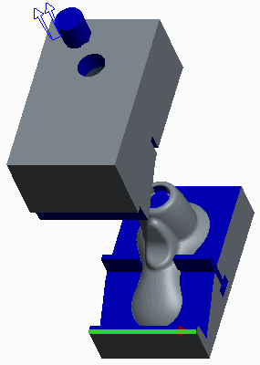

1. Type **-130** as the movement value and press ENTER.
2. Click **Done** from the menu manager.

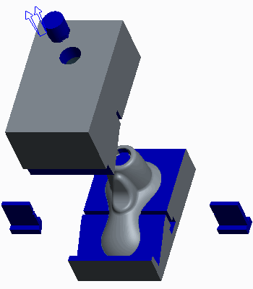

1. Click **Define Step > Define Move**.
2. Select SHOWER_HEAD_MOLDING.PRT as the member for the move.

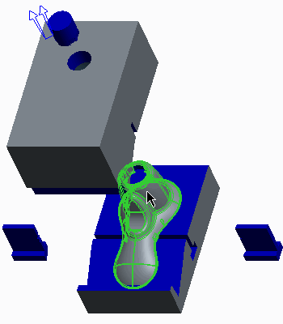

1. Click **OK** in the Select dialog box
2. Select the front, right, vertical edge to define the move direction.

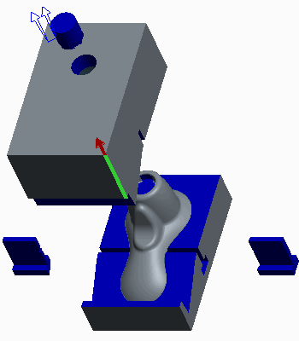

1. Type **100** as the movement value and press ENTER.
2. Click **Done** from the menu manager.
3. Spin the model and observe the mold opening sequence.

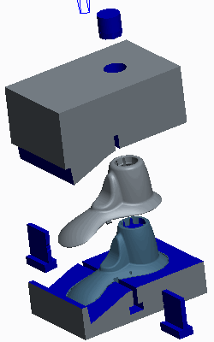

#### 3. Task 3. Perform a draft check on the PLUG.PRT.

1. Orient to the **Standard Orientation**.
2. Click **Modify > Step 1** from the menu manager.
3. Click **Draft Check > Both Sides > Three Color > Done** from the menu manager.
4. Click **Move Num > Move 1** from the menu manager.
5. Type **2** as the draft check angle and press ENTER.
6. Select PLUG.PRT.
7. Notice that in the area of the plug where there is proper negative draft (the cyan color) there is also positive draft (magenta).

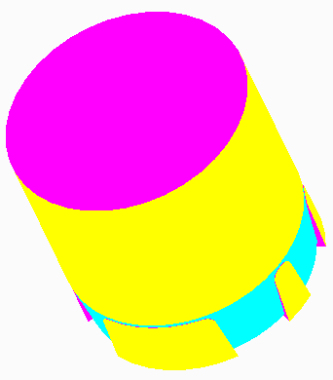

1. Click **Done/Return > Done/Return** from the menu manager.

#### 4. Task 4. Perform an interference check on the PLUG.PRT.

1. Click **Interference > Move 1** from the menu manager.
2. Select SHOWER_HEAD_MOLDING.PRT as the static part.
3. Spin the model and observe the location of the detected interference.

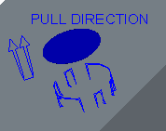

1. Notice that this detected interference is at the same location as the positive draft.
2. Click **Done/Return > Done > Done/Return** from the menu manager.

**5. Task 5. Redefine the PLUG_VOL mold volume to change the PLUG.PRT mold component geometry.**

1. Orient to the **Standard Orientation**.
2. Press CTRL and select SHOWER_HEAD_MOLD_REF.PRT and SHOWER_HEAD_MOLD_WRK.PRT from the model tree.
3. Right-click and select **Unblank**.

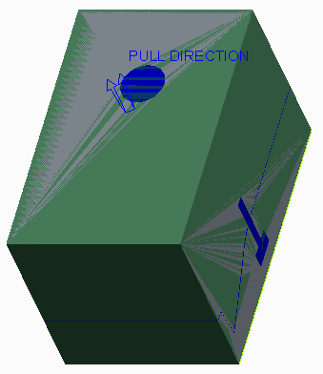

1. In the model tree, edit the definition of **Revolve 1**.
2. In the graphics window, right-click and select **Edit Internal Sketch**.
3. Enable only the following Sketcher Display types: .
4. Click **Sketch View Sketch View ** from the In Graphics toolbar.

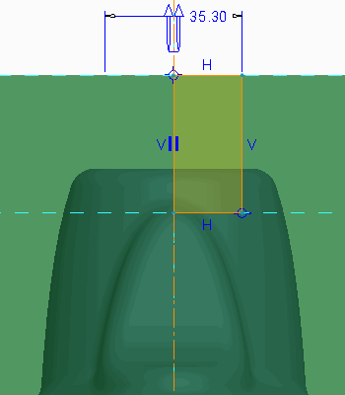

1. Drag a window around the existing sketch and delete it.
2. Click **Centerline Centerline ** from the Datum group and sketch a centerline on the vertical reference.
3. Click **Hidden Line**  from the In Graphics toolbar and zoom in on the top of the sketch.
4. Click **Project** from the Sketching group and select the three edges.

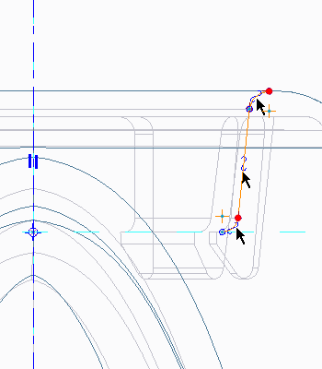

1. Click **Close** from the Type dialog box.
2. Click **Line Chain** from the Sketching group and sketch the four remaining lines.

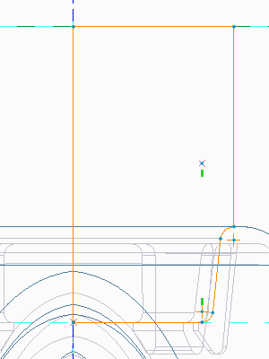

1. Click **Ok**
2. Orient to the **Standard Orientation**.
3. Click **Shading** .

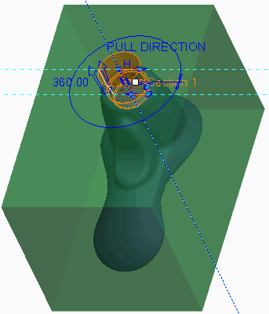

1. Click **Complete Feature**
2. Click **Regenerate**  from the Quick Access toolbar to update the mold model.
3. Press CTRL and select SHOWER_HEAD_MOLD_REF.PRT and SHOWER_HEAD_MOLD_WRK.PRT from the model tree.
4. Right-click and select **Blank**.
5. Right-click PLUG.PRT and select **Open**
6. 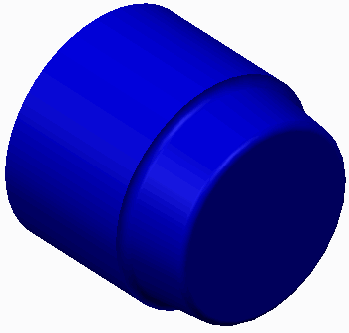Spin the model and notice the difference in geometry.
7. Click **Close** from the Quick Access toolbar to return to the mold model.

#### 6. Task 6. Rerun the interference check in the mold opening sequence.

1. Click **Mold Opening** .
2. Click **Modify > Step 1** from the menu manager.
3. Click **Interference > Move 1** from the menu manager.
4. Select SHOWER_HEAD_MOLDING.PRT as the static part.
5. Notice, in the status bar, that there is no longer any interference detected.
6. Click **Done/Return > Done > Done/Return** from the menu manager.

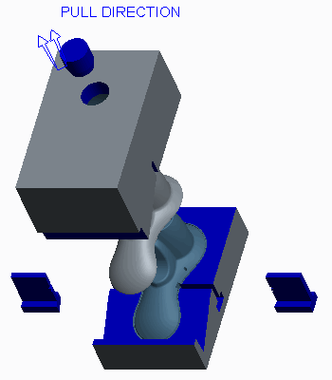

1. Click **Save**  from the Quick Access toolbar.
2. Click **File > Manage Session > Erase Current**, then click **Select All** and **OK** to erase the model from memory.

## 15.INTRODUCTION TO THE CREO PARAMETRIC SHEET-METAL DESIGN PROCESS

##### The typical sheet-metal design process can be summarized by five high-level steps.

* Primary Walls
* Secondary Walls
* Other Sheet-metal Features
* Flat States
* Detail Drawings  **Figure 1 – Primary Walls**

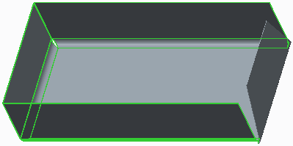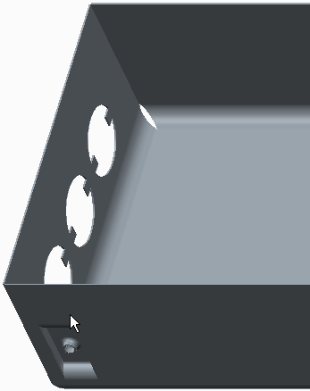

**Figure 2 – Secondary Walls** **Figure 3 – Other Sheet-metal Features**

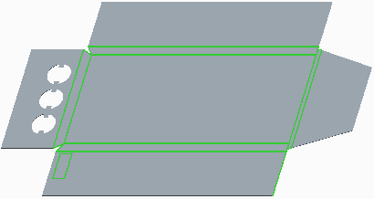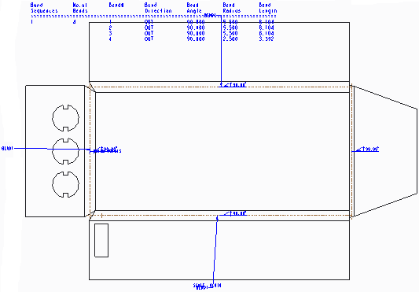

**Figure 4 – Flat States** **Figure 5 – Detail Drawings**

**Creo Parametric Sheet-metal Design Process**

All Creo Parametric sheet-metal designs start with a primary sheet metal wall. There are many different types of primary walls that you can start with, but the most common are the Planar and Extrude walls. In addition to these two types of primary walls, there are other types of primary walls including: Revolve, Blend, Offset, Variable Section Sweep, and Swept Blend. Any of these primary wall types can be used to create the primary wall for your sheet metal model. Creation of the base primary wall requires the same care that you would use when creating the base feature in a regular solid model. The base primary wall is the parent feature to all of the other sheet metal features in your model. As much as is possible, create the primary wall with the correct feature type, orientation, and dimension scheme. Changing them at a later time is possible, but it can be challenging.

#### Secondary Walls

After you have created a primary wall, you can add a number of different types of secondary walls to your sheetmetal model. As the name suggests, these walls are secondary to a primary wall in that they need to reference the edge of an existing wall to be created. You use these walls to continue to populate your model with sheetmetal walls to match your design intent. The types of secondary walls you can create are Flat, Flange, Twist, Extend, and Merge as well as any of the primary wall types.

#### Adding Other Sheetmetal Features

Once you have at least one wall in the model (either a primary wall or a secondary wall) you can begin to use other sheetmetal features to further capture the design intent of your model. These features include bends, unbends, sheetmetal cuts, forms, punches, notches, rips, edge bends, and corner reliefs.

#### Creating Flat States

When nearing completion of your sheetmetal model, you can create a flat state of the sheetmetal model. A flat state is essentially an unbent and flattened blank that can be used to manufacture the part. The most useful aspect of the flat state is that it is created as a family table instance, so you can easily put it in a drawing with the fully formed state.By doing this, you can provide the necessary dimensions for both the flat state and the finished “form” state to manufacture the part in a drawing.

#### Detailing Sheetmetal Models

The final step in the sheetmetal design process is the detailing step. You can make a drawing of any sheetmetal part and detail it as necessary by creating views, dimensions, and notes for both flat and formed states of the same model in the same drawing.Futhermore, you can add a Bend Order table with associative notes if you want to help document the order, sizes, and characteristics of bends used to fabricate the finished model.

## PROCEDURE - Process Exercise

### Objectives

After successfully completing this exercise, you will be able to:

* + Understand the basic process used when modeling sheet-metal designs in Creo Parametric.
  + Create a primary planar wall feature to use as the base feature for a sheet-metal design.
  + Create secondary flat wall and flange wall features.
  + Create notch and form features.
  + Create a flat pattern for a sheet-metal design.
  + Create a drawing to detail both the formed and flat patterns of sheet-metal designs.
  + Create a bend order table and add it to a drawing along with associative notes.
  + Create automatic ordinate dimensions for the flat pattern of a sheet-metal design.

**Step 1:** Create a new Creo Parametric sheet-metal model.

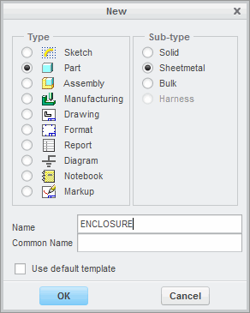

* Click **New ** from the Data group.
* Select **Sheetmetal** as the Sub-type in the New dialog box.
* Type **ENCLOSURE** in the Name field.
* Clear the **Use default template** check box and click **OK**.
* Select the **mmns_part_sheetmetal** template and click **OK** to create the new part.
* Enable only the following Datum Display types: .

**Step 2:** Create a primary planar wall 200 mm x 100 mm x .5 mm thick.

* Click Planar from the Shapes group.
* Select datum plane TOP from the model tree as the sketching plane.
* Right-click and select Corner Rectangle .
* Sketch and dimension a rectangle, as shown.
* Click OK .

1. In the dashboard, type 0.50 in the thickness field and click Complete Feature

|  |
| --- |
| 5. In the radius field, type **2.0** and press ENTER. The model should now appear as shown. |
| 6. Click **Complete Feature** from the dashboard. |

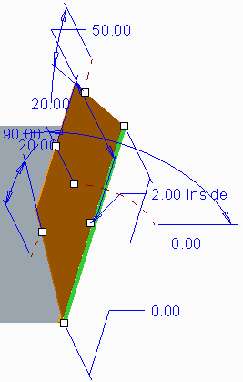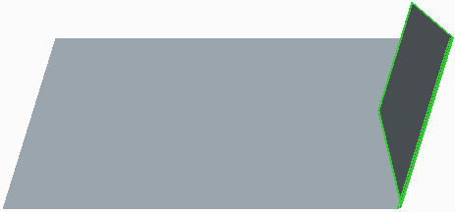**Step 4:** Create a secondary flange wall with an “I” profile.

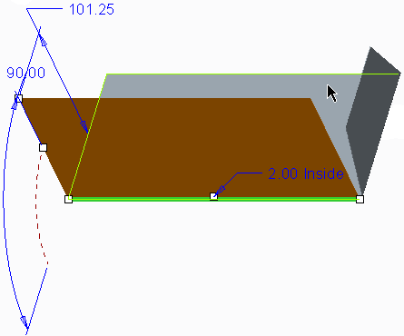

|  |
| --- |
| 1. Click **Flange**  from the Shapes group. 2. Zoom in and select the lower edge on the front of the model as the reference for the flat wall. |
| 3. Press SHIFT and select the surface as shown to select the surface loop.   |  | | --- | | 1. The surface loop appears, as shown. 2. In the dashboard, edit the radius to **5.0** and press ENTER. | | 6. Double-click the wall height dimension, then type **50** and press ENTER. | | 1. Click **Complete Feature** . 2. From the In Graphics toolbar, select **Corner Relief Notes**  and **Bend Notes**  from the Annotation Display types drop-down menu to disable their display. |   **Step 5:** Create points and pattern them to use as references for notch features.   |  | | --- | | 1. Rotate the model approximately as shown in the figure. | | 1. Click the Datum group drop-down menu and select **Point** . 2. Select the surface, as shown. | | 1. Right-click and select **Offset References**. 2. Press CTRL and select datum planes TOP and FRONT from the model tree as the offset references. 3. Double-click the vertical dimension, then type   **20.0** and press ENTER.   1. Double-click the horizontal dimension, then type **25.0** and press ENTER. 2. Click **OK** in the Datum Point dialog box. | |

|  |
| --- |
| 9. Press CTRL+D to orient to the Standard Orientation. |
| 1. With datum point PNT0 still selected, right-click and select **Pattern** . 2. Select the **25** dimension, and press ENTER to accept the default value of 25.00. 3. In the dashboard, type **3** as the number of Pattern members in the first direction, and click **Complete Feature** . |

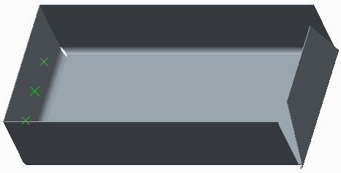**Step 6:** Create three sheetmetal notch features using the points you created in the previous task as references.

|  |
| --- |
| 1. Select **Punch Form** from the Form types drop-down menu in the Engineering group. 2. Click **Open Punch Model**  from the dashboard. 3. Select BOSS_FORM.PRT and click **Open**. |
| |  | | --- | | 1. Enable **Plane Display** . 2. Click **New Constraint** from the Placement tab and select **Coincident**  as the constraint type. 3. Select the FRONT datum plane from the form model and the TOP datum plane from the sheetmetal model and click **Flip**. 4. Click **New Constraint** and select **Distance**   as the constraint type.   1. Select the RIGHT datum plane from the form model and the RIGHT datum plane from the sheetmetal model. 2. Disable **Plane Display**  and **Point Display** . 3. Double-click the offset dimension, type **30**, and press ENTER. |  1. Select the **Options** tab in the dashboard.    * Click in the Excluded punch model surfaces collector.  |  | | --- | | 5. Select the **Placement** tab, select **Coincident** from the Constraint Type drop-down menu, and select the first reference from the form model. | | 6. Select the second reference from the sheetmetal model. |  * + Press CTRL and select the three surfaces, as shown. |

|  |
| --- |
| 14. Click **Complete Feature** . |

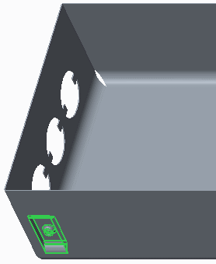**Step 8:** Create a flat pattern of the model to use later in a drawing.

|  |
| --- |
| 1. Select **Flat Pattern**  from the Flat Pattern types drop-down menu in the Bends group. |
| 2. Click **Complete Feature** . |

|  |
| --- |
| 1. In the model tree, right-click **Flat Pattern 1**, and select **Edit Definition** . 2. In the Dashboard, select the **Options** tab and clear the **Flatten forms** check box. 3. Click **Complete Feature** . |

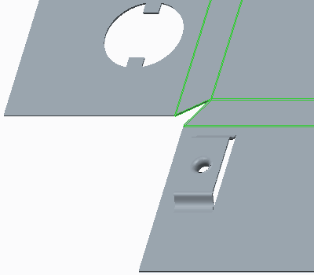

*.*

1. In the model tree, right-click **Flat Pattern 1**, and select **Edit Definition **.
2. In the dashboard, select the **Options** tab and select the **Flatten forms** check box.
3. Click **Complete Feature** .

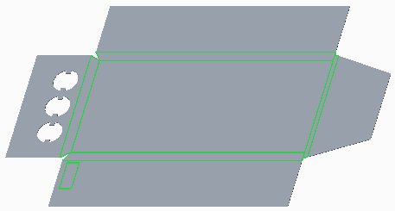

Step 9:Create a bend order table.

|  |
| --- |
| 1. In the model tree, right-click **Flat Pattern 1**, and select **Delete** . 2. Click **OK** in the Delete dialog box. 3. Click the Bends group drop-down menu and select **Bend Order**. |
| 1. When prompted to select a bend to add to the current sequence, select the bend surface on the left end of the model, . 2. Select the next bend surface toward the back of the model, . 3. Select the next bend surface near the front of the model, 4. Select the final bend surface on the right end of the model, |

|  |
| --- |
| 8. Review the finished bend order table. |
| 1. Click **OK** to close the dialog box. 2. Click **Save**  from the Quick Access toolbar and click **OK** to save the model. 3. Click **Close** from the Quick Access toolbar. |

**Step 10:** Begin creating a new drawing to document the formed and flat pattern for the ENCLOSURE.PRT.

|  |
| --- |
| 1. Click **New**  from the Data group. 2. Select **Drawing** as the Type in the dialog box. 3. Type **ENCLOSURE_C_DRW** in the Name field. 4. Click **OK**. 5. The New Drawing dialog box appears. Notice the default template is set to c_drawing.    * Click **Browse** in the Template section of the dialog box.   *.* |
| 1. In the Open dialog box, select PTC_C_DRAWING.DRW and click **Open**. 2. Click **OK** in the New Drawing dialog box to create the drawing. |

|  |
| --- |
| 1. Click **New Sheet** from the Document group. 2. Click **Drawing Models** from the Model Views group. 3. Click **Add Model** from the menu manager. 4. Select ENCLOSURE_FLAT1.PRT in the Open dialog box and click **Open**. |
| 1. Right-click in the drawing background and select **General View** . 2. Select **No Combined State** and click **OK** in the Select Combined State dialog box. 3. Click in the center of the drawing to place the view. 4. In the Drawing View dialog box, select TOP from the Model view names list. 5. Click **Apply**. |
| 1. In the Drawing View dialog box, select the **Scale** category. 2. Select the **Custom scale** option and type **1.75** as the scale value. 3. Click **Apply**. |
| 1. In the Drawing View dialog box, select the **View Display** category. 2. Select **No Hidden** from the Display style drop-down list. 3. Click **OK** to complete the drawing view. |

Step 11:Continue the drawing creation process by adding a second sheet to document the flat pattern of the model.

Step **12:** Add the bend order table, bend notes, and auto ordinate dimensions to the drawing.

|  |
| --- |
| 1. Select the **Annotate** tab. 2. With the view still selected, click **Show Model Annotations**  from the Annotations group. 3. Select the **Datums Tab**  in the Show Model Annotations dialog box. 4. Click **Select All**  to select all of the Datum Axes. |
| 1. Select the **Note Tab** in the Show Model Annotations dialog box.    * Click **Select All** .    * Click **OK**. 2. Click in the drawing background to de-select all geometry. |

|  |
| --- |
| 1. Select **Auto Ordinate Dimension** from the Ordinate Dimension types drop-down menu in the Annotations group. 2. Click and drag a box around all surfaces, as shown. |
| 1. Click **OK** in the Select dialog box. 2. Click **Select Base Line** from the menu manager and select the far left edge of the model's geometry, as shown.    * Note the resulting ordinate dimensions. |
| 11. Click **Select Base Line** and select the bottom-most edge of the model's geometry, as shown. |

12. Click **Done/Return** from the menu manager.

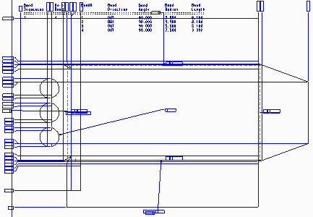

**Step 13:** Save the models and erase them from memory.

1. Click **Regenerate ** from the Quick Access toolbar.
2. Click **Save ** from the Quick Access toolbar and click **OK** to save the model.
3. Click **Close** from the Quick Access toolbar.
4. Click **Erase Not Displayed ** from the Data group.
5. Click **OK** to erase all objects from memory.

This completes the procedure.

## 16.SHEET-METAL MODEL FUNDAMENTALS

Let’s try to understand some fundamental characteristics of the Sheet metal mode in Creo Parametric.

1. **Constant thickness**
2. **Driving and offset sides**
3. **Flat or formed**
4. **Developed length**

Sheet metal Model Fundamentals:

Sheet metal models are solid parametric models that have a constant thickness throughout. Therefore, they do not accurately represent real world models that undergo deep drawing forming operations or other manufacturing processes that involve large amounts of plastic deformation of the material during formation.

Sheet metal models have a driving side and an offset side. When displayed as a wire frame, the driving side of the model is shown in green and the offset (or driven side) is shown in black. The side surfaces of sheet metal models are formed only after the driving and offset surfaces have been regenerated.

Sheet metal models can be displayed in either the formed design state (bent into the final shape used in the design) or the flat pattern (unbent to display the blank of metal needed prior to bending).

 Creo Parametric can accurately calculate the developed length of most bends in a sheet metal model. This enables you to design the model in its formed model. If you unbend it later to form the flat pattern, you can apply the developed length to each of the bends in the model so that an accurate flat model can also be generated for manufacturing.

Best practices:

Because of the general thinness of a sheet metal part, you should select flat surfaces as references when placing a feature. If a flat surface is not applicable, edges are more convenient than side surfaces. When you orient a sheet metal part, the first selection must be a planar surface or a datum plane and the second selection may be an edge. This is contrary to orienting non-sheet metal solid parts (where it is recommended that the second reference be a surface instead of an edge). Edges are often references in sheet metal models.

**Understanding Developed Length**

Creo Parametric can automatically calculate the developed length of most sheet metal bends

Developed Length (Bend Allowance) can be determined by:

• System Equation (Y/K Factor)

• Provided Bend Tables (soft, medium and hard materials)

• User-defined Bend Tables

• Entered Value

Accurate developed length calculations (often referred to as bend allowances) enable you to capture your design intent in the solid model while also developing a precise flattened model that manufacturers can use when developing the actual product. Physical sheet metal parts are often manufactured by taking a flat piece of sheet metal material and bending it into the finished part. This final shape is often referred to as the developed or formed model. When you bend or form a piece of sheet metal, the material on the outside of the neutral bend axis stretches while the material on the inside of the neutral bend axis compresses. The neutral bend axis itself remains the same before and after the bend because it is neither stretched nor compressed. You can account for this material behaviour by establishing appropriate material descriptions and formulae for accurately calculating the bend allowance. It is very helpful to be able to provide the manufacturers of your sheet metal models with the overall dimensions of the flat stock (often referred to as the blank) that they need to begin the manufacturing process. Creo Parametric can create a blank that incorporates the developed lengths of the formed mode into the flat model.

**Calculating Developed length:**

The developed length of a bend depends on the thickness, bend radii, bend angles, and other material properties (principally the hardness of the material). The developed length calculation compensates for stretching in the area of a bend.

The developed length of a bend is determined in Creo Parametric using one of four methods:

• System Equation (default)

• System Equation (default)

• Entered Value

• Provided Bend Tables

• User-defined (Customized) Bend tables

System Default equation:

By default, Creo Parametric uses a default bend formula to calculate the developed length that uses y-factor or k-factor values.

The equation, shown in figure 1, is stated as L = (π/2 x R + y x T) q/90 Where: L = developed length, R = inside radius, T = material thickness, q = bend angle (deflection angle, in °), and y = y-factor.

The y-factors and k-factors are part constants defined by the location of the sheet metal material's neutral bend line, which is largely based on the hardness of the material. The k-factor is a value that expresses a parameterized location of the neutral bend axis. It is calculated as k = d/T. In the figure, you can view that d is the distance away from the inside radius where the neutral bend axis lies. Therefore, a value of k = 0 would indicate that the neutral bend axis is on the innermost surface of the bend, while a value of k = 1 would indicate that the neutral bend axis is located on the outermost surface of the bend.

 Both the k-factors and y-factors increase as the hardness of the material increases. Therefore, harder materials have larger developed lengths than softer materials.

The y-factor is calculated with the equation y = k * π/2. The default value for the y-factor is 0.50

**Entered Values**

Another way to control the developed length of a given bend is to override whatever value is given to the bend (by a bend table or the default equation) with a user supplied value. This approach can be useful when the developed length is known heuristically from some source (such as a manufacturing vendor) and just needs to be incorporated in the model.

## PROCEDURE - Understanding Developed Length

**Task 1:** Examine and modify the developed length of a bend by changing the Y factor

|  |
| --- |
| 1. Disable all Datum Display types. 2. Right-click the **First Wall** feature in the model tree and select **Edit** . |
| 1. Click **File > Prepare > Model Properties**.    * In the Sheet metal section of the Model Properties dialog box, click **change** in the Bend Allowance Y factor row.    * In the Sheet metal Preferences dialog box, type **0.70** for the new Factor value.    * Click **OK** in the Sheet metal Preferences dialog box.    * Close the Model Properties dialog box. |

|  |
| --- |
| 4. Right-click the **First Wall** feature in the model tree and select **Edit** . |

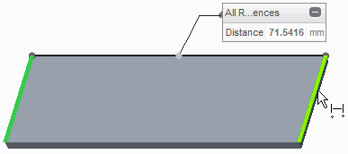**Task 2:** Unbend the model and measure the length of the flat model.

|  |
| --- |
| 1. Select **Unbend** from the Unbend types drop-down menu in the Bends group. 2. Click **Complete Feature** from the dashboard. |
| 1. Select the **Analysis** tab. 2. In the Measure group, select **Distance**  from the Measure types drop-down menu. 3. Press CTRL and select the edges shown for the references. |
| 6. Close the Measure dialog box. |

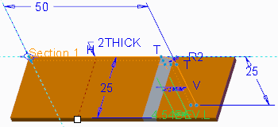**Task 3:** Override the calculated developed length with a user-defined value and measure the length of the flat model again.

|  |
| --- |
| 1. Right-click the **First Wall** feature in the model tree and select **Edit** . 2. Double-click the **4.54 DEV.L** dimension, and type **5.12** as the new value and press ENTER. |
| 1. Select **Distance**  from the Measure types drop-down menu. 2. Press CTRL and select the edges shown. |

|  |
| --- |
| 5. Close the Measure dialog box. |

This completes the procedure.

## PROCEDURE - Creating a New Sheet metal Part in Assembly Mode

**Task 1:** Create and assemble a new sheet metal part in the MACHINE.ASM

|  |
| --- |
| 1. Enable only the following Datum Display types:  . 2. Click **Create**  from the Component group. 3. In the Create Component dialog box, select **Part** as the Type, if necessary, and select **Sheet metal** as the Sub-type. 4. Type **front_enclosure** in the Name field and click **OK**. |
| 5. In the Creation Options dialog box, verify that **Copy from existing** is selected. |

|  |
| --- |
| 1. Click **Browse** and double-click the **templates**   folder.   1. Select PTC_MM_KG_SEC_SHEET.PRT in the Choose template dialog box and click **Open**. 2. Verify that the dialog box appears as shown and click **OK** to create the new sheet metal part. |
| 1. Right-click in the graphics window and select   **Default Constraint**, as shown.   1. Click **Complete Component** to finish assembling the component. |
| 11. Right-click the new FRONT_ENCLOSURE.PRT sheet metal part in the model tree and select **Activate** . |

This completes the procedure.

**Converting Solid Models to Sheet metal**

There are three methods for creating a new sheet metal model. One method is to convert a solid model to a sheet metal model.

You can convert existing solid models to sheet metal models in Creo Parametric. Once you open a solid model, you can click the Operations group drop-down menu and select Convert to Sheet metal. The Sheet metal dashboard displays with the conversion options. For models with constant thickness or thin protrusions, you can select the Driving Surface option and then select the driving surface. If the model does not have constant thickness, you can select the Shell option and specify which surfaces to remove to create a shell model with a constant thickness. Once you complete either of these steps, the FIRST WALL feature is added to the model tree and you gain access to the Sheet metal menus and feature icons. Once you have converted a solid model to a sheet metal model using this technique, you can employ additional sheet metal features to help create a developable part. A developable part is typically defined as a sheet metal model that can display in its flat state and is capable of being manufactured. The most common tool that you use for this task is the Conversion feature, but you can use any sheet metal feature to create a developable part

Activity:

Converting solid models to sheet metal

**Task 1:** Convert a solid model to a sheet metal model.

|  |
| --- |
| 1. Disable all Datum Display types. 2. Examine the features in the model tree. |
| 1. Click the Operations group drop-down menu and select **Convert to Sheet metal**. 2. In the dashboard, click **Shell**  from the First Wall group. |
| 1. Press CTRL and select the two hidden surfaces on the back of the model, as shown in the figure (highlighted in green). 2. Edit the thickness to **1.0** and click **Complete Feature**  from the dashboard. |

**Task 2:** Examine the converted model

|  |
| --- |
| 1. Examine the features in the model tree. |
| 1. Rotate the model to examine the surfaces that have been removed from the back of the model. |

This completes the procedure

## 17.CREATING PRIMARY SHEET METAL WALL FEATURES

In this module, you learn how to create sheet metal wall features

Objectives:

After completing this module you are able to:

1. Primary walls
2. Extruded sheet metal wall features
3. Revolved Sheet metal Features
4. Blend sheet metal wall features
5. Creating offset walls
6. Advanced primary walls

**Creo Parametric Sheet metal wall features**

There are five steps to summarize as follows:

1. Primary walls
2. Secondary walls
3. Other Sheet metal features
4. Flat States
5. Detail drawings

**Primary walls:**

In Creo all Sheet metal parts start with a primary sheet metal wall. There are so many different types of primary walls, Planar and extrude walls are the most commonly used. In addition to these the other types of primary walls are:

Revolve

Blend

Offset

Variable section sweep

Swept blend

You can continue to create primary walls after an initial primary wall has been created, but these walls are created as unattached primary walls and can later be attached to existing sheet metal geometry.

**Secondary walls:**

Secondary wall features need to reference existing Sheet metal geometry**.** Typically, the first step in creating a secondary wall is to select an edge of an existing Sheet metal wall to which you will attach the secondary wall.

Attached vs unattached walls:

Secondary walls are unattached walls, they are attached to the existing wall. However, since primary walls can be created without referencing any other existing sheet metal geometry, it is possible to create more than one primary wall in a sheet metal design.

**Creating Planar Walls:**

Primary planar walls can take any kind of flat shape because it is a closed sketch that defines the extent of the feature

**Activity:**

**Creating Planar walls**

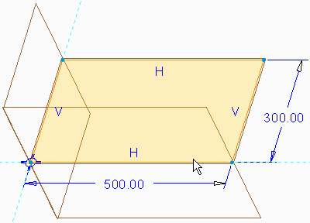**Task 1:** Create a primary planar wall feature.

|  |
| --- |
| 1. Enable only the following Datum Display types: . 2. In the ribbon, click **Planar**  from the Shapes group. 3. Click **References** from the dashboard and click **Define**. 4. Select datum plane TOP as the sketch plane. 5. Verify that the resulting default for the Sketch Orientation reference is the RIGHT datum plane and that the Orientation field is set to **Right**. 6. Click **Sketch** to start Sketcher mode. |
| 1. Select **Corner Rectangle**  from the Rectangle types drop-down menu in the Sketching group and sketch the rectangle. 2. Click **One-by-One**  from the Operations group and edit the dimensions as shown. |

|  |
| --- |
| 1. Click **OK** from the dashboard to complete the sketch. 2. Type **1.50** in the thickness field in the dashboard, as shown. |
| 11. Click **Complete Feature**  This completes the procedure. |

**Extruded sheet metal wall features:**

An extruded walls can be created by taking a sketch you create and extending It normal to the sketch plane. This creates a surface where you can add thickness to the sheet metal inside or outside.

**Revolved Sheet metal Features**

A revolved wall is created by revolving the sketch through an axis. Then you can add thickness inside and outside to the revolved sheet metal.

**Blend sheet metal wall features**

Multiple sections can join together to create a blend primary wall feature. You can create a blended wall by creating two or more pre-existing sketches together. And the sketches shouldn’t have to be parallel to each other.

**Creating offset walls**

An offset walls can be created by specifying an existing surface, and the direction and distance you wish to offset. This creates a new surface to which you can add sheet metal thickness to the inside our outside.

Sheet metal offset options are as follows:

* Add blend on sharp edges: Apply bend radius to avoid sharp edges in the resulting offset wall.
* Set driving surface opposite offset surface: Flip the green sheet metal surface to the other side.
* Merge wall geometry to the model: Merge the offset wall with existing adjacent walls.

**Sheet metal wall sketching tools**

The thicken option is available in sketcher mode for sheet metal features

Sheet metal bends are often formed on a break where the sheet metal is bent over a specifically sized die to form an inside radius. Since the inside radius of the bend is set by a specifically sized die, it is important to the design intent of a model.

**Advanced primary walls**

In addition to the most common types of primary walls, there are quite a few less common but often useful types of primary walls:

1. Variable Section Sweep: A variable section sweep creates a primary wall feature by sweeping a section along the selected trajectories and simultaneously controlling the section’s orientation, rotation and geometry along the trajectory.
2. Swept blend: A swept blend creates a primary wall feature by sweeping along a trajectory, while simultaneously varying the cross section from one user defined cross section to the next.
3. Helical sweep: A helical sweep creates a primary wall feature by sweeping a section along a helical trajectory.
4. Boundary blend: The Boundary Blend option creates a primary wall feature by enabling you to create a surface by specifying curves that the surface will pass through in one or two directions.
5. Blend Tangent on surfaces: The blend tangent to surfaces option enables you to create a blended surface tangent to surfaces from an edge or a curve.

## PROCEDURE - Revolved Sheet metal Wall Features

**Task 1:** Create a primary revolved wall feature.

|  |
| --- |
| 1. Disable all Datum Display types. 2. In the ribbon, click the Shapes group drop-down menu and select **Revolve** . 3. Select datum plane FRONT from the model tree as the sketch plane. |
| 1. Click **Center line**  from the Datum group and sketch a geometry center line on the vertical reference. 2. Click **Line Chain** from the Sketching group and sketch the vertical and horizontal lines. 3. Select **3-Point / Tangent End**  from the Arc types drop-down menu and sketch the arc. 4. Click **Tangent**  from the Constrain group and 5. constrain both ends of the arc tangent to the line entities. 6. Click **Normal** from the Dimension group and dimension the sketch. |
| 9. Click **OK** to complete the sketch . |
| 10. Click **Complete Feature** |

## PROCEDURE - Blend Sheetmetal Wall Features

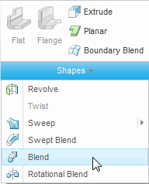**Task 1:** Create a Blended Primary Wall feature.

|  |
| --- |
| 1. Enable only the following Datum Display types: . 2. Click the Shapes group drop-down menu and select **Blend** . 3. In the dashboard, select the **Options** tab.    * Select **Straight** as the Blended surfaces option. |
| 1. In the dashboard, select the **Sections** tab.    * Click **Define**. 2. Select datum plane FRONT as the Sketch Plane.    * Click **Sketch**. |
| 1. Select **Center and Point**  from the Circle types drop-down menu in the Sketching group. 2. Sketch the circle, middle-click, and edit the diameter to **10**. 3. Click **OK** from the dashboard. | |
| 1. Select the **Sections** tab.    * Edit the offset to **75**.    * Click **Sketch**. 2. Reorient the model to view the section crosshair. 3. Click **Center and Point**  and sketch the circle, then middle-click and edit the diameter to **20**. 4. Click **OK** . | |
| 1. Select the **Sections** tab.    * Click **Insert**.    * Edit the offset to **75**.    * Click **Sketch**. 2. Reorient the model to view the section crosshair. 3. Click **Center and Point**  and sketch the circle, then middle-click and edit the diameter to **120**. 4. When you finish sketching and dimensioning the geometry, click **OK** to leave Sketcher mode. | |
| 17. Click **Refit**  from the In Graphics toolbar. | |

1. Click **Complete Feature** from the dashboard.
2. Disable **Plane Display **.

This completes the procedure.

**PROCEDURE - Creating Offset Walls**

**Task 1:** Create a primary offset wall feature.

1. Disable all Datum Display types.
2. In the ribbon, click **Offset ** from the Editing group.

|  |
| --- |
| 1. Select the surface to offset, as shown. |
| 1. Edit the offset distance to **25.0** and the thickness to **10.0**, if necessary. |
| 1. Select the **Options** tab, select the **Add bends on sharp edges** check box, if necessary, and edit the radius to **35.0**. 2. Click **Complete Feature** . |

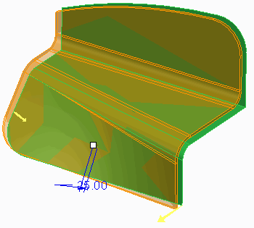This completes the procedure.

## PROCEDURE - Sheet metal Wall Sketching Tools

**Task 1:** Create an extruded primary wall feature with an existing sketch, but re-dimension the sketch to match your design intent

|  |
| --- |
|  |
| 1. Disable all Datum Display types. 2. Click **Extrude**  from the Shapes group. 3. Select **Sketch 1** from the model tree. 4. Click **Solid** from the dashboard. 5. In the dashboard, select the **Placement** tab and click **Unlink**.    * Click **OK** from the Unlink dialog box. |
| 6. Click **Edit** from the Placement tab to start Sketcher mode.  7. Right-click in the graphics window and select  **Thicken**. |
| 1. Click **Flip > Okay** from the menu manager to flip the arrow to the right. 2. Type **2.0** as the thickness and press ENTER. |

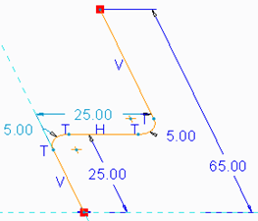

|  |
| --- |
| 10. Edit the 3.00 dimension to **5.0** and press ENTER. |
| 1. Click **Normal** from the Dimension group and select the thickness line and the vertical reference line to create the 29.00 dimension, as shown. 2. Select the **29.00** dimension, then right-click and select **Modify**.    * Type a value of **25.00** in the Modify Dimensions dialog box and click **OK**. 3. Click **OK** to complete the sketch. 4. Type **100** for the depth in the dashboard. |
| 15. Click **Complete Feature** from the dashboard. |

This completes the procedure

**18.CREATING SECONDARY SHEET METAL WALL FEATURE**

**Understanding Secondary walls**

Secondary walls are always dependent on primary walls as we discussed in previous sessions. A secondary wall is always child feature of the primary wall it references.

You can create any primary wall type as a secondary wall. In addition to the primary walls, there are six other wall features that can ONLY be created as secondary walls:

1. Flat
2. Flange
3. Extruded
4. Extend
5. Twist and Merge

**Flat:**

You can create a secondary flat wall using the Flat icon (as opposed to a primary flat wall that is created using the Planar icon). You create it by referencing the edge of an existing wall and then using a modifiable predefined shape (rectangle, trapezoid, L, or T) or a user-defined sketch. You use an open sketch that is attached to the referenced edge to define the shape of the wall. You can specify the angle of the attachment as well as the radius of an optional bend.

**Flange:**

A flange feature consists of a face and bend connected to an existing face along a straight edge. To add a flange feature, you select one or more edges, and specify the size and position of the material added.

**Extruded**:

The extruded wall is very similar to a flange wall. For this type of secondary wall, a single straight edge is selected to act as an extrude direction and a sketched section is created that follows along this edge to create the Sheetmetal geometry.

**Extend:**

An extend wall lengthens an existing wall. You can extend the wall from a straight edge on an existing wall to either a planar surface or a specified distance.

**Twist:**

You can create a twist wall by selecting a straight edge on an existing planar wall l. It is formed by extending the wall and twisting it around an axis that typically runs through the center of the wall. The distance of extension and degrees of twist are specified by the user.

**Merge:**

The merge walls tool combines two or more unattached walls that are tangent and touching each other in to contiguous wall.

**Unattached primary walls**

As mentioned, you can create all of the primary wall types as secondary walls. You can create a primary wall as an unattached wall after the initial primary wall has been created a model. Once the unattached wall has been attached via the Merge Walls tool, it becomes a child of the Merge Walls feature. Since it is dependent on another wall feature, it becomes a secondary wall.

**Creating Secondary flat walls**

You can create a secondary flat wall by referencing a straight edge on an existing wall, you can then specify a number of different elements that determine the final configuration of flat wall.

**Predefined shapes**

First you should specify the overall shape of the wall. The wall is always created as an open loop sketch that is attached to the referenced straight edge. You can select a predefined sketch shape or define the sketch yourself.

You can select from the following predefined shapes:

1. Rectangle
2. Trapezoid
3. L
4. T

**Modifying predefined shapes**

It can be done in different ways:

* Drag handles
* Modifying Dimensions
* Sketch Mode

**Drag handles**

You can right-click in the display area and select Edit Shape. Drag handles appear on the model that enable you to click the shape and drag it to a new location while the preview geometry updates in real-time.

**Modifying Dimensions**

You can double-click any dimension and specify a new value for it

**Sketch Mode**

You can take the predefined geometry into Sketch mode and manipulate it there. You can delete, modify, or create new entities in Sketch mode to create a shape that matches your design intent. The only requirement for the sketch is that it is an open loop with the open ends of the sketch terminating at the edge you referenced for attachment.

**Wall Angle**

You can also control the angle of the wall from 0 to 180 degrees. A 0-degree wall inserts the wall parallel to the existing wall. You cannot use a negative angle or an angle greater than 180 degrees to make the wall angle reverse its direction. Instead, you must select the sheet metal edge on the opposite side of the edge you selected as the attachment reference.

## PROCEDURE - Creating Secondary Flat Walls

**Task 1:** Create a secondary flat wall.

1. Disable all Datum Display types.
2. 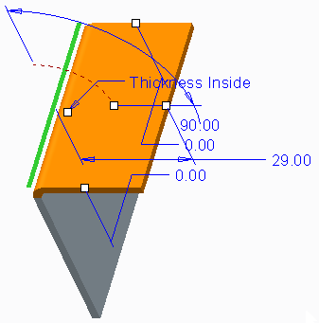In the ribbon, click **Flat ** from the Shapes group.
3. Select the edge on the top-left side of the model, as shown.

4. Select **L** from the Shape drop-down list in the dashboard, as shown.

|  |
| --- |
| 1. In the dashboard, edit the radius value to **5.0**. 2. Click the angle drag handle and drag the wall to   **110** degrees, as shown. |
| 7. Drag the drag handle for the longer side of the L wall to a value of **40**, as shown. |
| 1. In the dashboard, select the **Shape** tab and edit the height of the shorter side of the L wall to **20**, then press ENTER. 2. Click **Sketch** from the Shape tab to start Sketch mode. |
| 1. Select **Circular**  from the Fillet types   drop-down menu in the Sketching group and create the fillet, as shown.   1. Click **One-by-One**  from the Operations group and edit the fillet radius dimension to **10.0**, then click **OK**  to complete the sketch. |

12. Click **Complete Feature** from the dashboard to complete the feature.

This completes the procedure.

## PROCEDURE - Using Flange Walls

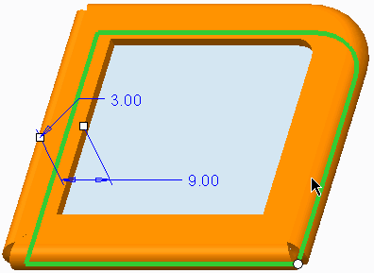**Task 1: Create a flange wall.**

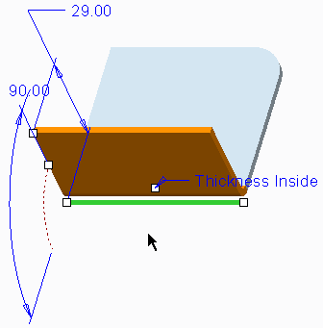

|  |
| --- |
| 1. Disable all Datum Display types. 2. Click **Flange**  from the Shapes group. 3. Select the bottom front edge, as shown. |
| 1. Select **Open** from the Shape drop-down list in the dashboard. 2. In the dashboard, select the **Placement** tab and click **Details**. 3. In the Chain dialog box, select **Rule-based** for the reference type and select **Complete loop** as the Rule.    * Click **OK**. |
| 1. Select **I** from the Shape drop-down list in the dashboard. 2. Select the **Shape** tab and click **Sketch**. 3. Click **Sketch** in the Sketch dialog box. 4. Select **3-Point / Tangent End**  from the Arc types drop-down menu in the Sketching group and sketch the arc tangent to the vertical line. 5. Select **Line Chain** from the Line types drop-down menu in the Sketching group and sketch a line tangent to the arc. 6. Constrain the second line to Vertical if necessary. 7. Click **Normal** from the Dimension group and dimension the sketch, editing the values as shown. 8. Click **OK** . |

|  |
| --- |
| 1. In the dashboard, select the **Edge Treatment**   tab.   * + Verify that **Edge Treatment #1** is selected and select **Gap** from the Type drop-down list.   + Type **2.00** for the gap dimension and press ENTER.  1. Repeat the above step for Edge Treatment #2 and Edge Treatment #3. 2. In the dashboard, select the **Miter Cuts** tab.    * Type **2.00** for the gap dimension and press ENTER. |
| 1. Click **Complete Feature** the dashboard. 2. From the In Graphics toolbar, select **Corner Relief Notes**  and **Bend Notes**  from the Annotation Display types drop-down menu to disable their display. |

This completes the procedure.

**Using Flange walls**

A flange feature consists of a face and bend connected to an existing face along a straight edge. To add a flange feature, you select one or more edges, and specify the size and position of the material added.

There are three types of flange wall profiles

* Frequently used shapes
* Hem shapes
* User defined shapes
* Frequently used shapes

The frequently used shapes that available are I, ARC and S shapes.

**Hem Shapes**

The hems that available are Open, Flushed, Joggle, C, Z and Duck.

**User defined shapes**

You can start with predefined geometry and start sketch and manipulate the sketch as per your requirement which matches to your design requirement.

**Flange wall dashboard options**

In addition to having the dashboard options that are common to both secondary flat and secondary flange walls, you can also set the following options that are specific to flange walls.

* Length
* Miter cuts
* Edger Treatment

**Length:**

Creo Parametric creates the flange wall from the start to the end of the edge chain you select for attachment. If you want either end of the wall to stop short of or extend beyond the selected chain, you can use the Length option on the Flange Wall dashboard.

There are three settings for either end of the wall:

1. Chain End: When this option is selected (it is the default setting), the wall begins (or terminates) at the end of the chain you selected for attachment
2. Blind: Using the Blind option, you specify a positive or negative linear distance where the wall terminates relative to the chain end
3. To selected: The To Selected option enables you to have the wall terminate at a piece of geometry that you select. Points, curves, planes, and surfaces are references that you can select to set the extents of the wall on either end.

**Miter cuts:**

You can add a miter cut at the intersection of two tangent wall segments of a swept flange wall. Specify the value of both the width of the miter cut and the offset distance between the end of the miter cut and the placement chain. You can define miter cut settings when creating a flange wall, or you can predefine them in the Miter Cuts area of the Sheet metal Preferences dialog box or using sheet metal parameters. Keep in mind the following when creating miter cuts:

• Half the specified width value is used to cut the material from each side of the miter cut center line.

• The value specified for Offset defines the distance between the end of the miter cut and the placement chain. If the intersecting wall segments are tangent, you cannot define an offset.

• When the deformation area of the miter cut is retained, a rip is automatically added to the deformed area. This rip connects the miter cut to the point that represents the deformation area and enables the geometry to regenerate.

**Edge Treatment:**

You can use the Edge Treatment tab of the Flange tool to define the way that two non-tangent wall segments of a swept flange wall intersect. You can also use the Edge Rip tool to apply edge treatment to the intersection of non-tangent wall segments. You can define edge treatment settings during feature creation.

**Using extruded walls**

In Creo Parametric, you can use the Extrude tool to create extruded walls to handle special modeling requirements. If you use flat and flange type walls, you can only add constant radius type bends. If you need to create an elliptical or any other non-circular type bend, you can use the Extrude tool in sheet metal to create such a wall.

To create an extruded sheet metal wall, you must first specify the attachment details. In the extrude sketch, you must include necessary bend details as well. You can integrate the new extruded wall feature into the existing primary walls using the Merge Walls tool. If you create partial or overextended walls using an extruded wall, you may also need to create datum features to use as starting or ending reference points. In most cases, unless you have a special need that requires the Extruded Wall tool, it is easier to use a flange type wall attached along a single edge to generate this type of geometry.

**Wall Dashboard Options**

In Creo Parametric, several dashboard options are available that are common to secondary flat walls and flange walls. Using the Wall dashboard options, you can fully capture your design intent in a Creo Parametric sheet metal model. The Wall dashboard has options such as Shape, Offset, Relief, Bend Allowance, Bend/No Bend, Bend Radius, I/O Bend Dimension, and so on.

With the Shape option, you can use various predefined shapes for flat and flange walls. You can use the Shape option to flip the sketch profile in the flange walls. Using the Offset option, you can decide how far to offset the newly added geometry from the attachment edge.

 By default, this option is disabled, and the wall is added to the geometry as though the sketch were connected to the attachment edge for flat walls and common profile flange walls. You can define the offset by specifying a value or a part edge or automatically.

 Using the Relief option, you can use several types of relief available. For partial secondary flat and partial secondary flange walls (walls that do not extend to the end of the referenced edge or edge chain), five different types of bend relief are available:

No relief, Rip, Stretch, Obround, and Rectangular.

With the Bend Allowance option, you can set the bend allowance for the wall to an allowance specific to the feature instead of using the default bend allowance for the entire part.

You can add a sheet metal bend to a wall or add the wall without the bend exactly as the sketch profile would create the geometry using the Add Bend option from the Wall dashboard. Using the Bend Radius option, you can specify the bend radius from the dashboard.

## PROCEDURE - Wall Dashboard Options

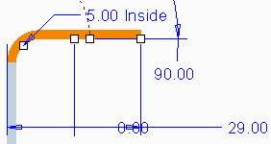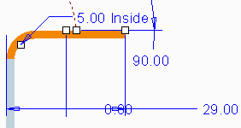**Task 1: Edit the definition of the Flat 1 feature.**

1. Disable all Datum Display types.
2. Right-click **Flat 1** in the model tree and select

**Edit Definition **.

1. Enable the addition of an edge bend by clicking

**Add Bend ** from the Flat dashboard.

1. Select **Inside Radius** from the Radius Dimension Type drop-down list to dimension the inside of the radius.
2. In the radius dimension field, type **5.0**, if necessary, and press ENTER.
3. Click **Change Thickness Side ** from the dashboard and note how the thickness of the sheetmetal moves from one side of the sketch plane to the other.

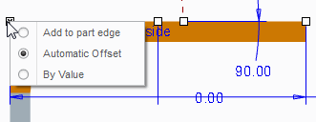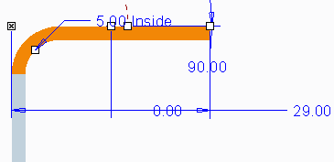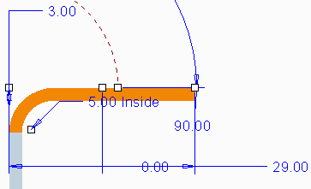**Task 2: Explore the different offset options.**

|  |
| --- |
| 1. Select the **Offset** tab from the dashboard. 2. Select the **Offset wall with respect to attachment edge** check box. |
| 3. Right-click the offset drag handle, as shown. |
| 4. Select **Add to part edge**. |
| 1. Right-click the offset drag handle again and select **By Value**. 2. Drag the drag handle for the offset dimension (currently 7.00) to 3.00 below the attachment edge, as shown. |

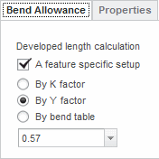**Task 3:** Change the bend allowance for Flat 1 to a feature-specific Y factor.

1. Select the **Bend Allowance** tab from the dashboard and select the **A feature specific setup** check box.
2. Select **By Y factor**, type **0.57**, and press ENTER, as shown.

|  |
| --- |
| 3. Click **Complete Feature** from the dashboard. |
| 4. Press CTRL+D to orient to the Standard Orientation. |

**Using Partial and overextended walls**

In Creo Parametric, you can build partial and overextended walls so that you can fully capture your design intent in sheet metal wall features. Partial walls do not extend to the end of the referenced edge or edge chain. The overextended walls extend beyond the end of the referenced edge or edge chain.

By default, Creo Parametric creates full walls when you create a new secondary flat or secondary flange wall. However, you can create partial or overextended walls using secondary Flat and Flange tools. While creating a flat wall, you can change a standard shape's dimensions such that it starts and ends along the attachment edge or use drag handles to drag the start or end points of a standard shape or sketch a custom shape with its ends dimensioned to create partial or overextended walls. You can use the Trim First End, Trim Second End, Trim First End To Reference, Trim Second End To Reference, Use First End, and Use Second End options from the Flange dashboard to create partial or overextended walls. There are five different settings you can use to provide bend relief for a secondary partial or overextended wall when necessary, such as No relief, Rip, Stretch, Obround, and Rectangular.

## PROCEDURE - Using Partial and Overextended Walls

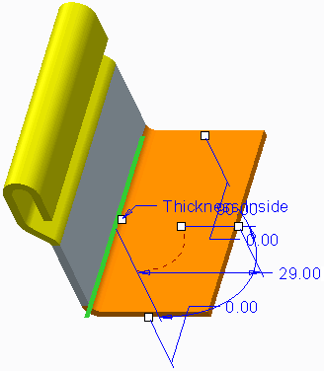**Task 1:** Create a new partial flat wall feature that is overextended on one end.

|  |
| --- |
| 1. Disable all Datum Display types. 2. Click **Flat**  from the Shapes group. 3. Select the edge on the bottom-left side of the model, as shown. |
| 1. Drag the drag handle near the top of the screen down to **5.00**, editing it if necessary. 2. Drag the drag handle near the bottom of the screen down to **7.00**, editing it if necessary. 3. Click **Complete Feature** from the dashboard. |

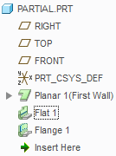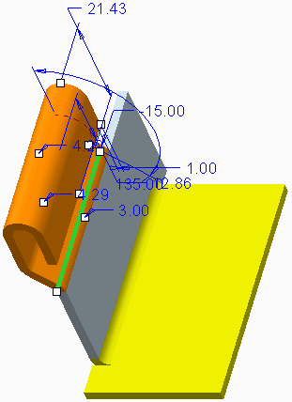**Task 2:** Change the order of Flange 1 in the model tree and change the length options such that it becomes a partial and overextended wall.

|  |
| --- |
| 1. Select **Flange 1** from the model tree and drag it below the Flat 1 feature you just created, as shown. |
| 1. Right-click **Flange 1** from the model tree and select **Edit Definition** . 2. Drag the drag handle near the top of the screen down until the wall is **–15.00** inside the edge of the wall it is attached to, as shown. |

|  |
| --- |
| 1. Select **Trim Second End To Reference**  from the Second End Length Options drop-down list. 2. Select the side surface of the overextended edge of the flat wall, as shown. |
| 6. Click **Complete Feature** |

**Understanding Releif**

Bend reliefs and corner reliefs are often necessary when creating secondary walls.

In Creo Parametric, there are two primary types of relief available for secondary walls: Bend Relief and Corner Relief. Using Bend Relief, you can add relief when a bend meets a wall. Using Corner Relief, you can add relief where multiple non-tangent adjacent walls fold next to each other. You can add wall relief to help control the sheetmetal material and prevent unwanted deformation when performing an unbend operation. Adding relief in Cero Parametric, you can better represent an accurate, real-life model that reflects material stretching.

For flat and flange walls, you can add bend and corner relief during wall creation. You can set the relief type for each wall end or corner individually or create sets of relief. While creating partial secondary walls, the new wall extends into the wall it is attached to, or the wall it is attached to extends into the new wall. In these cases, it is often necessary to specify a bend relief to enable Creo Parametric to transition from the existing wall to the partial secondary wall. There are five types of bend relief that you can use: No relief, Rip, Stretch, Rectangular, and Obround. There are seven types of corner relief that you can use in Creo Parametric: No relief, Square, Normal, Obround, Rectangular, Circular, V notch.

**Corner Relief**

Corner relief helps control the sheetmetal material behaviour and prevents unwanted deformation. You can add corner reliefs using an option available in the flange wall dashboard or as a separate feature by using the Corner Relief.

## PROCEDURE - Understanding Relief

## Task 1: Edit the existing Flange 1 wall and explore the bend relief options.

|  |
| --- |
| 1. Disable all Datum Display types. 2. Right-click the **Flat 1** feature and select **Edit Definition** . 3. Notice the relief on both ends of the wall defaults to the rip relief type. |
| 1. In the dashboard, select the **Relief** tab. 2. Select **Stretch** from the Type drop-down list. 3. Select **Thickness** in the width field, then type   **5.0** and press ENTER.   |  | | --- | | 1. Select **Rectangular** from the Type drop-down list. 2. Click **Preview Feature** from the dashboard to view the result. 3. After you are done viewing the result, click   **Resume Feature**  . | | 1. In the dashboard, select the **Relief** tab. 2. Select the **Define each side separately** check box.    * Select **Side 2**. 3. Select **Obround** from the Type drop-down list. 4. Select **Blind** from depth drop-down list, type   **12.0** as the depth value, and press ENTER.  15. Click **Complete Feature** from the dashboard. |   7. Notice that the relief type on both ends of the wall is now the stretch relief type. |

**Creating twist wall features**

In Creo Parametric, you can add a twist to your sheet metal planar wall using the Twist tool. You can use the twisted wall to create a spiral or coil-shaped section of sheet metal. You can find the Twist tool in the Walls group drop-down menu.

To create a twist wall, select a straight edge to attach the twist wall to. By default, the twist wall width value is the same as the length of the edge selected. However, you can modify it by specifying the first and second direction Start Width values. You can also modify the end width value with the help of the Modify End Wall dashboard option. While creating a twist wall, you can also define the overall length of the twist wall and the angle about which the wall twists. The twist axis is the axis about which the twisted wall symmetrically bends. By default, as the twist wall width is the same as the length of the selected attachment edge, the twist axis is created at the midpoint of the edge selected as the twist wall attachment edge. You can also specify a datum point where the twist axis is created, or you can specify the start width of the twist wall, and the width will be symmetric about the twist axis. You can also specify the wall length in an unbent state or the bend allowance. The bend allowance is used anytime the twist wall is in its flat or unbent state. The wall is stretched out to the length you specified for the developed length.

## PROCEDURE - Creating Twist Wall Features

**Task 1:** Create a twist wall.

|  |
| --- |
| 1. Enable only the following Datum Display types: . 2. In the ribbon, click the Shapes group drop-down menu and select **Twist**. 3. Select the edge on the right side of the model as the attachment edge, as shown. 4. For the twist axis, select datum point **PNT0** from the graphics window. 5. Type **20.0** for the start width and press ENTER. 6. Type **10.0** for the end width and press ENTER. |
| 1. Type **50.0** for the twist length and press ENTER. 2. Type **225** for the twist angle and press ENTER. 3. Type **60.0** for the developed length and press ENTER. |
| 10. Click **OK** in the TWIST dialog box to create the feature. |

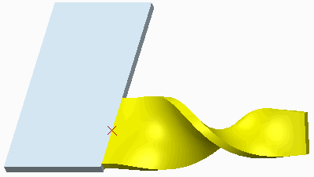**Task 2:** Measure the current and developed length of the twist wall.

1. In the ribbon, select the **Analysis** tab.
2. In the Measure group, select **Distance ** from the Measure types drop-down menu.
3. 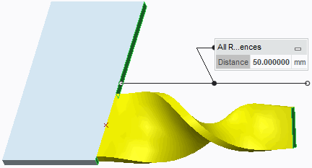Press CTRL and select the two surface references.
4. Close the Measure dialog box.
5. In the ribbon, select the **Model** tab.
6. Select **Unbend** from the Unbend types drop-down menu in the Bends group.
7. Click **Complete Feature** from the Unbend dashboard.
8. In the ribbon, select the **Analysis** tab and select **Distance ** from the Measure types drop-down menu.
9. Press CTRL and select the same two surface references previously selected.

**Extending and Trimming walls**

You can use extend and trim walls to lengthen or shorten existing walls.

• Extending an edge. – Extend an edge by distance or reference plane.

• Extending an edge with Adjacent Surface and Along Boundary Edge options.

 – Create a sharp edge or blend the boundary edge.

• Using Extend to “trim” an edge.

– Remove material by using the Extend tool.

In Creo Parametric, you can extend or trim the wall from a straight edge on an existing wall to either a planar surface or a specified distance. You can use extend and trim walls to lengthen or shorten existing walls. You can use the Extend tool at corners to close gaps between walls and model various overlap conditions; thus, you can fully express your design intent in a Creo Parametric sheet metal model.

To extend or trim a wall, you must specify an edge and the distance. You can directly specify a distance value to extend or trim. You can also extend the wall up a plane using the Through Until method, in which the section must pass through the selected reference. You can select an existing planar surface or datum plane or create a new datum plane. Another method to extend the wall up to a plane is by using the To Selected method, in which the section does not need to pass through the selected reference. You can select an existing planar surface or datum plane or create a new datum plane. You can extend the edge sharply without blending the boundary edge. If you select the Along Boundary Edge option, it blends the boundary edge with the extended edge.

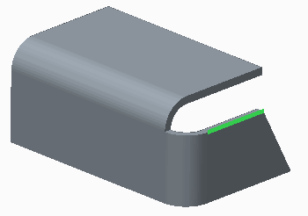**Task 1:** Use the Extend tool to extend a wall and experiment with options.

|  |
| --- |
| 1. Disable all Datum Display types. 2. Press ALT and select the edge, as shown. |
| 3. In the ribbon, click **Extend**  from the Editing group and edit the value to **7.0**. |

|  |
| --- |
| 1. Select the **Extension** tab from the Extend dashboard. 2. For the Side 1 extension, select **Along Boundary Edge** and view the part. Undo the selection by selecting **Normal to Extended Edge**. |
| 1. For the Side 2 extension, clear the **Extend surface adjacent to edge** check box and view the part. Undo the selection by checking the **Extend surface adjacent to edge** check box. 2. Click **Complete Feature** . |

**Task 2:** Use the Extend Wall tool to extend a wall up to a plane.

|  |
| --- |
| 1. Press ALT and select the edge, as shown. |
| 1. Click **Extend**  and then click **Extend Surface To Plane**  and select the inner wall surface, as shown. 2. Click **Complete Feature** . |

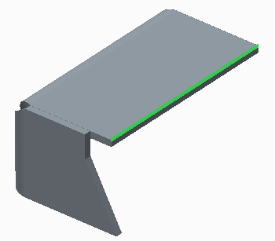**Task 3:** Use Extend to trim a wall.

|  |
| --- |
| 1. Reorient the model as shown. 2. Press ALT and select the edge, as shown. 3. Click **Extend** . |
| 4. Drag the handle inward to approximately 5.0 to trim the wall. |
| 1. Click **Extend Surface To Plane**  and select the surface, as shown. 2. Click **Complete Feature** . |

**Using Merge Feature**

In Creo Parametric, you can combine two or more unattached walls into one contiguous piece of sheetmetal using the Merge Walls tool. With all unattached walls combined into a single piece of sheetmetal, you can unbend the sheetmetal or create flat patterns.

To merge walls, the walls must be touching and be tangent to each other at the edges of contact, and the driving sides of the wall must match before you use the Merge feature. When creating a merge wall feature, you need to specify four elements: Basic Refs, Merge Geoms, Merge Edges, and Keep Lines. When using the Basic Refs element, you must select all surfaces of the base wall(s) to merge. In the Merge Geoms you must select all the surfaces of the walls you will be merging to the base wall(s). In the Merge Edges, you can add or remove edges deleted by the merge. In the Keep Lines, you can control the visibility of merged edges on surface joints. It defaults to Do not Keep Lines.

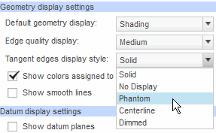**Task 1:** Change the display characteristics of the model to assist in the creation of merge wall features.

|  |
| --- |
| 1. Disable all Datum Display types. 2. Click **File > Options**. 3. In the PTC Creo Parametric Options dialog box, select the **Entity Display** category. 4. Select **Phantom** from the Tangent edges display style drop-down list. 5. Click **OK** to close the dialog box and click **No** if prompted to save the setting. |
| 6. From the In Graphics toolbar, select **Wireframe**  from the Display Style types drop-down menu. |

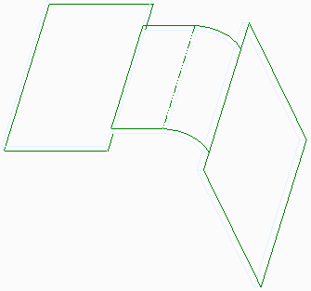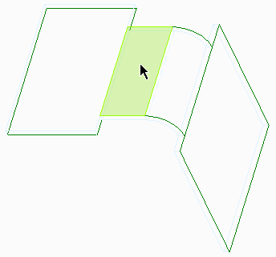**Task 2:** Create a merge wall feature between the horizontal flat wall and the adjacent extruded wall feature.

|  |
| --- |
| 1. Click the Editing group drop-down menu and select **Merge > Merge Walls**. 2. Select the surface reference to which unattached walls will be merged. 3. Click **Done Refs** from the menu manager. |
| 1. Select the surface reference to be merged. 2. Click **Done Refs**. |
| 1. Click **Preview** from the Merge Walls dialog box. 2. Click **Repaint**  from the In Graphics toolbar. |
| 1. Click **Cancel > Yes** in the Confirm Cancel dialog box.    * In the model tree, right-click **Planar 2** and select **Edit Definition** .    * In the Planar dashboard, select the **Options** tab and select the **Set driving surface opposite sketch plane** check box.    * Click **Complete Feature** from the dashboard. |
| 1. Click the Editing group drop-down menu and select **Merge > Merge Walls**. 2. Select the same surface reference again to which unattached walls will be merged, then click   **Done Refs**.   1. Select the same surface reference again to be merged, then click **Done Refs**. |
| 12. Click **OK** in the Merge Walls dialog box to complete the feature. |
| 1. Right-click the wall feature you just created in the model tree and select **Delete** .    * Click **OK**. |

|  |
| --- |
|  |
| 1. Click the Editing group drop-down menu and select **Merge > Merge Walls**. 2. Press CTRL and select the two surfaces as references to which unattached walls will be merged. 3. Click **Done Refs** from the menu manager. |
| 1. Press CTRL and select the two surfaces as references to be merged. 2. Click **Done Refs** from the menu manager. |

Click **OK** in the Merge Walls dialog box to complete the feature.

**19.BENDING AND UNBENDING SHEET METAL MODELS**

##### A bend feature adds a bend to a flat section of the part.

Types of Bend Features:

* + - Angle Bend
    - Roll Bend

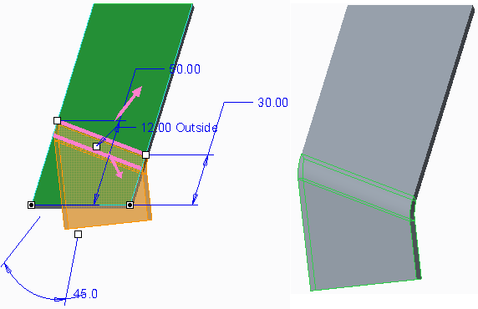

**Figure 1 – Angle Bend**

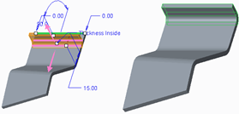  **Figure 2 – Angle Bend From Edge**  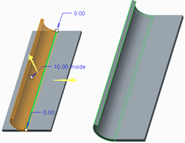

**Figure 3 – Roll Bend**

**Creating Bend Features**

While manufacturing sheet metal parts, you bend flat sheets using bending tools. Creo Parametric enables you to create bends and other geometry to reflect the true manufacturing process. You can bend a sheet using various tools, such as angle bend or roll bend. You use bend lines to determine the location and shape for the bend geometry in your sheet metal parts. A bend line is also a reference point to calculate the developed length.

A bend feature enables you to bend or roll a sheet metal model along a defined line. Bend features have the following characteristics:

* The bend line is a reference point for calculating the developed length and creating the bend geometry.
* You can add bends at any time during the design process.
* You can add bends across form features.
* Depending on where you place the bend in your sheet metal design, you may need to add bend relief.
* A bend cannot be added where it crosses another bend feature.
* You cannot copy a bend with the mirror option.
* While you can generally unbend zero-radius bends, you cannot unbend bends with slanted cuts across them.
* You can modify the developed length of a bend area. If you do modify the developed length, remember that revising the developed length only affects unbent geometry and does not affect the bend back features.
* Bends are made along the axis of the radius. To define a bend line, use one of the following:
* A surface.

– You can directly manipulate the dynamic bend line with drag handles and offsets, or you can create an internal sketch.

* An existing sketch.

## PROCEDURE - Creating Bend Features

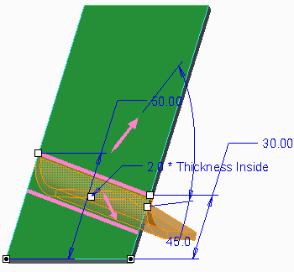**Task 1:** Create an angle bend on the provided sheetmetal part.

|  |
| --- |
| 1. Disable all Datum Display types. 2. Select **Bend**  from the Bend types drop-down menu in the Bends group. 3. Select the top surface and drag the location handles to the sides. |
| 1. Drag the reference handles to the bottom edge.    * Edit the left dimension to **50**.    * Edit the right dimension to **30**.    * Edit the angle to **90**.    * In the dashboard, select **2.0 * Thickness** from the bend radius drop-down list. 2. Select the **Relief** tab from the dashboard. 3. Select **No relief** from the Type drop-down list. |
| 1. In the dashboard, click **Bend To Bend Line**  to bend the material to the bend line. 2. Click **Bend On Both Sides**  to bend the material on both sides of the bend line. |
| 1. Click **Bend On Other Side** . 2. Edit the bend angle to **45** degrees. 3. Select **Internal Bend Angle** from the Bend angle types drop-down menu. |

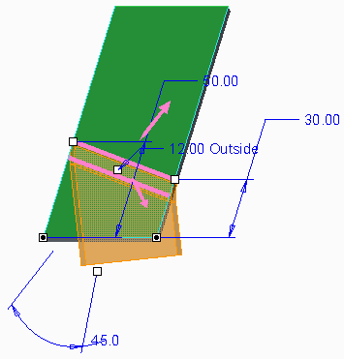11.Select **Bend Angle From Straight** from the Bend angle types drop-down menu.

1. Select **Outside Radius ** from the Radius types drop-down menu.
2. Edit the radius to **12**.

14.Click **Complete Feature** from the dashboard.

**Task 2:** Create an angle bend using an internal sketch.

|  |
| --- |
| 1. Enable **Plane Display** . 2. Click **Bend** . 3. Select the surface. |
| 1. Select the **Bend Line** tab from the dashboard. 2. Click **Sketch**. 3. Click **References**  from the Setup group and select the left and right surfaces and the datum plane. 4. Sketch the bend line and click **OK** |
| 1. Click **Change Bending Direction**  from the dashboard to flip the direction of the bend. 2. Edit the radius to **12**. 3. Disable **Plane Display**  and click **Complete Feature** |

**Task 3:** Create an angle bend from a model edge.

|  |
| --- |
| 1. Click **Bend** . 2. Select the top edge. 3. Edit the radius to **12**. 4. Select **Inside Radius** from the Radius types drop-down menu. |
| 5. In the dashboard, select the **Placement** tab and edit the offset to **15**. |
| 1. Edit the bend angle to **90**. 2. Click **Change Bending Direction** . 3. Edit the bend radius to **Thickness**. |
| 1. Click **Bend To End**  to toggle the bend to a roll bend. 2. Click **Complete Feature** . |

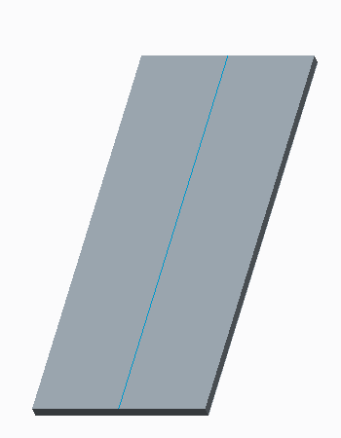**Task 4:** Create a roll bend from an existing sketch.

1. Select the three bends in the model tree, then right-click and select **Suppress **.
   * Click **OK**.
2. Select ROLL_LINE in the model tree, then right-click and select **Unhide **.

|  |
| --- |
| 1. Click **Bend**  to insert a bend feature. 2. Select the datum curve, if necessary.    * Edit the radius to **10**.    * Click **Inside Radius** , if necessary. |
| 5. Click **Bend To End**  to create a roll bend. |
| 1. Click **Bend To Bend Line** . 2. Click **Bend On Both Sides** . |

|  |  |  |  |
| --- | --- | --- | --- |
| 1. Click **Bend On Other Side** 2. Click **Change Fixed Side** |  |  | . |
| 1. Click **Change Fixed Side**  again. 2. Click **Change Bending Direction** . | | | |
| 12. Click **Complete Feature** | . |  |  |

## Adding Transition to Bends

##### A transition deforms the surface between a bend and a section of the model that is to remain flat.

* + - 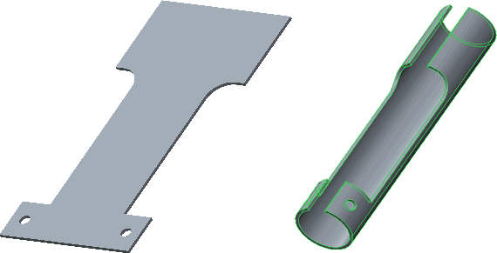Sketch bend line.
    - Sketch transition area.

Figure 1 – Original Model with Roll Bend

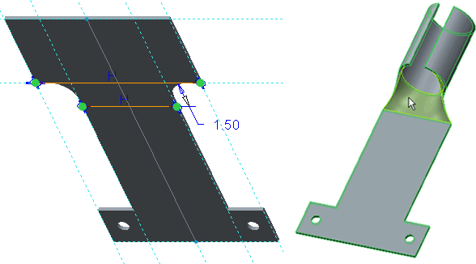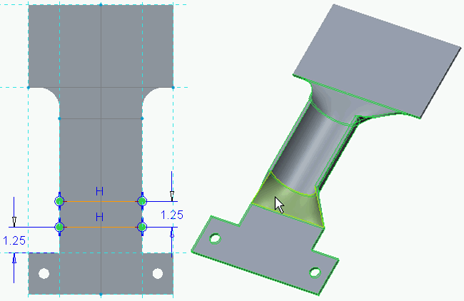

Figure 2 – First Transition Added Figure 3 – Second Transition Added

**Adding Transition to Bends**

A transition area shapes one section of a sheet metal surface while leaving another section flat or with different bent conditions.

You can use the bend tool to add one or more transition areas to an angled or rolled bend. Figure 1 shows a model with a roll bend applied. When creating a transition area, first sketch the bend line and then sketch the transition area to remain flat or to bend differently. Each transition area sketch must have two open line entities. The first line must be adjacent to the bend area and the second line must complete the transition area.

Figure 2 and Figure 3 show the model with transitions added. The transitions enable the bend to apply to only the areas necessary for your design.

## PROCEDURE - Adding Transition to Bends

**Task 1:** Add transition to a roll bend.

* Disable all Datum Display types.
* Select **Bend ** from the Bend types drop-down menu in the Bends group.
* Select the front surface.

|  |
| --- |
| 1. Right-click and select **Define/Edit Internal Bend Line**. 2. Click **Line Chain** from the Line types drop-down menu in the Sketching group and sketch the line starting from the reference intersection. 3. Press ALT and select the lower horizontal edge to create a reference.    * Select the reference to complete the line. 4. Click **OK** to complete the sketch. |
| 1. In the dashboard:    * Edit the bend radius to **1.2**.    * Click **Bend To End** .    * Click **Bend On Both Sides** . |
| 1. Select the **Transitions** tab from the dashboard.    * Click **Add Transition > Sketch**.    * Click **References**  from the Setup group, select the references, and then create the sketch shown.    * Click **OK** . |
| 1. Click **Complete Feature** from the dashboard. 2. Reorient the model and notice the transition area. |

**Task 2:** Add a second transition to the bend.

|  |
| --- |
| 1. In the model tree, right-click **Bend 1** and select   **Edit Definition** .   1. Select the **Transitions** tab.    * Click **Add Transition > Sketch**.    * From the In Graphics toolbar, click **Sketch View** . 2. Click **References** , and then select the references highlighted in red. |
|  |
| 4. Sketch the two lines shown, and then click **OK** |
| 5. Click **Complete Feature** and notice the additional transition has isolated the roll bend to the center of the model. |

This completes the procedure.

## Bending in Multiple Planes

##### You can create bends on multiple surfaces.

* + - * Can create Bends:
        + Over multiple surfaces
        + Across gaps
      * Requirements: Surfaces must be co-planar

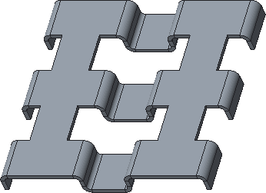**Figure 1 – Original Model**

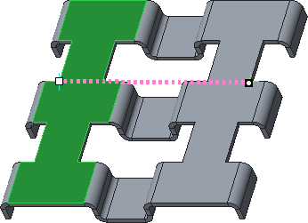 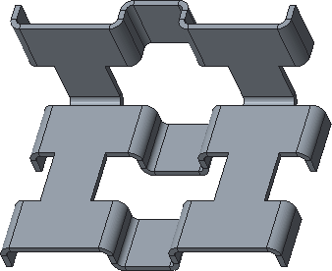

**Figure 2 – Bend Line** **Figure 3 – Completed Bend**

**Bending in Multiple Planes**

You can create bends over multiple co-planar surfaces and across gaps.

The surfaces must be co-planar, and the bending only occurs where the bend line touches the co-planar surfaces.

## PROCEDURE - Bending in Multiple Planes

**Task 1:** Create Bends in multiple planes.

|  |
| --- |
| 1. Disable all Datum Display types. 2. From the In Graphics toolbar, select **Shading With Edges**  from the Display Style types drop-down menu. |
| 1. Click **Bend**  from the Bends group.    * Select the top model surface.  |  | | --- | | 1. Click **Change Bending Direction**  to flip the bend direction upward. 2. Click **Change Fixed Side**  to flip the fixed direction frontward.    * Click **Complete Feature** . | | 1. Click **Bend** .    * Select the top model surface.    * Click and drag the endpoints to the vertices shown. | | 1. Click **Bend To Bend Line**  from the dashboard. 2. Click **Change Bending Direction**  to flip the bend direction downward. 3. Click **Change Fixed Side**  to flip the fixed direction rearward.    * Click **Complete Feature** . |  * + Click and drag the endpoints to the vertices shown. |

This completes the procedure.

## Creating Planar Bends

##### A planar bend is formed around an axis perpendicular to the driving surface and sketching plane.

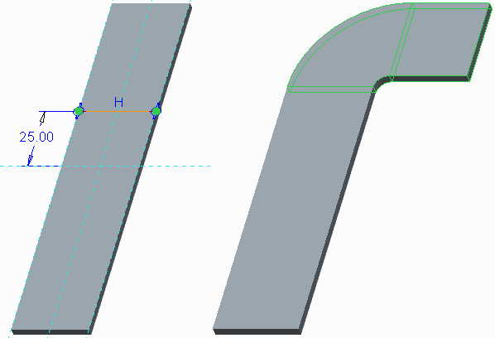Bend around axis normal to driving surface and sketch plane.

* + - Bend Tables not applicable.
    - Sketch bend line.
    - Angle or Roll type.

Figure 1 – Angle Planar Bend

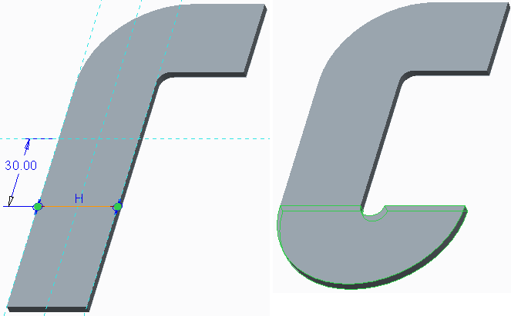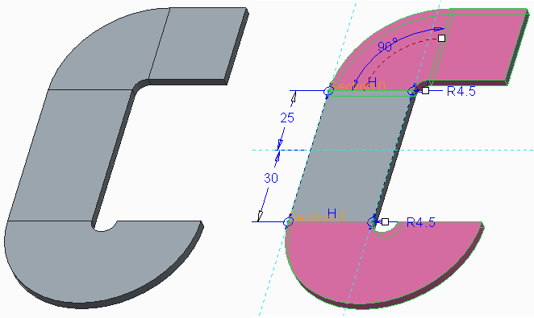

**Creating Planar Bends**

A planar bend creates a bend feature around an axis that is perpendicular to the driving surface and the sketching plane. The neutral point for planar bends is placed according to the current Y-factor andA planar bend forces the sheetmetal wall around an axis that is normal (perpendicular) to the surface and the sketching plane. You sketch a bend line and form the planar bend around the axis using direction arrows. While this type of bend is not utilized on the factory floor, it can help you reach your overall design intent for model shape.The dimension scheme for a planar angle bend and a planar roll bend is shown on the completed model in Figure 3. In particular, note the lack of a bend angle dimension for the roll bend.

## 

## PROCEDURE - Creating Planar Bends

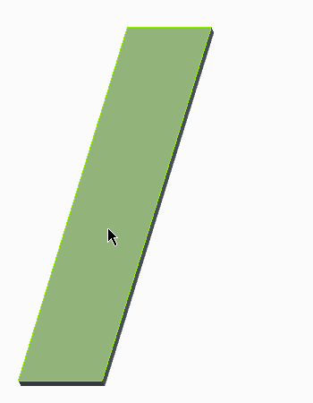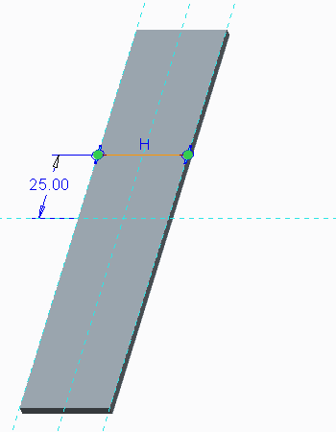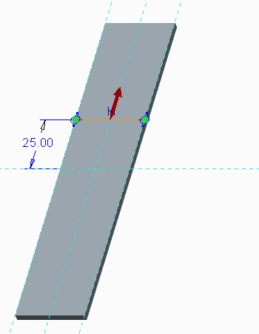**Task 1:** Create a planar angle bend.

|  |
| --- |
| 1. Disable all Datum Display types. 2. Select **Planar Bend**  from the Bend types drop-down menu in the Bends group. 3. Click **Angle > Done** from the menu manager. 4. Click **Part Bend Tbl > Done/Return**. 5. Select the front surface as the sketch plane reference.    * Click **Okay** for the viewing direction.    * Select **Default** for the sketch orientation. |
| 1. Right-click and select **References**.    * Select the left and right references.    * Sketch the line shown, and then click **OK** . |
| 7. Click **Okay** from the menu manager to accept the bend side. |
| 8. Click **Flip** to flip the fixed side, and then click  **Okay**. |
| 1. Click **90.000 > Done**. 2. Click **Enter Value**, type **4.5**, and press ENTER. 3. Click **Flip** to flip the bend direction, and then click **Okay**. |
| 12. Click **OK** from the BEND Options dialog box. |

**Task 2:** Create a planar roll bend

* Click **Planar Bend **.
* Click **Roll > Done** from the menu manager.
* Click **Part Bend Tbl > Done/Return**.
* Select **Use Prev** for the sketch plane reference.
* Click **Okay** for the viewing direction.
* Right-click and select **References**.
* Select the left and right references.

Sketch the line shown, and then click **OK**

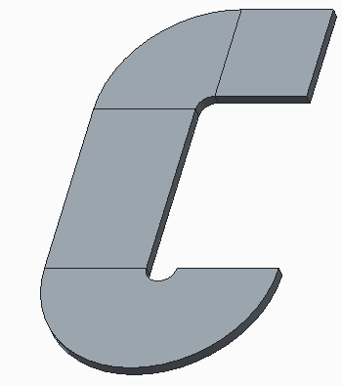**Task 3:** Compare the angle and the roll planar bends.

|  |
| --- |
| 1. From the In Graphics toolbar, select **Shading With Edges**  from the Display Style types drop-down menu, and notice the difference in bend portions. |
| 1. Press CTRL and select both bends. 2. Right-click and select **Edit** . 3. Notice that the roll bend does not have an angle. 4. Select **Shading**  from the Display Style types drop-down menu in the In Graphics toolbar. |

This completes the procedure.

## PROCEDURE - Creating Unbend Features

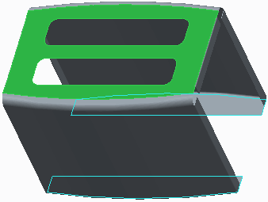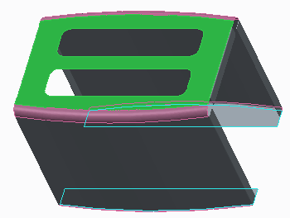**Task 1:** Unbend the developable geometry in the toaster body.

|  |
| --- |
| 1. Disable all Datum Display types. 2. Select **Unbend** from the Unbend types drop-down menu in the Bends group. 3. Notice the fixed geometry is selected, but the unbend preview is not shown. |
| 1. In the dashboard, select the **Deformations** tab. 2. Click and drag to select each of the detected deformation surfaces. Notice they highlight in the graphics window in magenta. |
| 1. In the dashboard, select the **References** tab.    * Notice that **Select References Automatically**   is selected.   1. Click **Select References Manually**  . 2. In the Bent geometry collector, right-click the two large WALL SURFACE references and select **Remove**. 3. Notice that the unbend preview now displays. |
| 10. Click **Complete Feature** . |

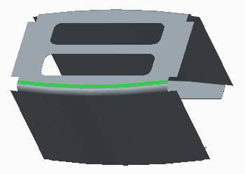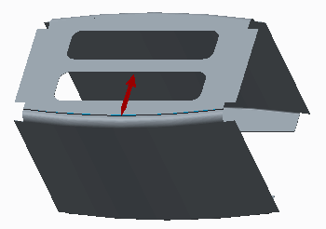**Task 2:** Unbend one side of the toaster body using the Xsec Driven method, by selecting the Xsec Curve.

|  |
| --- |
| 1. Select **Cross Section Driven Unbend** from the Unbend types drop-down menu. 2. Select the edge to remain fixed. |
| 1. Click **Done > Sketch Curve > Done** from the menu manager. 2. Select the surface. 3. Click **Default** from the menu manager. |
|  |
|  |

**20.SHEET METAL FORM FEATURES**

## Punch Form Features

##### Your sheet metal models can be formed using punches.

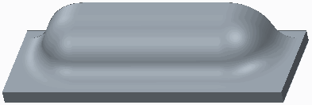Assemble with Dashboard

* + - Surface Csys
    - Interfaces
* Constraints Options
* Round sharp edges
* Exclude Surfaces
* Merge or Inheritance

**Task 1:** Create a louver using a punch form

|  |
| --- |
| 1. Disable all Datum Display types. 2. In the ribbon, select **Punch Form** from the Form types drop-down menu in the Engineering group. 3. Click **Open Punch Model**  from the dashboard.    * Double-click LOUVER_FORM.PRT. 4. Place the cursor over the upper model surface.    * Query and select the underlying surface. |
| 1. Drag the handles to the front and right surfaces of the model.    * Edit the offset values as shown. |
| 1. Select the **Placement** tab from the dashboard and select the **Add rotation about the first axis** check box.    * Drag the rotation handle to 90. |
| 1. Select the **Options** tab.    * Click in the **Excluded punch model surfaces**   collector.   * + Select the surface shown. |
| 8. Click **Complete Feature** |

**Task 2:** Create a gusset using a punch form.

|  |
| --- |
| 1. Click **Punch Form.** 2. Click **Open Punch Model**  from the dashboard.    * Double-click GUSSET_FORM.PRT. 3. Select the right model surface. |
| 1. Select the upper model surface.    * Select the front model surface.    * Drag the offset handle to 20. |

1. 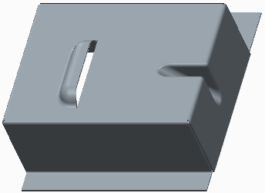Select the **Options** tab from the dashboard and select the **Placement edges** check box.
   * Select **Thickness** from the Radius drop-down list.

. Click **Complete Feature** .

This completes the procedure.

**Task 1:** Create a Punch Model annotation feature

1. Disable all Datum Display types.
2. 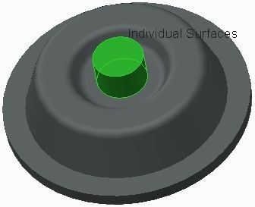In the model tree, expand the **Footer** and INTERFACES nodes and select **INTFC001**.
3. Select the **Annotate** tab and click **Annotation Feature ** from the Annotation Feature group.
4. Click **Specify Punch Model Properties** in the Annotation Feature dialog box.In the Form Model dialog box, click in the **Excluded Surfaces** collector, then press CTRL and select the three surfaces shown.
5. Click **OK** in the Form Model dialog box and click

**OK** in the Annotation Feature dialog box.

6.Click **Close** from the Quick Access toolbar.

**Task 2:** Create a punch form utilizing the defined punch model annotation.

|  |
| --- |
| 1. Click **Open**  from the Quick Access toolbar and double-click ANNOTATIONS .PRT. 2. Select **Punch Form** from the Form types drop-down menu in the Engineering group. 3. Click **Open Punch Model**  from the Punch Form dashboard.    * Double-click ROUND_FORM.PRT. 4. Place the cursor over the upper model surface.    * Query-select the underlying surface. |
| 1. Drag the reference handles to the front and right surfaces of the model.    * Edit the offset values as shown. |
| 1. Select the **Options** tab from the dashboard.    * Notice there are excluded surfaces defined. 2. Click **Preview Feature** .    * Notice the placement edges are not rounded.    * Click **Resume Feature**  . |
| 1. Select the **Options** tab.    * Select the **Placement edges** check box.    * Select **Thickness** from the Radius drop-down list. 2. Click **Complete Feature** from the dashboard. |

## Creating Die Forms

##### You can create impressions in sheet metal using Die Forms.

* + - Prepare Die Form model:
* 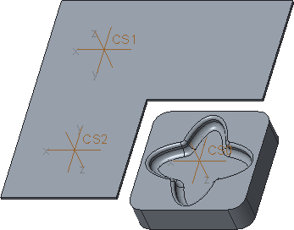Geometry pocket
* Coordinate System (optional)
  + - Prepare Sheet metal model:
* Sheet metal Geometry
* Coordinate System (optional)
  + - Place Die Form:
* Assembly Constraints
* On-Surface Coordinate System
* Component Interface Coordinate System
  + - Form Options:
* Surfaces to Exclude
* Round Edges
* Dependent / Independent

#### Preparing Die Form Models

First, you create the geometry to use for the impression as a pocket on a planar solid surface. You can create multiple pockets in the die form model.You can optionally create a coordinate system and specify it as a Component Interface for rapid placement. Generally, the Z-axis of the coordinate system is oriented to face into the pocket geometry.

#### Preparing Sheet metal Models

First, you create the sheet metal geometry for placement of the die.Optionally, you can place a coordinate system to locate the die on the model. Generally, the Z-axis of the coordinate system is oriented to face into the pocket geometry.

#### Placing Die Forms

You have the following options when placing a die form:

* + Assembly Constraints – Assemble the form using typical placement constraints.
  + On-Surface Coord Sys – Assemble the form by specifying a placement surface and offset references. An optional rotation angle about the Z-axis can also be specified.

## PROCEDURE - Creating Die Forms

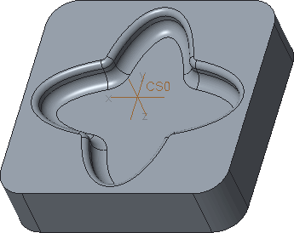**Task 1:** Prepare a Die Form model.

|  |
| --- |
| 1. Enable only the following Datum Display types:      1. From the In Graphics toolbar, select **Shading With Edges**  from the Display Style types drop-down menu. |
| 1. In the model tree, select the coordinate system **CS0**. 2. Click **Component Interface**  from the Model Intent group.    * Click **Apply-Save Changes** from the Component Interface dialog box. 3. In the model tree, expand the **Footer** node.    * Expand the **Interfaces** node and notice INTFC001. 4. Click **Close** from the Quick Access toolbar. |

**Task 2:** Utilize a Die Form model using an on-surface coordinate system.

|  |
| --- |
| 1. Click **Open**  from the Quick Access toolbar.    * Double-click DIE_SHEETMETAL.PRT. |
| 1. Select **Die Form**  from the Form types drop-down menu in the Engineering group. 2. Click **Open Punch Model** .    * Double-click DIE_FORM.PRT. 3. Notice **Place Using Coordinate System**  is active and you can now specify the assembly references.    * Query-select the underlying surface.    * Drag the die to the top-right of the sheet metal form.    * Drag the handles to each edge shown and edit both dimensions to **40**. |
| 1. Select the **Shape** tab.    * Click in the Die shape collector and notice the surfaces are selected automatically. 2. Click **Complete Feature** from the dashboard. |

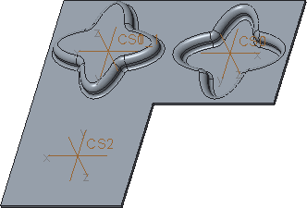**Task 3:** Utilize a Die Form model using a component interface.

|  |
| --- |
| 1. Select **Die Form**  from the Form types drop-down menu. 2. Click **Place Using Interface**  from the dashboard.    * Click **Yes** in the Warning dialog box. 3. In the model tree, select CS1 and notice the form orientation.    * Click **Complete Feature** . |
| 1. In the model tree, right-click FORM 2 and select **Delete** .    * Click **OK**. |
| 1. Select **Die Form**  fom the Form types drop-down menu. 2. Click **Place Using Interface** .    * Click **Yes**. 3. Click **Inheritance Copy**  from the dashboard. 4. In the model tree, select CS2 and notice the form orientation.    * Click **Complete Feature** . |

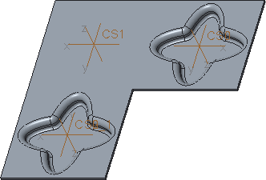**Task 4:** Place a Die from the library.

|  |
| --- |
| 1. Select **Die Form**  from the Form types drop-down menu. 2. Select **CLOSE_OFFSET_DIE_FORM_MM** from the Punch Model drop-down menu. 3. Click **Place Using Interface** .    * Click **Yes**. |
| 1. In the model tree, select CS1. 2. Click **Show In Separate Window** . 3. Select the **Options** tab.    * Click in the Excluded die model surfaces collector. 4. In the new window, press CTRL and select the bottom surface and the two bottom rounds.    * Click in the Excluded die model surfaces collector to view the surfaces. |
| 1. Click **Complete Feature** . 2. Disable the **Csys** display. |

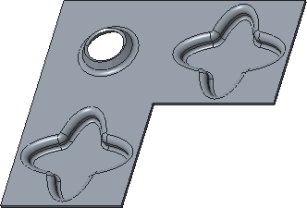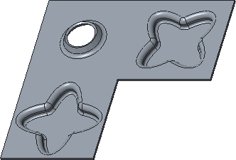**Task 5:** Edit the placed forms.

|  |
| --- |
| 1. In the model tree, right-click FORM 1 and select   **Edit Definition** .   1. Select the **Placement** tab.    * Select the **Add rotation about the first axis**   check box.   * + Edit the Rotation Angle to **45**.  1. Click **Complete Feature** . |
| 1. In the model tree, right-click FORM 1 and select   **Open Base Model**.   1. Right-click EXTRUDE 2 and select **Edit** .    * Edit the depth value to **12**.    * Press CTRL+G to regenerate the model. 2. Click **Close** from the Quick Access toolbar to return to the sheetmetal model. 3. Press CTRL+G and notice only the Form 1 depth has been updated. |
| 1. Expand FORM 2.    * Notice that only this form contains inherited features, which are available for editing. |

This completes the procedure.

## Creating Die Forms Using Annotations

##### You can pre define Die Form surfaces with Annotation features.

* 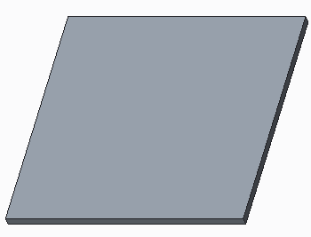Annotation feature
  + Die shape
  + Excluded surfaces
* Place Die Form
  + Surfaces utilized automatically

**Figure 1 – Original Sheet Metal Model**

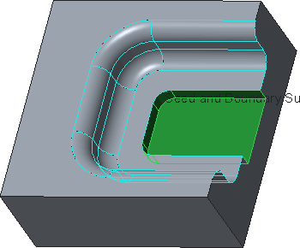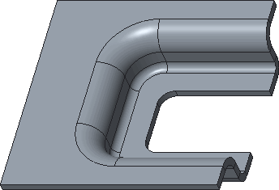

**Figure 2 – Die Form with Annotation Surfaces Figure 3 – Completed Sheet Metal Model**

**Creating Die Forms Using Annotations**

Within the die form model, you can use an annotation feature to predefine the die shape surfaces and the surfaces to be excluded.You can select individual surfaces, or select a surface set using any method, such as seed and boundary surfaces.Upon placement of the die on the sheet metal part, the surface sets are utilized automatically.Predefinition of die shape surfaces is useful for complex or custom die shapes, or those with multiple pockets.

## PROCEDURE - Creating Die Forms Using Annotations

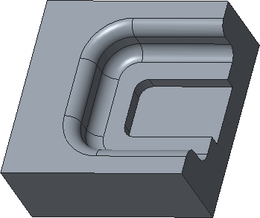**Task 1:** Create an annotation feature on a Die Form model.

|  |
| --- |
| 1. Disable all Datum Display types. 2. From the In Graphics toolbar, select **Shading With Edges**  from the Display Style types drop-down menu. |
| 1. In the ribbon, select the **Annotate** tab. 2. Click **Annotation Feature**  from the Annotation Features group. 3. Click **Specify Punch Model Properties** from the Annotation Feature dialog box. 4. Click in the Die Shape collector.    * Select the seed surface. |
| 1. Press and hold SHIFT.    * Select the side boundary surface. |
| 8. While still holding SHIFT, select the top boundary surface. |
| 9. Release SHIFT and observe the die shape. |
| 1. Click in the Excluded Surfaces collector.    * Select the bottom of the die form. |
| 1. Press and hold SHIFT.    * Select the side boundary surface. |
| 12. While still holding SHIFT, select the top boundary surface. |
| 13. Release SHIFT and observe the Excluded Surfaces. |
| 1. Click **OK > OK**.    * Notice the Annotation feature in the model tree. 2. Click **Close** |

**Task 2:** Place the Die Form using the Annotation feature

|  |
| --- |
| 1. Click **Open**  from the Quick Access toolbar.    * Double-click DIE_ANNOTATION .PRT. 2. Select **Die Form**  from the Form types drop-down menu in the Engineering group. 3. Click **Open Punch Model** .    * Double-click DIE-FORM_CUTOUT.PRT. |
| 1. Notice **Place Using Interface**  is active in the dashboard and you can specify the assembly references. 2. Query-select the bottom surface as the first coincident surface. |
| 6. Select the front face as the second coincident surface. |
| 1. The form feature is now displayed. 2. Select the **Shape** tab and notice the die shape is pre-defined. 3. Select the **Options** tab and notice the excluded surfaces are pre-defined. |
| 11. Click **Complete Feature**. |

This completes the procedure.

**Creating Sketched Forms**

Sketched forms allow you to quickly create forms that are sketch based rather than having to use a separate model. Creating a sketched form is similar to creating an extruded feature. The sketched form allows for the use if sketch libraries for common shapes. There are two types of sketched forms:

* **Punch** — Extrudes the sketch shape, and creates additional walls normal to the sheet metal surface by default. The following options can be applied:

– Exclude Surfaces

* Capped ends
* Add taper
* Round sharp edges options of Non-placement edges and Placement edges
  + **Piercing** — Cuts the sketch shape without removing material, and offsets resulting wall portion normal to sheet metal surface, offset from zero up to the material thickness. The Round sharp edges options of Non-placement edges and Placement edges can be applied.

## 21.MODIFYING SHEET METAL MODELS

## Sheet metal Cuts

##### Sheet metal cuts are created normal to the part surface while solid cuts are created normal to the sketch plane.

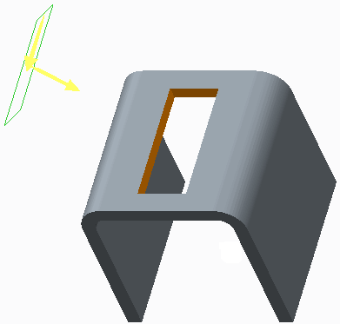Types of Cuts

* + - Sheet metal Cut
* Solid
* Thin
  + - Solid Cut

**Figure 1 – Cut Normal to Surface**

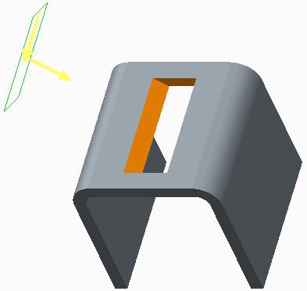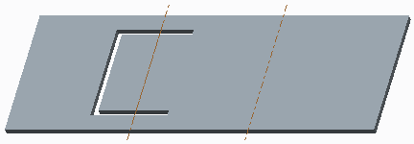

**Figure 2 – Cut Normal to Sketch Figure 3 – Thin Sheet metal Cut**

**Sheet metal Cuts**

You can remove the material from a sheet metal part using cuts. The cut is made normal to the sheet metal surface, as if the part were completely flat, even if it is in a bent state. The cut adopts the sheet metal material's natural behavior, like bending and warping, when the part is bent. You sketch cuts on a plane and then project them onto the sheet metal wall. Either the driving or offset side of the sheetmetal wall can determine the cut direction.

You can create sheet metal cuts using the **Extrude ** tool.

The sheet metal cut can be created normal to the driven surface, offset surface, or both surfaces. Types of sheet metal cuts:

* + Solid – Removes solid sections of the sheet metal wall.
  + Thin – Removes only a thin section of the material.

You can use advanced options such as Revolve, Sweep, Blend, and so on, to make advanced cuts in the sheet metal wall. Note that cuts can be made on an edge.To make a defined-angle cut, you must click the **Normal To Surface** icon in the dashboard, which disables the three normal to surface options, and makes the cut normal to the sketch plane.

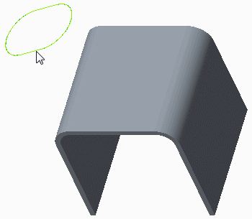**Task 1:** Create a cut, using the existing datum curve, that is normal to the sketch plane.

1. Disable all Datum Display types.
2. Select the datum curve, as shown.
3. Click **Extrude ** from the Shapes group.
4. In the dashboard, select **Through All** as the depth.
5. Click **Normal To Surface** to disable it.
6. 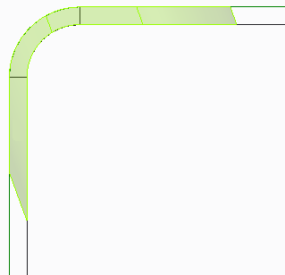Click **Complete Feature** from the dashboard.
7. From the In Graphics toolbar, select **Hidden Line ** from the Display Style types drop-down menu.
8. From the In Graphics toolbar, click **Saved Orientations ** and select FRONT.

**Task 2:** Edit the definition of the cut and make it normal to the wall surface.

1. 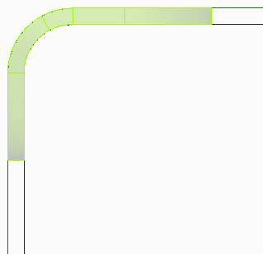In the model tree, right-click **Extrude 2** and select **Edit Definition **.
2. Click **Normal To Surface** .
3. Click **Complete Feature** .

**Task 3:** Create a circular cut through the model.

|  |
| --- |
| 1. Press CTRL+D to orient to the standard orientation. 2. Click **Extrude** . 3. Select **Through All** as the depth. 4. Right-click and select **Define Internal Sketch**. 5. Select the surface shown for the sketch plane. |
| 1. Select datum plane TOP as the Sketch Orientation reference and click **Sketch** in the Sketch dialog box. 2. Select the front, right, vertical edge as a sketch reference and click **Close** from the References dialog box. 3. Select **Center and Point**  from the Circle types drop-down menu in the Sketching group and sketch the circle. 4. Select **One-by-One**  from the Select types drop-down menu in the Operations group and edit the dimensions, as shown. 5. Click **OK** from the dashboard. |

1. 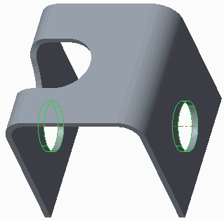Click **Complete Feature** .
2. Enable **Axis Display **.
3. From the In Graphics toolbar, select **Shading **

from the Display Style types drop-down menu.

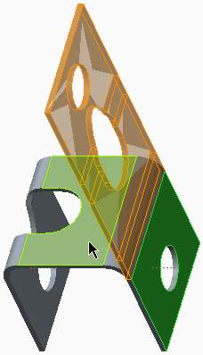**Task 4:** Unbend the model.

|  |  |
| --- | --- |
| 1. Select **Unbend** from the Unbend types drop-down menu in the Bends group. 2. Select the surface shown as the surface to remain fixed.  |  | | --- | | 3. Click **Complete Feature** . |   This completes the procedure. |

## Notches and Punches

##### You use notches and punches as templates to cut and relieve sheet metal walls.

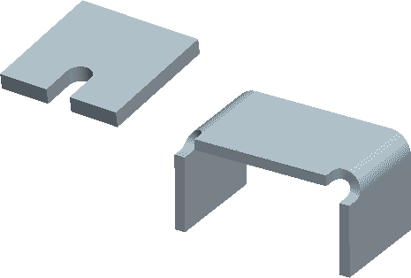Punches and notches are used to create cuts and capture manufacturing information.

* + - Notches are placed on edges.
    - Punches are placed in the middle.

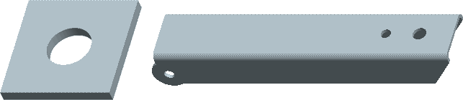

**Figure 2 – Punch Used to Create Holes**

**Notches and Punches**

You use notches and punches as templates to cut and relieve sheet metal walls. You place notches on the edges and punches in the middle of the sheet metal wall. Notches are used to relieve material that interferes with bending in places such as the corners of flanges. You use punches and notches to create cuts and capture manufacturing information, such as the tool name.

## Creating Multiple Bend Reliefs

##### Multiple reliefs can be created within a single bend feature.

* 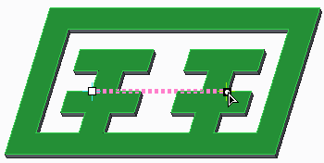Reliefs created at:
  + Bend line ends
  + Intermediate locations
  + Bend extent lines
* Bending takes precedence over relief creation.

**Figure 1 – Bend Lin**e

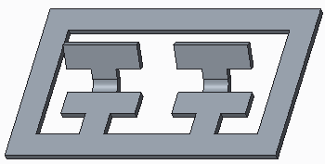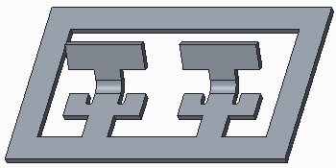

**Figure 2 – Bend Created Figure 3 – Multiple Reliefs**

**Task 1:** Experiment with multiple Bend Reliefs.

|  |
| --- |
| 1. Disable all Datum Display types. 2. From the In Graphics toolbar, select **Shading With Edges**  from the Display Style types drop-down menu. |
| 1. Click **Bend**  from the Bends group. 2. Select the top model surface.  |  | | --- | | 1. Click **Change Bending Direction**  to flip the bend direction upward. 2. Click **Change Fixed Side**  to flip the fixed direction frontward. 3. Type **60** in the Bend Angle text box. 4. Select **2.0 * Thickness** from the Bend Radius text box. 5. Click **Preview Feature** .    * Notice the bend does not need relief. 6. Click **Resume Feature**  . | | 1. Click **Bend On Both Sides** . 2. Select the **Relief** tab.    * Select **Obround** from the Type drop-down menu.    * Select **Blind** from the Depth Option types drop-down menu. 3. Click **Preview Feature** .    * Notice the bending of the lower inner material. | | 1. Click **Resume Feature**  . 2. Click **Bend On Other Side** .    * Notice the four reliefs created. | | 1. Type **1.0** in the Bend Radius text box. 2. Click **Complete Feature** .    * Notice the bending of the upper inner material. | | 1. In the model tree, right-click BEND 1 and select   **Edit** .   * + Edit DEV.L to **1** and press ENTER.  1. Press CTRL+G to regenerate the model.    * Notice the eight reliefs created. | | 1. Click **Unbend** from the Bends group.    * Click **Complete Feature** . |  * + Click and drag the endpoints to the vertices |

## Creating Corner Relief

##### Corner relief helps prevent unwanted deformation by controlling the sheet metal material behavior.

* + - 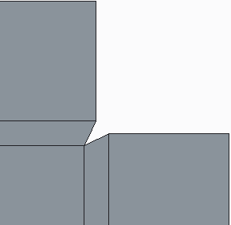Five types of corner relief:
* V Notch (default)
* No Relief
* Circular
* Obround
  + - Four methods:
* Create the corner relief as a feature.
* Create default relief automatically while unbending.
* Setup default relief for all corners.
* Define relief in a Conversion feature.

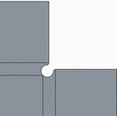 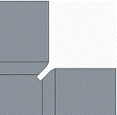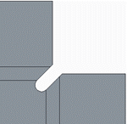

**Creating Corner Relief**

Corner relief helps prevent unwanted deformation by controlling the sheet metal material behavior. To utilize the corner relief option, you must have at least one ripped edge and **Annotation Display ** and **Corner Relief Notes ** enabled.

You can create five types of corner relief:

* + V Notch (default) — Retains the default V-notch shape.
  + No Relief — Generates a square corner.
  + Circular — Generates a circular notch.
  + Rectangular — Generates a rectangular notch.
  + Obround — Generates an obround notch.

## PROCEDURE - Creating Corner Relief

**Task 1:** Change the default flat state corner relief type for all corners

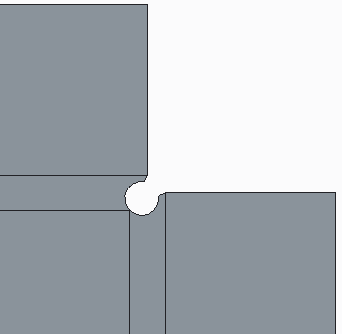

1. Disable all Datum Display types.
2. From the In Graphics toolbar, select **Shading With Edges ** from the Display Style types drop-down menu.
3. Select **Flat State Corner Relief ** from the Corner Relief types drop-down menu in the Engineering group.
4. In the menu manager, click **Confirm > Circular >**

**Task 2:** Use corner relief to edit all the relief for all corners.

|  |
| --- |
| 1. From the In Graphics toolbar, select **Corner Relief Notes**  from the Annotation Display types drop-down menu to enable, if necessary. 2. Select **Corner Relief**  from the Corner Relief types drop-down menu in the Engineering group. 3. In the dashboard, click **Select References Automatically** , if necessary. 4. Notice that all four corners are selected. |
| 1. In the dashboard, select the **Placement** tab.    * Select **Rectangular** from the corner relief Type drop-down list. |
| 1. Click **Complete Feature** from the dashboard. 2. With the corner relief feature still selected, right-click and select **Suppress** .    * Click **OK**. |

**Task 3:** Edit the corners to display the other relief types

1. Click **Corner Relief **.
2. In the dashboard, click **Select References Manually** 
   * Select the upper-right corner relief note.
   * Select the **Placement** tab.
   * Select **No relief** from the corner relief Type drop-down list.

|  |  |
| --- | --- |
| 3. Click **Complete Feature** . | |
| 1. Click **Corner Relief** . 2. Click **Select References Manually**  . 3. Select the upper-left corner relief note. 4. In the dashboard, select the **Placement** tab.    * Select **V notch** from the corner relief Type drop-down list. | |
| 8. Click **Complete Feature** . | |
| 1. Click **Corner Relief** . 2. Click **Select References Manually**  . 3. Select the lower-left corner relief note. 4. In the dashboard, select the **Placement** tab.    * Select **Rectangular** from the corner relief Type drop-down list.    * Select **2.0 * Thickness** from the depth thickness drop-down list. | |
| 13. Click **Complete Feature** . | |
| 1. Click **Corner Relief** . 2. Click **Select References Manually**  . 3. Select the lower-right corner relief note. 4. Select the **Placement** tab.    * Select **Obround** from the corner relief Type drop-down list.    * Select **2.0 * Thickness** from the depth thickness drop-down list.    * Select **2.0 * Thickness** from the width thickness drop-down list. | |
| 18. Click **Complete Feature** . | |
| 1. Compare the various corner relief results. 2. From the In Graphics toolbar, select **Shading**   from the Display Style types drop-down menu. | |

This completes the procedure.

## Creating Rip Features

##### You can add rips to your models to help flatten otherwise unbendable geometry. A Rip feature can be created between different contours on the same surface.

* + - Edge Rip:
* Define sets.
* Define edge treatment and gap setting per set.
* Edge trimming.
  + - Surface Rip:
* Define sets.
* Action-object workflow enables auto-complete.
* Sketched Rip:
  + Internal or external sketch.
  + Flip sketch projection direction.
  + Other options.
* Rip Connects:
  + Define sets.
  + Define rip end points.
* A gap to the rip.

## PROCEDURE - Creating Rip Features

**Task 1: Add surface rips to remove material in four corners.**

|  |
| --- |
| 1. Disable all Datum Display types. 2. From the In Graphics toolbar, click **Saved Orientations**  and select RIPS1. 3. Select **Surface Rip**  from the Rip types drop-down menu in the Engineering group. 4. Press CTRL and select the four surfaces shown. |
| 5. Click **Complete Feature** from the dashboard. |

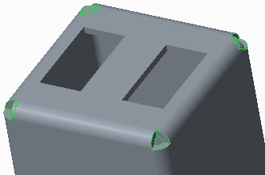**Task 2: Create an edge rip along three edges of the part.**

|  |
| --- |
| 1. Select **Edge Rip**  from the Rip types drop-down menu in the Engineering group. 2. Press CTRL and select the three lower edges shown. |
| 3. Click **Complete Feature** . |

**Task 3: Create a sketched rip.**

|  |
| --- |
| 1. Select **Sketched Rip**  from the Rip types drop-down menu in the Engineering group. 2. Select the surface shown as the sketch plane. |
| 3. Create the sketch shown. |
| 1. Click **OK** to complete the sketch. 2. Click **Complete Feature** |

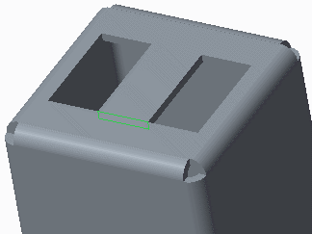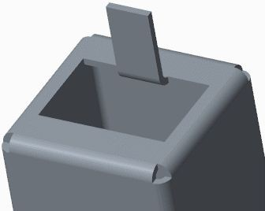**Task 4: Create a rip connect.**

|  |
| --- |
| 1. Select **Rip Connect**  from the Rip types drop-down menu in the Engineering group. 2. Press CTRL and select the two vertices as shown. |
| 3. Click **Complete Feature** |
| 1. In the model tree, right-click **BEND_SKETCH**   and select **Unhide** .   1. Click **Bend**  from the Bend types drop-down menu in the Bends group.    * Click **Change Bending Direction**  from the dashboard.    * Click **Complete Feature** . 2. Right-click **BEND_SKETCH** and select **Hide** . |

**Task 5: Unbend the model.**

|  |
| --- |
| 1. Press CTRL+D to orient to the Standard Orientation. 2. Select **Unbend** from the Unbend types drop-down menu in the Bends group. 3. Select the surface shown as the fixed geometry. |
|  |

## Patterning Walls

##### You can now pattern walls using direction and reference patterns.

* + Pattern Flat or Flanged.
    - Use Direction pattern.
  + Can Reference pattern.

**Figure 1 – Original Model**

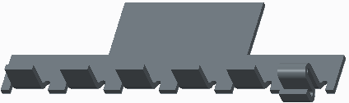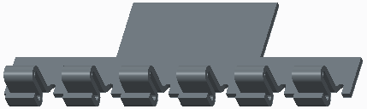

**Figure 2 – Flat Wall Patterned Figure 3 – Flange Wall Reference Patterned**

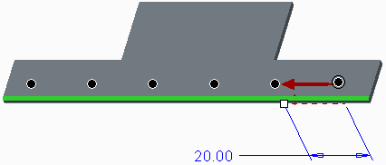**Task 1:** Create a direction pattern of a flat wall.

|  |
| --- |
| 1. Disable all Datum Display types. 2. In the model tree, right-click **Flat 1** and select   **Pattern** .   * + Select the front edge.   + Type **–20** as the pattern increment and press ENTER. |
| 3. Type **6** as the quantity in the dashboard and press ENTER. |
| 4. Click **Complete Feature** from the dashboard. |

**Task 2:** Create a reference pattern of a flange wall.

|  |
| --- |
| 1. In the model tree, right-click **Flange 1** and select   **Pattern** .   * + In the dashboard, select **Reference** as the pattern type, if necessary. |
| 2. Click **Complete Feature** . |

This completes the procedure.

## Mirroring Walls

##### You mirror sheet metal walls to create symmetric models.

* + A mirrored wall is its own feature.
    - Dependent by default
    - Can make section independent
    - Can redefine independently

**Figure 1 – Original Model**

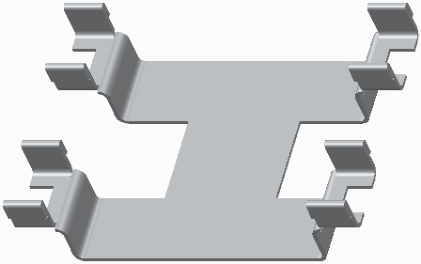

**Mirroring Walls**

You can now use the mirror option to create symmetric models. Once you select the walls and a planar reference, the mirror is created as dependent by default.

You can change the dependency in the dashboard, or right-click the mirrored wall and make its section independent. You can also redefine the wall to break the associative link, and change its shape or options independently from the original.

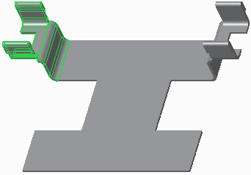**Task 1:** Mirror a selection of walls.

|  |
| --- |
| 1. Disable all Datum Display types. 2. Select the **Flat 1** wall from the model tree.    * Press SHIFT and select **Flange 3**. 3. Click the Editing group drop-down menu and select **Mirror** .    * Select datum plane RIGHT from the model tree.    * Click **Complete Feature** from the dashboard. |

4. Notice that each mirrored wall is its own feature in the model tree.

**Task 2:** Mirror the original and previously mirrored walls, then redefine a wall.

|  |
| --- |
| 1. With Mirror 1 still selected, press SHIFT and select **Flat 1** from the model tree. 2. Click the Editing group drop-down menu and select **Mirror** .    * Select datum plane FRONT from the model tree.    * Click **Complete Feature** . |
| 3. Select **Flange 3 (3)**, as shown. |
| 1. Right-click and select **Edit Definition** .    * In the dashboard, modify the shape from Flushed to **Duck**.    * Click **Yes** in the Section Redefine dialog box.    * Click **Complete Feature** . |

**22.SHEET METAL SETUP AND TOOLS**

## Bend Line Adjustments

##### You can control the location of a bend feature by adding a Bend Line Adjustment (BLA).

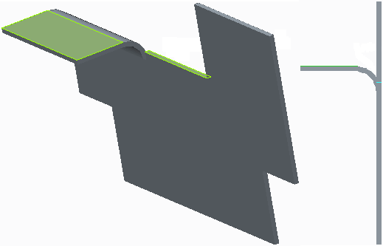The bend line location can be adjusted.

* Use the equation: BLA = L - (R+T).

**Figure 1 – Original Bend Line Location**

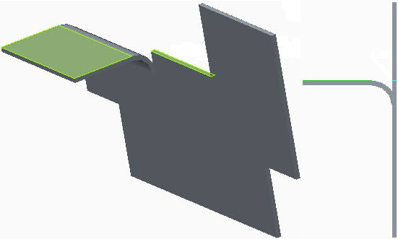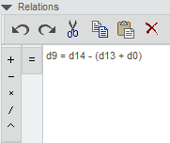

**Figure 2 – Relation to Control the Bend**

**Task 1:** Determine whether the bend is in the desired location.

1. 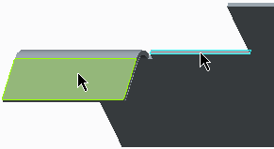Disable all Datum Display types.
2. In the ribbon, select the **Analysis** tab.
   * Select **Distance ** from the Measure types drop-down menu in the Measure group.
   * Press CTRL and select the two surfaces as references.

|  |
| --- |
| 1. From the In Graphics toolbar, click **Saved Orientations**  and select FRONT.    * Notice that the distance is approximately 0.80. |
| 1. In the Measure dialog box, click **Save Analysis** .    * Select **Save Analysis** and click **OK**.    * Close the Measure dialog box. |

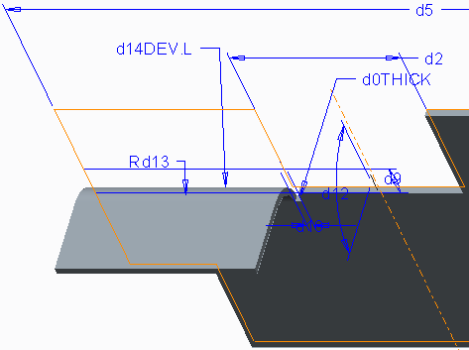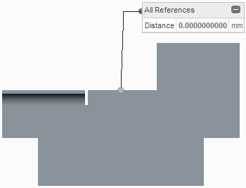**Task 2: Add a relation to control the BLA.**

|  |
| --- |
| 1. Press CTRL+D to orient to the Standard Orientation. 2. Right-click the Bend feature in the model tree and select **Edit** .    * Notice that the developed length (DEV.L) is 1.7. |
| 1. With dimensions still displayed, select the   **Model** tab.   1. Click the Model Intent group drop-down menu and select **Relations** .    * Select the **First Wall** from the model tree.    * Identify the symbolic form for the dimensions. Find the developed length (d14), the inside radius (d13), the thickness (d0), and the bend line location (d9). |
| 1. In the Relations dialog box, type the following BLA relation:    * d9 = d14 – (d13+d0).    * Click **OK**. 2. Click **Regenerate**  from the Quick Access toolbar. 3. Click **Saved Orientations**  and select FRONT.    * Notice that the distance is now 0.0. |

**Task 3:** Test the relations added.

Modify the bend radius.

* + 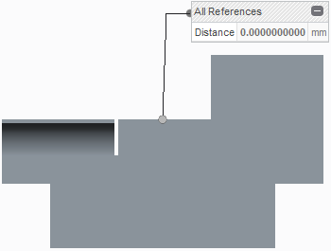Right-click the Bend feature in the model tree and select **Edit **.
  + Double-click the radius value, then type **2** and press ENTER.
  + Click twice in the background to de-select all geometry.
  + Notice that the distance is still 0.0 due to the bend line adjustment relation.

## Fixed Geometry You can specify a default reference for the fixed surface for unbend and bend back features.

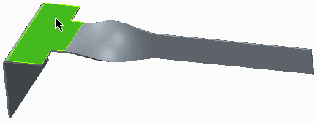You do not have to select the fixed side after setting default fixed geometry.

Applies to:

* Unbend features
* Bend Back features **Figure 1 – Surface Selected as Fixed** Geometry

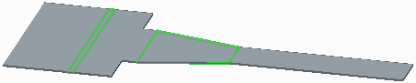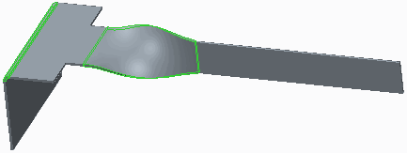

**Figure 2 – Unbend Uses Fixed Surface Figure 3 – Bend Back**

**Task 1:** Define the default fixed wall for all bend back and unbend operations

|  |
| --- |
| 1. Disable all Datum Display types. 2. In the ribbon, click **File > Prepare > Model Properties**. 3. In the Sheetmetal section of the Model Properties dialog box, click **change** for Fixed Geometry. 4. Select the wall surface to remain fixed, as shown. 5. Click **OK** in the Fixed Geometry dialog box. 6. Close the Model Properties dialog box. |
| 1. Test the fixed geometry setup. Create an unbend feature.    * In the ribbon, select **Unbend** from the Unbend types drop-down menu in the Bends group.    * Click **Complete Feature** |
| 1. Create a bend back feature.    * In the ribbon, click **Bend Back** from the Bends group.    * Notice that the fixed geometry is automatically selected and highlighted.    * Click **Complete Feature** |

## Design Rules : Design rules are geometric standards for your design.

A Rule table contains the design standards.

* MIN_DIST_BTWN_CUTS
* MIN_CUT_TO_BOUND
* MIN_CUT_TO_BEND
* MIN_WALL_HEIGHT
* MIN_SLOT_TAB_WIDTH
* MIN_SLOT_TAB_LENGTH
* MIN_LASER_DIM

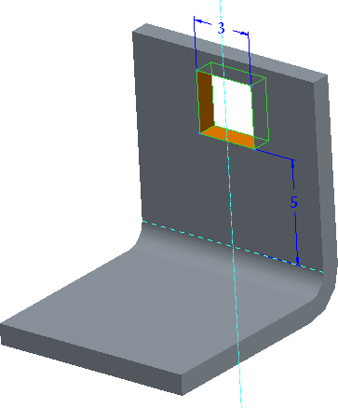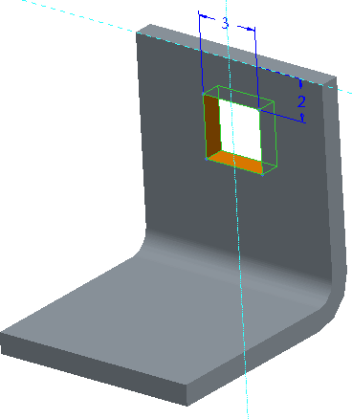**Figure 1 – MIN_CUT_TO_BEND Figure 2 – MIN_CUT_TO_BOUND**

## Defaults and Parameters

##### Sheet metal defaults can be customized.

Defaults are managed through the Model Properties dialog box.

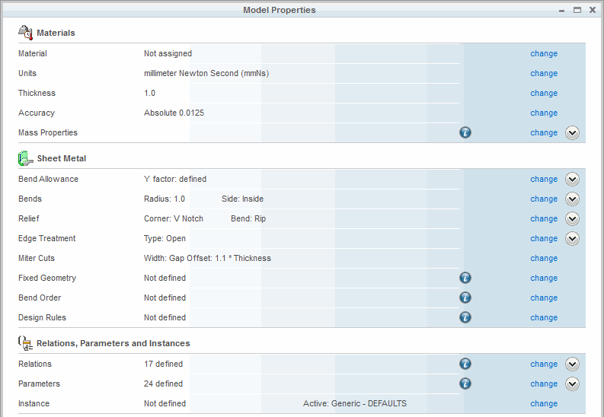

**Figure 1 – Model Properties**

**Task 1:** Open the Model Properties dialog box and check for non-default parameter values.

|  |
| --- |
| 1. Disable all Datum Display types. 2. Click **File > Prepare > Model Properties**. 3. In the Materials section, notice that the Thickness parameter is set to 0.25, which is not the default value.    * Click **change**. 4. In the Material Thickness dialog box, type **1.0**   and click **Regenerate**. |

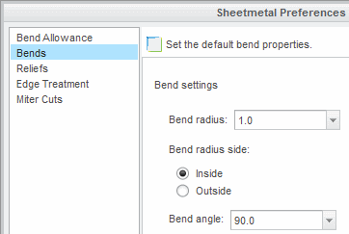

**Task 2:** Set several defaults in the Model Properties dialog box

1. Set the default bend radius, and enable it to apply automatically:
   * In the Sheetmetal section of the Model Properties dialog box, click **change** in the Bends row.
   * Type **1.0** for the Bend radius.
2. Set the default bend angle:
   * For the Bend angle, notice that it is set to **90**, which is the default.
3. Click **OK** in the Sheetmetal Preferences dialog box.

**Task 3:** View Relations and Parameters.

|  |
| --- |
| 1. To view the model’s relations:    * In the Relations, Parameters, and Instances section of the Model Properties dialog box, click **change** in the Relations row.    * When you are finished viewing the relations, click **Cancel** in the Relations dialog box and click **Yes**. |
| 1. To view the model’s parameters:    * In the same section, click **change** in the Parameters row.    * When you are finished viewing the parameters, click **Cancel** in the Parameters dialog box. 2. Close the Model Properties dialog box. |

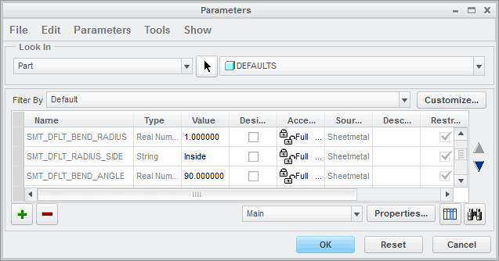**Task 4:** Create a bend feature to view the impact of setting the defaults.

1. Click **Bend ** from the Bend types drop-down menu in the Bends group.
2. Select the surface shown.

|  |
| --- |
| 3. Drag the reference handles as shown. |
| 4. Drag the second set of reference handles as shown. |
| 5. Modify the two dimensions to **5.0** as shown. |
| 6. Click **Complete Feature** from the dashboard. |

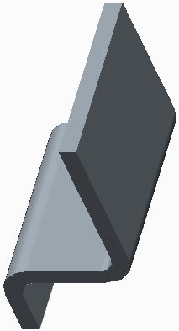This completes the procedure.

## Using Conversion Features

##### You can use the Conversion tool to make undevelopable parts developable when you convert an existing model to a sheetmetal model.

* The Conversion tool enables you to define:
  + Edge Rips
  + 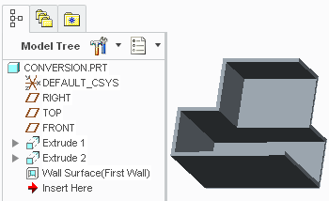Rip Connects
  + Edge Bends
  + Corner Reliefs

**Figure 1 – Original Model**

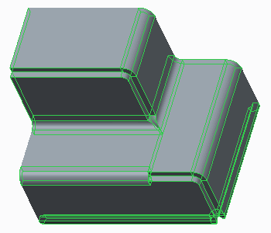

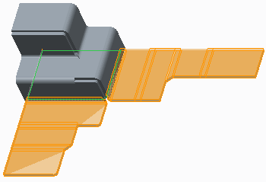**Figure 2 – Conversion Feature Created** **Figure 3 – Creating a Flat Pattern**

**Using Conversion Features**

If a converted part is not developable, you can either create individual features to make it developable, such as rips and corner reliefs, or you can use the Conversion tool to add alterations, such as rips, bends, and corner relief.

The Conversion tool enables you to define the following features:

* Edge Rip – Enables you to make a rip along the edge. The selected edge can be either straight or curved.
* Rip Connect – Enables you to connect rips with planar, straight-line rips. The rip connects are sketched with point-to-point connections, which require you to define rip endpoints. The rip endpoints can be datum points or vertices and must either be at the end of a rip or on the part border. The rip connects cannot be collinear with existing edges.
* Edge Bend – Enables you to define a bend along an existing sharp corner edge. Similar to Edge Rips, the selected edge can be either straight or curved. An edge bend is similar to creating a round

on a solid model.

* Corner Relief – Enables you to place relief in selected corners. You can define the corner relief Type you wish to create, and specify its values.

These Conversion tool features display as sub-dashboards of the Conversion dashboard. Using the Conversion tool creates a single feature in the model tree, but it is in fact a collection of features. This is useful when taking a model that was converted to sheetmetal using shell and making it possible to unbend.

## PROCEDURE - Using Conversion Features

## Task 1: Create a conversion feature.

|  |
| --- |
| 1. Enable only the following Datum Display types: . 2. Observe the model. It was shelled as it was converted from a solid model. |
| 1. Orient to the **Standard Orientation**. 2. Click the Datum group drop-down menu and select **Point** . 3. Select the edge shown to locate the point. 4. In the Datum Point dialog box, select **Reference**   as the Offset reference.   * + Select the surface.   + Edit the offset value to **18**.   + Click **OK**. |
| 1. Click **Conversion**  from the Engineering group. 2. In the dashboard, click **Edge Bend** . 3. Press CTRL and select the two edges.    * Notice that the feature defaults to an Inside thickness, or Inside radius. 4. Click **Complete Feature** from the dashboard. |
| 1. In the dashboard, click **Edge Rip** . 2. Press CTRL and select the four edges.    * Notice that the additional edge bends are created as necessary. |
| 1. Select the edge with the datum point.    * Select the end point, press SHIFT and drag the endpoint to snap to the datum point. 2. Click **Complete Feature** . |
| 1. In the dashboard, click **Rip Connect** . 2. Select the datum point. |
| 1. Press CTRL and select the connect location. 2. Click **Complete Feature** . |
| 1. In the dashboard, click **Corner Relief** . 2. In the dashboard, select **Circular** from the Type drop-down list.    * Select the **Placement** tab.    * Select **2.0 * Thickness** from the Width drop-down list. 3. Click **Complete Feature** . 4. Click **Complete Feature** again to complete the Conversion feature. |
| 1. From the In Graphics toolbar, select **Corner Relief Notes**  from the Annotation Display types drop-down menu.   Disable **Point Display** .    **Task 2:** Create a flat pattern.  1. Select **Unbend** from the Unbend types drop-down menu in the Bends group. |